The Second Sunday of Easter
Divine Worship Service
Grace Evangelical Lutheran Church of Oberlin, Ohio
April 16, 2023

Prelude:

Welcome:

Opening Hymn: “Alleluia, Alleluia! Hearts to Heaven” (LSB # 477; © Hope Publ. Co. 1982)
1. Alleluia! Alleluia! Hearts to heav'n and voices raise;
Sing to God a hymn of gladness, Sing to God a hymn of praise.
He who on the cross as Savior For the world's salvation bled,
Jesus Christ, the King of Glory, Now is risen from the dead.
2. Alleluia, Christ is risen! Death at last has met defeat:
See the ancient pow’rs of evil In confusion and retreat;
Once He died and once was buried: Now He lives forevermore,
Jesus Christ, the world’s Redeemer, Whom we worship and adore.

3. Alleluia! Alleluia! Glory be to God on high;
Alleluia to the Savior, Who has gained the victory;
Alleluia to the Spirit, Fount of love and sanctity!
Alleluia! Alleluia! To the Triune Majesty.

Invocation:
P: In the Name of the Father and of the Son+ and of the Holy Spirit.
C: Amen.

Confession and Absolution:
P: If we say we have no sin, we deceive ourselves, and the truth is not in us.
C: But if we confess our sins, God, who is faithful and just, will forgive our sins and cleanse us from all unrighteousness.

(Silence for personal self-examination.)
P: Let us then confess our sins to God our Father.
C: Most merciful God, we confess that we are by nature sinful and unclean. We have sinned against You in thought, word, and deed, by what we have done and by what we have left undone. We have not loved You with our whole heart; we have not loved our neighbors as ourselves. We justly deserve Your present and eternal punishment. For the sake of Your Son, Jesus Christ, have mercy on us. Forgive us, renew us, and lead us, so that we may delight in Your will and walk in Your ways to the glory of Your holy name. Amen
P: Almighty God in His mercy has given His Son to die and rose again for you and for his sake forgives you all your sins. As a called and ordained servant of Christ, and by His authority, I therefore forgive you all your sins in the name of the Father and of the Son + and of the Holy Spirit.
C: Amen.

Psalm: Psalm 105:1-5, 8
P: Oh give thanks to the LORD; call upon His name;
C: Make known His deeds among the peoples!
P: Sing to Him, sing praises to Him;
C: Tell of all His wondrous works!
P: Glory in His holy name;
C: Let the hearts of those who seek the LORD rejoice!
P: Seek the LORD and His strength;
C: Seek His presence continually!
P: Remember the wondrous works that He has done,
C: His miracles, and the judgments He uttered,
P: He remembers His covenant forever,
C: The word that He commanded, for a thousand generations

Kyrie: (sung)
P: In peace let us prayer to the Lord.
C: Lord, have mercy.
P: For the peace from above and for our salvation let us pray to the Lord.
C: Lord, have mercy.
P: For the peace of the whole world, for the well-being of the Church of God and for the unity of all let us pray to the Lord.
C: Lord, have mercy.
P: For this holy house and for all who offer here their worship and praise let us pray to the Lord.
C: Lord, have mercy.
P: Help, save, comfort, and defend us, gracious Lord.
C: Amen.

Hymn of Praise: (sung)
Refrain: This is the feast of victory for our God. Alleluia, alleluia, alleluia!
Worthy is Christ, the Lamb who was slain, whose blood set us free to be people of God. [Refrain]
Power and riches and wisdom and strength, and honor and blessing and glory are His. [Refrain]
Sing with all the people of God and join in the hymn of all creation:
Blessing and honor and glory and might be to God and the Lamb forever. Amen. [Refrain]
For the Lamb who was slain has begun his reign. Alleluia. [Final Refrain]

Salutation and Collect:
P: The Lord be with you.
C: And also with you.
P: Let us pray.
P: Almighty God, grant that we who have celebrated the Lord’s resurrection may by Your grace confess in our life and conversation that Jesus is Lord and God; through the same Jesus Christ, Your Son our Lord, who lives and reigns with You and the Holy Spirit, one true God, now and forever.
C: Amen.

First Reading: Acts 5:29-42
²⁹ But Peter and the apostles answered, “We must obey God rather than men. ³⁰ The
God of our fathers raised Jesus, whom you killed by hanging him on a tree. ³¹ God
exalted him at his right hand as Leader and Savior, to give repentance to Israel
and forgiveness of sins. ³² And we are witnesses to these things, and so is the Holy
Spirit, whom God has given to those who obey him.”
³³ When they heard this, they were enraged and wanted to kill them. ³⁴ But a Pharisee
in the council named Gamaliel, a teacher of the law held in honor by all the people, stood
up and gave orders to put the men outside for a little while. ³⁵ And he said to them, “Men
of Israel, take care what you are about to do with these men. ³⁶ For before these days
Theudas rose up, claiming to be somebody, and a number of men, about four hundred,
joined him. He was killed, and all who followed him were dispersed and came to
nothing. ³⁷ After him Judas the Galilean rose up in the days of the census and drew away
some of the people after him. He too perished, and all who followed him were
scattered. ³⁸ So in the present case I tell you, keep away from these men and let them
alone, for if this plan or this undertaking is of man, it will fail; ³⁹ but if it is of God, you
will not be able to overthrow them. You might even be found opposing God!” So they
took his advice, ⁴⁰ and when they had called in the apostles, they beat them and charged
them not to speak in the name of Jesus, and let them go. ⁴¹ Then they left the presence of
the council, rejoicing that they were counted worthy to suffer dishonor for the
name. ⁴² And every day, in the temple and from house to house, they did not cease
teaching and preaching that the Christ is Jesus.

R: This is the Word of the Lord
C: Thanks be to God.

Gradual:
Christ has risen from the dead.
God the Father has crowned Him with glory and honor,
He has given Him dominion over the works of His hands;
He has put all things under His feet.

Epistle Reading: 1 Peter 1:3-9
³ Blessed be the God and Father of our Lord Jesus Christ! According to his great mercy, he has caused us to be born again to a living hope through the resurrection of Jesus Christ from the dead, ⁴ to an inheritance that is imperishable, undefiled, and unfading, kept in heaven for you, ⁵ who by God's power are being guarded through faith for a salvation ready to be revealed in the last time. ⁶ In this you rejoice, though now for a little while, if necessary, you have been grieved by various trials, ⁷ so that the tested genuineness of your faith—more precious than gold that perishes though it is tested by fire—may be found to result in praise and glory and honor at the revelation of Jesus Christ. ⁸ Though you have not seen him, you love him. Though you do not now see him, you believe in him and rejoice with joy that is inexpressible and filled with glory, ⁹ obtaining the outcome of your faith, the salvation of your souls.

R: This is the Word of the Lord
C: Thanks be to God.

Alleluia: (stand and sing)
Alleluia. Lord, to whom shall we go? You have the words of eternal life. Alleluia, alleluia.

Gospel Reading: John 20:19-31
P: The Holy Gospel according to St. John the 20th Chapter.
C: Glory to You, O Lord.

¹⁹ On the evening of that day, the first day of the week, the doors being locked where
the disciples were for fear of the Jews,^{[c]} Jesus came and stood among them and said to
them, “Peace be with you.” ²⁰ When he had said this, he showed them his hands and his
side. Then the disciples were glad when they saw the Lord. ²¹ Jesus said to them
again, “Peace be with you. As the Father has sent me, even so I am sending you.” ²² And
when he had said this, he breathed on them and said to them, “Receive the Holy
Spirit. ²³ If you forgive the sins of any, they are forgiven them; if you withhold
forgiveness from any, it is withheld.”
²⁴ Now Thomas, one of the twelve, called the Twin,^{[d]} was not with them when Jesus
came. ²⁵ So the other disciples told him, “We have seen the Lord.” But he said to
them, “Unless I see in his hands the mark of the nails, and place my finger into the mark
of the nails, and place my hand into his side, I will never believe.”
²⁶ Eight days later, his disciples were inside again, and Thomas was with
them. Although the doors were locked, Jesus came and stood among them and
said, “Peace be with you.” ²⁷ Then he said to Thomas, “Put your finger here, and see my
hands; and put out your hand, and place it in my side. Do not disbelieve, but
believe.” ²⁸ Thomas answered him, “My Lord and my God!” ²⁹ Jesus said to him, “Have
you believed because you have seen me? Blessed are those who have not seen and yet
have believed.”
³⁰ Now Jesus did many other signs in the presence of the disciples, which are not
written in this book; ³¹ but these are written so that you may believe that Jesus is the
Christ, the Son of God, and that by believing you may have life in his name.

P: This is the Gospel of the Lord.
C: Praise to You, O Christ.

Apostle’s Creed:
I believe in God, the Father almighty,
Maker of heaven and earth.
And in Jesus Christ, His only Son, our Lord,
who was conceived by the Holy Spirit, born of the Virgin Mary, suffered under Pontius Pilate, was crucified, died, and was buried.
He descended into hell.
The third day He rose again from the dead.
He ascended into heaven and sits at the right hand of God the Father Almighty. From thence He will come to judge the living and the dead.
I believe in the Holy Spirit, the Holy Christian Church, the communion of saints, the forgiveness of sins, the resurrection of the body, and the life everlasting. Amen.

Children’s Message:

Sermon Hymn: Jesus Christ, My Sure Defense” (LSB # 741, st. 1-3, 5)

1. Jesus Christ, my sure defense And my Savior, now is living!
Knowing this, my confidence Rests upon the hope here given,
Though the night of death be fraught Still with many an anxious thought.

2. Jesus, my Redeemer, lives; Likewise I to life shall waken.
He will bring me where He is; Shall my courage then be shaken?
Shall I fear, or could the Head Rise and leave His members dead?

3. No, too closely I am bound, By my hope to Christ forever;
Faith’s strong hand the Rock has found, Grasped it, and will leave it never;
Even death now cannot part From its Lord the trusting heart.

5. Glorified, I shall anew With this flesh then be enshrouded;
In this body I shall view God, my Lord, with eyes unclouded;
In this flesh I then shall see Jesus Christ eternally.

Sermon: “Hope in the mist of suffering”

Prayer of the Church:
(Each petition of the prayers concludes with the response:)
P: Lord, in your mercy,
C: hear our prayer.

Lord’s Prayer:
Our Father who art in heaven, hallowed be Thy name, Thy kingdom come, Thy will be done, on earth as it is in heaven. Give us this day our daily bread; and forgive us our trespasses as we forgive those who trespass against us; and lead us not into temptation, but deliver us from evil.
For Thine is the kingdom and the power and the glory forever and ever. Amen.

Benediction:
P: The Lord bless you and keep you.
The Lord make His face to shine upon you
and be gracious to you.
The Lord lift up His countenance upon you and give+ you peace.
C: Amen.

Closing Hymn: “How Firm a Foundation” (LSB # 728, st. 1-3, 5)

1. How firm a foundation, O saints of the Lord,
Is laid for your faith in His excellent Word!
What more can He say than to you He has said
Who unto the Savior for refuge have fled?

2. “Fear not! I am with you, O be not dismayed,
For I am your God and will still give you aid;
I'll strengthen you, help you, and cause you to stand
Upheld by My righteous, omnipotent hand.

3. "The soul that on Jesus has leaned for repose
I will not, I will not, desert to his foes;
That soul, though all hell should endeavor to shake,
I’ll never, no never, no never forsake!

5. "Throughout all their lifetime My people will prove
My sov'reign, eternal, unchangeable love;
And then, when gray hairs will their temples adorn,
Like lambs they will still in My bosom be borne."
Postlude:

+ + +

Preacher: Vicar Glenn Mertz
Organist: Oziah Wales
Order of Worship: Divine Service Setting 1 from LSB (CPH, 2006) p. 151-166

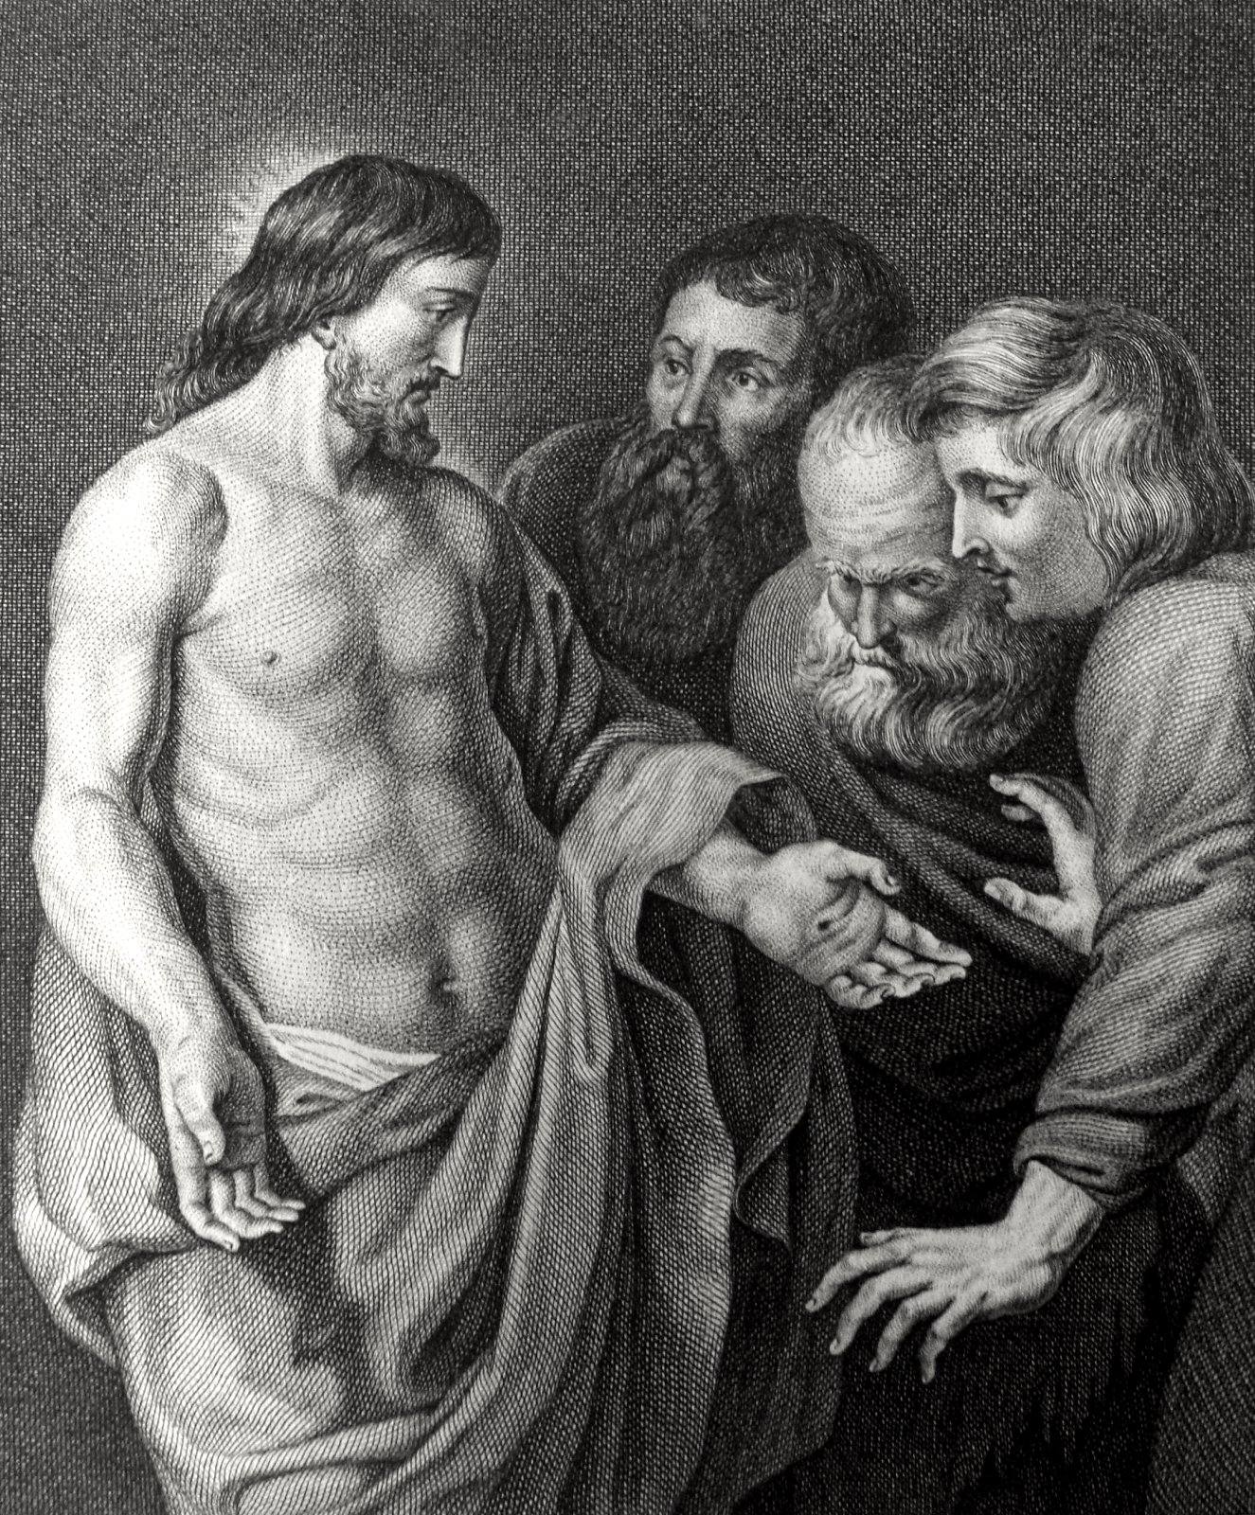

Jesus Appears to Thomas and His Disciples

