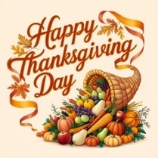
Grace Announcements 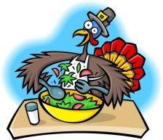
For the Week of November 23, 2025

IN OUR PRAYERS THIS WEEK:

Please pray for Karen Huston and family at the passing of Karen’s husband, Mark, who was called to his eternal heavenly home on Monday, Nov. 3, 2025; for the family of Kathryn Sharp (Carolyn Husted’s sister), who was called from this life to her heavenly home on October 31, 2025; Marcia Metzger (wife), Lisa LaLonde (daughter) and the remaining family of Dave Metzger, who was called to his eternal heavenly home on Thursday, Oct. 2nd (additionally, please continue to pray for Marcia’s health); Glen & Karen Fridenstine; Tom Hadaway; the family of Ken Deidrick (brother-in-law of Bonnie Abicht), who was called to his heavenly home; Teresa Fehlan (mother of Jen Jones); Bill Petersen (brother-in-Law of Fred C. Feddeck); Barbara Hadaway; Carolyn Husted; David Robinson (brother of Lee Anne Christner), Mike & Melissa Bennett (son-in-law and daughter of John and Kathy Knipper); Diane & Ron Senyak; Bev & Ray Hines, and Coralie Swanzer.
COMING UP AT GRACE

Sun. 11/23 Worship Service 10:00 am
Sun. 11/23 Bible Study w/VicarMertz 11:15 am
(Studying the book of Hebrews)
Wed. 11/26 Bible Study w/Pastor Weldon 1:30 pm
(Studying the book of Galatians)
Wed. 11/26 Bible Study w/Harriett Thomas Canceled 7:00 pm
(Studying the book of Ruth at
Church and with Zoom-contact Harriett)
Wed. 11/26 THANKSGIVING EVE Worship Service 6:00 pm
Sun. 11/30 Worship Service 10:00 am
Sun. 11/30 Bible Study w/VicarMertz 11:15 am
(Studying the book of Hebrews)

SERVING THE LORD
DATE | USHER | Counters | Altar Guild | Lay Reader | Comm. Assist.
Nov 23  10am | Dale Rider | Fred C. & Greg | Robin Turnbull | Dave Jones | Bob Izold
Nov 30  10am | Dale Rider | Bonnie & Lisa | Colleen Karp | Paul Castle | Andy Karp
Dec 7  10am | Tom Monroe | Bonnie & Lisa | Colleen Karp | Dave Jones | Andy Karp
Dec 14  10am | Tom Monroe | Jan & Dale | Kathy Knipper | Fred Feddeck | Dave Jones

Thanksgiving, Advent and Christmas are coming soon…
THANKSGIVING EVE, ADVENT and CHRISTMAS SERVICES
Thanksgiving Eve on Nov. 26th at 6pm
Advent Service on Dec. 3rd at 6pm
Advent Service on Dec. 10that 6pm
Advent Service on Dec. 17that 6pm
Christmas Eve Service on Dec. 24that 6pm

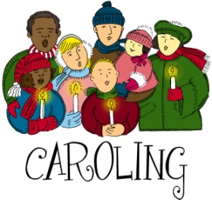
Do you miss some of those Old Fashioned Christmas Traditions???

JOIN in for some fun, as we go Caroling this Christmas Season. Let’s show our Oberlin community (and especially the Nursing Home and Shut-Ins ) that God’s Church is as alive today, as in Christmases past, and that we care! we are blessed to be able to honor our Lord and Savior by sharing some glorious Christmas Carols and spreading some good cheer and, of course, God’s Love.
A sign-up sheet is in the Narthex on the table by where the Bulletins are. Would you please sign up and let us know which of the days (or both) you are available to participate in? Thank you.

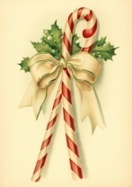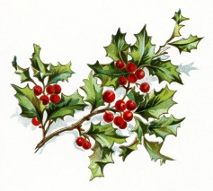

Ladies Aid…

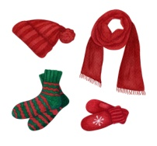
MITTEN TREE: Once again Ladies Aid has set up a Christmas Tree in the Narthex. We are collecting mittens, scarfs and hats for the children in our Community. On Dec. 1st, we will be delivering them to the Community Center in Oberlin.
⁴⁰ And the King shall answer and say unto them, Verily I say unto you, Inasmuch as ye have done it unto one of the least of these my brethren, ye have done it unto me. Matthew 25:40
BAKE SALE: Ladies Aid is asking for VOLUNTEERS TO BAKE cookies, cakes, pies, candy, etc. …anything you wish for the upcoming Christmas Season…and if possible, your help the day of. We will be advertising and opening it up to the public. It will be held on December 13th from 9:00 am until 12 noon at Grace Lutheran Church Oberlin in the Fellowship Hall. Please call Lee Anne Christner at 440-864-9456 to let her know you will be baking; and if you know, what you will be baking. All proceeds will go towards providing future mission work.

 NOVEMBER BIRTHDAYS

James Feddeck 11/10
Daniel Bremke 11/20
Added: Sydney Wright 11/30
Harriett Thomas 11/21
Fred Feddeck 11/22
Added: Jennifer Storr 11/30
 November Anniversaries 

None

NOTES FOR WORSHIP

Welcome GUESTS! We are SO GLAD that you have joined us today to worship our Lord together. We would love for you to sign our Guest Book in the Narthex. Today we will be using the Divine Service Setting 1 Liturgy. If you might be unfamiliar with it, please turn to page 151 in the pew hymnal to follow along.

Children’s Bulletins are available on the table in the narthex for kids ages 3 & up and 7 & up. Help yourself!

Announcements and worship service bulletins can be picked up from the table in the narthex.

