December 24, 2025 CHRISTMAS EVE 6:00 PM
Thank you for joining us for worship this evening.
Please silence your cell phone as we worship together in God's House.

T In Nomine Jesu T

Welcome and Announcements

(Please stand, turn and face the Processional Cross)
P And an angel of the Lord appeared to them, and said: “Fear not, for behold, I bring you Good News of great joy that will be for all the people. For unto you is born this day in the city of David a Savior, who is Christ the Lord.
C “Let us go over to Bethlehem and see this thing that has happened, which the Lord has made known to us.”

Opening Hymn O COME, ALL YE FAITHFUL LSB 379 (vs. 1, 2 & 4)

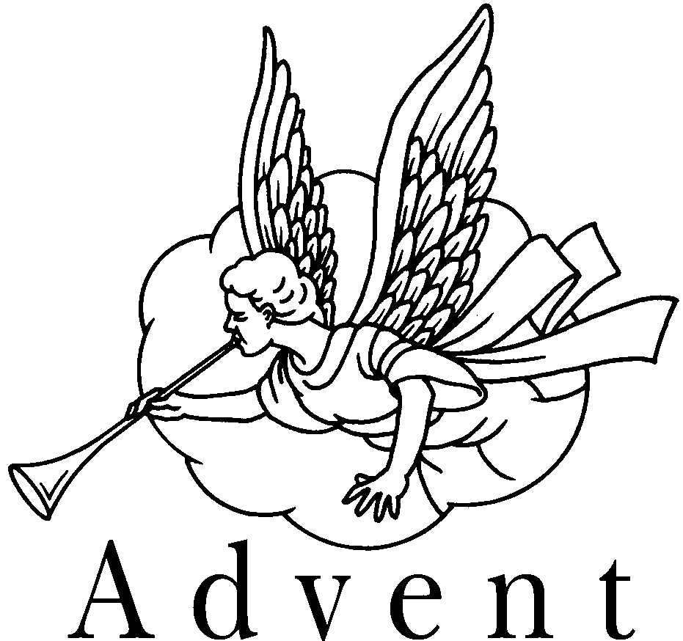
Oh, come, all ye faithful, Joyful and triumphant!
Oh, come ye, oh, come ye to Bethlehem;
Come and behold Him Born the King of angels:
Oh, come, let us adore Him, Oh, come, let us adore Him,
Oh, come, let us adore Him, Christ the Lord!

The Highest, most holy, Light of Light eternal,
Born of a virgin, A mortal He comes;
Son of the Father Now in flesh appearing!
Oh, come, let us adore Him, Oh, come, let us adore Him,
Oh, come, let us adore Him, Christ the Lord!

Yea, Lord, we greet Thee, Born this happy morning;
Jesus, to Thee be glory given! Word of the Father,
Now in flesh appearing!
Oh, come, let us adore Him, Oh, come, let us adore Him,
Oh, come, let us adore Him, Christ the Lord!

The Invocation
P In the name of the Father and of the T Son and of the Holy Spirit.
C Amen.
P This is the day that the Lord has made!
C We will rejoice and be glad in it!
P In the beginning, there was the Word and the Word was with God,.
C and the Word was God.
P The Word became flesh and lived among us, and we have seen His glory.
C Oh Come, Let us worship Him.
P The people walking in darkness have seen a great light.

C The Light shines in the darkness, but the darkness has not overpowered it.
P On those living in the land of the shadow of death a light has dawned.

C We have seen His glory, the glory of the one and only Son who came from the Father.
P For to us a child is born, to us a Son is given.
C In Him was life, and that light was the life of man.
P Christ is born; today salvation has appeared.

C GLORY TO GOD IN THE HIGHEST! ALLELUIA!

P When we see the way Jesus Christ lived upon the earth we are somewhat startled by the pictures of humility, poverty, and simplicity. When Jesus was born, the Father chose to first reveal the Good News to some lowly, humble shepherds in a field. When Jesus grew and wandered the land of Israel, He favored the poor and lowly of heart, often choosing to spend His time with them. In fact, when He chose His disciples, we see that most of them were poor, uneducated, and without any title or fame that they should be singled out. Jesus’ preferences have not changed. He still singles out the humble of heart with whom to share His secrets. Will we be found among these?

Silence for reflection on God's Word and for self-examination.

P Most Faithful God…
C Almighty God, though we are completely unworthy, You have given to us this night the most wonderful gift we could ever imagine! You have given Your Son, born in a lowly manger. You have sent Him to teach us right ways to live, and You have sent Him to die for us, so that we will not be lost forever in our sin. Thank You for this marvelous gift! Thank You that we have been born again and made your children by adoption and grace. Help us to follow in Jesus’ footsteps, walking humbly before You, with self-control, right conduct, and whole-hearted devotion to You alone. Forgive our sins, and renew us daily by the power of Your Holy Spirit, through Jesus Christ our Lord. Amen.
P Our Almighty God has had mercy on us and forgiven us of all our sins through our Lord, Jesus Christ. He loves you. He will not stop loving you. He has given you eternal life through this Baby of Bethlehem! Amen.
C Rejoice, Rejoice, Oh Emmanuel!

SERVICE OF HYMNS AND READINGS

1ST READING Isaiah 35:1-4,10
COME, THOU PRECIOUS RANSOM, COME LSB 350 (vs. 1 & 4)


Come, Thou precious Ransom, come, Only hope for sinful mortals!
Come, O Savior of the world! Open are to you all portals.
Come, Thy beauty let us see; Anxiously we wait for Thee.

Hail! Hosanna! David’s Son! Jesus, hear our supplication!
Let Thy kingdom, scepter, crown, Bring us blessing and salvation.
That forever we may sing: Hail! Hosanna to our king!

2nd READING Isaiah 11:1-2,5

LO, HOW A ROSE E'ER BLOOMING LSB 359 (vs. 1 & 4)
Lo, how a rose e’er blooming From tender stem hath sprung!
Of Jesse’s lineage coming, As prophets long have sung.
It came, a flow’ret bright, Amid the cold of winter,
When half-spent was the night.
O Savior, child of Mary, Who felt our human woe;
O Savior, King of glory, Who dost our weakness know:
Bring us at length, we pray, To the bright courts of heaven,
And to the endless day.

3rd READING Isaiah 9:2,6-7
ANGELS WE HAVE HEARD ON HIGH LSB 368 (vs. 1 & 3)

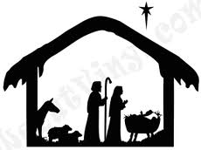

Angels we have on heard high, Sweetly singing o'er the plains,
And the mountains in reply, Echoing their joyous strains
Gloria in excelsis Deo. Gloria in excelsis Deo.
Come to Bethlehem and see Him whose birth the angels sing;
Come, adore on bended knee Christ the Lord the newborn King
Gloria in excelsis Deo. Gloria in excelsis Deo.

4th READING Micah 5:2,4 O LITTLE TOWN OF BETHLEHEM LSB 361 (vs. 1 & 2)

O little town of Bethlehem, How still we see thee lie!
Above thy deep and dreamless sleep The silent stars go by;
Yet in thy dark streets shineth The everlasting light.
The hopes and fears of all the years Are met in thee tonight.

For Christ is born of Mary, And, gathered all above.
While mortals sleep, the angels keep Their watch of wond’ring love.
O morning stars, together Proclaim the holy birth,
And praises sing to God the king And peace to all the earth!

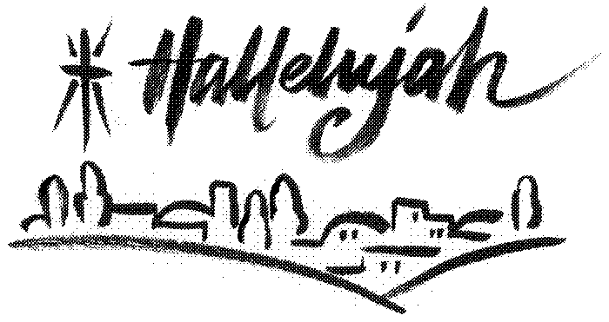

5th READING John 1:1-4,9-14
WHAT CHILD IS THIS LSB 370 (vs. 1)

What Child is this who, laid to rest On Mary's lap is sleeping?
Whom angels greet with anthems sweet,
While shepherds watch are keeping?
This, this is Christ the King,
Whom shepherds guard and Angels sing;
Haste, haste, to bring Him laud, The babe, the Son of Mary!

6th READING Matthew 1:18-25
AWAY IN A MANGER LSB 364 (vs. 1 & 3)

Away in a manger, No crib for His bed
The little Lord Jesus Laid down His sweet head
The stars in the sky looked down where He lay,
The little Lord Jesus asleep on the hay.

Be near me, Lord Jesus, I ask Thee to stay
Close by me forever And love me I pray
Bless all the dear children in Thy tender care,
And take us to heaven to live with Thee there.

7th READING Matthew 2:1-2,9-12
LSB 380 (vs. 1, 2 & 3)
HARK! THE HERALD ANGELS SING

Hark! the herald angels sing, "Glory to the new born King,
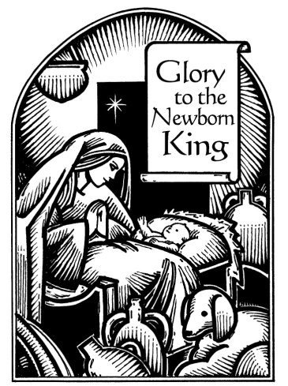
Peace on earth, and mercy mild, God and sinners reconciled!"
Joyful, all ye nations rise, Join the triumph of the skies;
With th' angelic host proclaim, "Christ is born in Bethlehem!"
Hark! the herald angels sing, "Glory to the new born King!

Christ, by highest heaven adored; Christ, the everlasting Lord;
Late in time behold him come, Offspring of a virgin's womb.
Veiled in flesh the Godhead see; Hail th' incarnate Deity!
Pleased as Man with man to dwell, Jesus, our Immanuel!
Hark! the herald angels sing, "Glory to the new born King!"

Hail, the heaven-born Prince of Peace!
Hail the Sun of Righteousness!
Light and life to all He brings, Ris'n with healing in His wings.
Mild He lays His glory by, Born that man no more may die,
Born to raise the sons of earth, Born to give them second birth.
Hark! the herald angels sing, "Glory to the new born King!

Sermon

Offering (Please pass your offering to the center aisle as it is being gathered by the Ushers.)

Prayer of the Church

P Lord, remember us in Your kingdom and teach us to pray:
Lord's Prayer LSB 196
C Our Father who art in heaven, hallowed be Thy name,
Thy kingdom come, Thy will be done on earth as it is in heaven;
give us this day our daily bread; and forgive us our trespasses
as we forgive those who trespass against us; and lead us not into temptation, but deliver us from evil.
For Thine is the kingdom and the power and the glory forever and ever. Amen.

The Lighting of the Candles

The sanctuary lights are turned down until all is dark.
P In the beginning was the Word, and the Word was with God, and the Word was God. He was with God in the beginning. Through him all things were made; without him nothing was made that has been made. In him was life, and that life was the light of men. The light shines in the darkness, but the darkness has not understood it. There came a man who was sent from God; his name was John. He came as a witness to testify concerning that light, so that through him all men might believe. He himself was not the light; he came only as a witness to the light. The true light that gives light to every man was coming into the world.

(After the reading the Pastor will light his Candle from the Advent wreath.
Once Pastor has his candle lit, please turn your candle on. After the service, please take your candle home as a reminder that Jesus Is the LIGHT of the World.)

READING: THE NATIVITY OF OUR LORD Luke 2
LSB 363(vs. 1, 2 & 3)
SILENT NIGHT, HOLY NIGHT

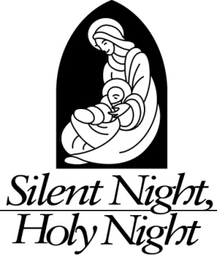
Silent night, holy night! All is calm, All is bright
Round yon Virgin, mother and Child,
Holy Infant, so tender and mild,
Sleep in heavenly peace, Sleep in heavenly peace.

Silent night, holy night! Shepherds quake at the sight;
Glories stream from heaven afar,
Heav'nly hosts sing Al-le-lu-ia!
Christ, the Savior is born! Christ, the Savior is born!

Silent night, Holy night! Son of God, love's pure light
Radiant beams from Thy holy face,
With the dawn of redeeming grace,
Jesus, Lord, at Thy birth; Jesus, Lord, at Thy birth.

The Benediction
P The Lord bless you and keep you. The Lord make His face shine on you and be gracious to you. The Lord look upon you with favor and T give you peace.
C Amen.

Closing Hymn
JOY TO THE WORLD LSB 387 (vs. 1, 3 & 4)

Joy to the world, the Lord is come! Let earth receive her King;
Let ev’ry heart prepare Him room And heav’n and nature sing,
And heav’n and nature sing, And heav’n, and heav’n and nature sing.

No more let sins and sorrows grow Nor thorns infest the ground;
He comes to make His blessings flow Far as the curse is found,
Far as the curse is found, Far as, far as the curse is found.

He rules the world with truth and grace And makes the nations prove
The glories of His righteousness And wonders of His love,
And wonders of His love, And wonders, wonders of His love.

P Go in peace. Serve the Lord.
C Thanks be to God.

Postlude

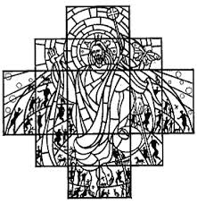



Christmas Eve Candlelight
Worship Service

Grace Lutheran Church
Oberlin, Ohio
December 24, 2025, 6:00pm

Pastor: Robert Weldon
Organist: James Feddeck

