Grace Lutheran Church
310 West Lorain Street, Oberlin, Ohio 44074
January 18, 2026
10:00 AM

January 18, 2026 SECOND SUNDAY AFTER THE EPIPHANY 10:00 AM

Divine Worship Service
Grace Evangelical Lutheran Church of Oberlin, Ohio
Setting 1 from LSB (CPH, 2006) p. 151-166

Prelude:
Welcome:
Opening Hymn: O CHRIST, WHO CALLED THE TWELVE (LSB 856)
- O Christ, who called the Twelve To rise and follow You,
Forsaking old, familiar ways For ventures bold and new:
Grant us to hear Your call To risk security
And bound in heart and will to You, Find perfect liberty.

- O Christ, who taught the Twelve The truth for ages sealed,
Whose words and works awakened faith, The ways of God revealed.
Instruct us now, we pray, By Your empow’ring Word
True teacher, be for all who seek Their light, their life, their Lord.
- O Christ, who led the Twelve Among the desolate
And broke as bread of life for all Your love compassionate:
Lead us along the ways Where hope has nearly died
And help us climb the lonely hills Where love is crucified.
- O Christ, who sent the Twelve On roads they’d never trod
To serve, to suffer, teach, proclaim The nearer reign of God.
Send us on ways where faith Transcends timidity,
Where love informs and hope sustains Both life and ministry.

- O Christ, th’ apostle’s Lord, The martyrs’ strength and song,
The crucified and risen King To whom the saints belong:
Though generations pass, Our tribute still we bring.
Our hymns a sacrifice of praise, Our lives an offering.
Invocation:
V: In the Name of the Father and of the Son and of the Holy Spirit.
C: Amen.
Confession and Absolution: (LSB 151)
V: If we say we have no sin, we deceive ourselves, and the truth is not in us.
C: But if we confess our sins, God, Who is faithful and just, will forgive our sins and cleanse us from all unrighteousness.
(Silence for personal self-examination.)
V: Let us then confess our sins to God our Father.
C: Most merciful God, we confess that we are by nature sinful and unclean. We have sinned against You in thought, word, and deed, by what we have done and by what we have left undone. We have not loved You with our whole heart; we have not loved our neighbors as ourselves. We justly deserve Your present and eternal punishment. For the sake of Your Son, Jesus Christ, have mercy on us. Forgive us, renew us, and lead us, so that we may delight in Your will and walk in Your ways to the glory of Your Holy Name. Amen
V: In the mercy of Almighty God, Jesus Christ was given to die for us, and for His sake God forgives us all our sins. To those who believe in Jesus Christ He gives the power to
become the children of God and bestows on them the Holy Spirit. May the Lord, who
has begun this good work in us, bring it to completion in the day of our Lord Jesus Christ.
C: Amen.

Introit: Ps. 19:1–4a, b; antiphon: Ps. 19:14
V: Let the words of my mouth and the meditation of my heart be acceptable in your sight,
C: O Lord, my rock and my redeemer.
V: The heavens declare the glory of God,
C: and the sky above proclaims his handiwork.
V: Day to day pours out speech,
C: and night to night reveals knowledge.
V: There is no speech, nor are there words,
C: whose voice is not heard.
V: Their measuring line goes out through all the earth, and their words to the end of the
world.
C: In them he has set a tent for the sun.
V: Glory be to the Father and to the Son and to the Holy Spirit;
C: as it was in the beginning, is now, and will be forever. Amen.
V: Let the words of my mouth and the meditation of my heart be acceptable in your sight,
C: O Lord, my rock and my redeemer.
Kyrie:
V: In Peace let us Pray to the Lord.
C: Lord, have mercy.
V: For the Peace from above and for our salvation let us Pray to the Lord.
C: Lord, have mercy.
V: For the Peace of the whole world, for the well-being of the Church of
God and for the unity of all let us Pray to the Lord.

C: Lord, have mercy.
V: For this holy house and for all who offer here their worship and praise
let us pray to the Lord.
C: Lord, have mercy.
V: Help, save, comfort, and defend us, gracious Lord.
C: Amen.

Gloria in Excelsis: (sung) (LSB V. 154)
Glory to God in the highest, and Peace to his People on earth.
Lord God, heavenly King, almighty God and Father,
We worship you, we give You thanks, we praise You for Your glory.
Lord Jesus Christ, only Son of the Father, Lord God, Lamb of God,
You take away the sin of the world, have mercy on us;
You are seated at the right hand of the Father: receive our Prayer.
For You alone are the Holy One, You alone are the Lord,
You alone are the Most High, Jesus Christ, with the Holy Spirit,
in the glory of God the Father. Amen.

Salutation and Collect: (LSB V. 156)
V: The Lord be with you.
C: And also with you.
V: Let us pray.
Almighty and everlasting God, Who governs all things in heaven and on earth, mercifully
hear the prayers of Your people and grant us Your peace through all our days; through Jesus Christ, Your Son, our Lord, who lives and reigns with You and the Holy Spirit, one God, now and forever.
C: Amen.

Old Testament Reading: Isaiah 49:1–7
The Messiah prophetically proclaims through Isaiah that He will restore and redeem not only Israel, but also the Gentiles. He will receive the worship and honor He deserves, because He is the Lord’s chosen.

¹Listen to me, O coastlands, and give attention, you peoples from afar. The Lord called me from the womb, from the body of my mother He named my name.
²He made my mouth like a sharp sword; in the shadow of His hand He hid me; He made me a polished arrow; in His quiver He hid me away.
³And He said to me, “You are My servant, Israel, in whom I will be glorified.”
⁴But I said, “I have labored in vain; I have spent my strength for nothing and vanity; yet surely my right is with the Lord, and my recompense with my God.”
⁵And now the Lord says, He who formed me from the womb to be His servant, to bring Jacob back to Him; and that Israel might be gathered to Him—for I am honored in the eyes of the Lord, and my God has become my strength— ⁶He says: “It is too light a thing that you should be my servant to raise up the tribes of Jacob and to bring back the preserved of Israel; I will make you as a light for the nations, that my salvation may reach to the end of the Earth.”
⁷Thus says the Lord, the Redeemer of Israel and his Holy One, to one deeply despised, abhorred by the nation, the servant of rulers: “Kings shall see and arise; Princes, and they shall prostrate themselves; because of the Lord, who is faithful, the Holy One of Israel, who has chosen you.”

R: This is the Word of the Lord
C: Thanks be to God.
Gradual: Ps. 117:1–2a; 96:8
Praise the Lord, all nations!
Extol Him, all peoples!
For great is His steadfast love toward us,
and the faithfulness of the Lord endures forever.
Ascribe to the Lord the glory due His name;
bring an offering, and come into His courts!

Epistle: 1 Corinthians 1:1–9
Paul wrote to the Church in Corinth, rejoicing in their testimonies, giving thanks to God for all that He was doing
through them, and encouraging them to remain firm as they waited for Jesus to return.

¹Paul, called by the will of God to be an apostle of Christ Jesus, and our brother Sosthenes,
²To the Church of God that is in Corinth, to those sanctified in Christ Jesus, called to be saints together with all those who in every place call upon the name of our Lord Jesus Christ, both their Lord and ours:
³Grace to you and peace from God our Father and the Lord Jesus Christ.
⁴I give thanks to my God always for you because of the grace of God that was given you in Christ Jesus, ⁵that in every way you were enriched in Him in all speech and all knowledge— ⁶even as the testimony about Christ was confirmed among you— ⁷so that you are not lacking in any spiritual gift, as you wait for the revealing of our Lord Jesus Christ, ⁸Who will sustain you to the end, guiltless in the day of our Lord Jesus Christ. ⁹God is faithful, by whom you were called into the fellowship of His Son, Jesus.

R: This is the Word of the Lord
C: Thanks be to God.

Alleluia and Verse: (stand and sing)
Alleluia. Lord, to whom shall we go? You have the words of eternal life.
Alleluia, Alleluia.

Gospel Reading: John 1:29–42a
V: The Holy Gospel according to St. John, the first chapter.
C: Glory to You, O Lord.

The next day after Jesus was baptized, He passed by John the Baptist. John gave a powerful testimony and shared that Jesus was God’s Chosen One.

²⁹The next day [John] saw Jesus coming toward him, and said, “Behold, the Lamb of God, who takes away the sin of the world! ³⁰This is He of whom I said, ‘After me comes a man who ranks before me, because He was before me.’ ³¹I myself did not know him, but for this purpose I came baptizing with water, that He might be revealed to Israel.” ³²And John bore witness: “I saw the Spirit descend from heaven like a dove, and it remained on him. ³³I myself did not know him, but He who sent me to baptize with water said to me, ‘He on whom you see the Spirit descend and remain, this is He who baptizes with the Holy Spirit.’ ³⁴And I have seen and have borne witness that this is the Son of God.”
³⁵The next day again John was standing with two of his disciples, ³⁶and He looked at Jesus as He walked by and said, “Behold, the Lamb of God!” ³⁷The two disciples heard him say this, and they followed Jesus. ³⁸Jesus turned and saw them following and said to them, “What are you seeking?” And they said to him, “Rabbi” (which means Teacher), “where are you staying?” ³⁹He said to them, “Come and you will see.” So they came and saw where He was staying, and they stayed with him that day, for it was about the tenth hour. ⁴⁰One of the two who heard John speak and followed Jesus was Andrew, Simon Peter’s brother. ⁴¹He first found his own brother Simon and said to him, “We have found the Messiah” (which means Christ). ⁴²He brought him to Jesus. Jesus looked at him and said, “So you are Simon the son of John? You shall be called Cephas” (which means Peter).

V: This is the Gospel of the Lord.
C: Praise to You, O Christ.

Apostles' Creed:
I believe in God, the Father Almighty, maker of heaven and earth.
And in Jesus Christ, his only Son, our Lord, who was conceived by the Holy Spirit, born of the virgin Mary, suffered under Pontius Pilate, was crucified, died, and was buried. He descended into hell. The third day he rose again from the dead. He ascended into heaven and sits at the right hand of God the Father Almighty. From thence he will come to judge the living and the dead.
I believe in the Holy Spirit, the holy Christian Church, the communion of saints, the forgiveness of sins, the resurrection of the body, and the life everlasting. Amen.

Hymn of the Day: THE ONLY SON FROM HEAVEN (LSB 402)
- The only Son from Heaven, foretold by ancient seers,
By God the Father given, In human form appears.
No sphere His light confining, No star so brightly shining
As He, our Morning Star.

- O time of God appointed, O bright and holy morn!
He comes, the king anointed, The Christ, the virgin-born,
Grim death to vanquish for us, To open heav’n before us
And bring us life again.

- O Lord, our hearts awaken To know and love You more,
In faith to stand unshaken, In spirit to adore,
That we, through this world moving, Each glimpse of heaven proving,
May reap its fullness there.

- O Father, here before You With God the Holy Ghost
And Jesus, we adore You, O pride of angel host:
Before You mortals lowly Cry, “Holy, holy, holy,
O blessèd Trinity!”

Sermon:

Offering: (Offerings are brought forward)

Offertory: (stand and sing) “We Give Thee But Thine” (LSB 781)
- We Give Thee But thy Own, Whate’er the gift may be;
All that we have is Thine alone, A Trust, O Lord, from Thee.
- May we Thy bounties thus, As stewards true receive;
and gladly, as Thou blessed us, To Thee our first-fruits give!

Prayer of the Church: (Each Petition of the Prayers concludes with the response:)
V: Lord, in your mercy,
C: hear our prayer.

Preface: (sung)
V: The Lord be with you.
C: And also with you.
V: Lift up your hearts
C: We lift them to the Lord.
V: Let us give thanks to the Lord our God.
C: It is right to give Him thanks and praise.
V: It is truly good, right, and salutary…
…Your glorious name, evermore praising You and singing:
Sanctus: (sung)
Holy, holy, holy Lord God of Pow’r and might:
Heaven and earth are full of Your glory.
Hosanna. Hosanna. Hosanna in the highest.
Blessed is He who comes in the Name of the Lord.
Hosanna in the highest.
V: Lord, remember us in Your Kingdom and teach us to pray:

Lord’s Prayer:
Our Father Who art in heaven, hallowed be Thy name, Thy kingdom come, Thy will
be done, on earth as it is in Heaven. Give us this day our daily bread; and forgive us our trespasses as we forgive those who trespass against us; and lead us not into temptation, but deliver us from evil.
For Thine is the kingdom and the power and the glory forever and ever. Amen.

Pax Domini:
V: The Peace of the Lord be with you always.
C: Amen.

Agnus Dei: (sung)
Lamb of God, You take away the sin of the world; have mercy on us.
Lamb of God, You take away the sin of the world; have mercy on us.
Lamb of God, You take away the sin of the world; grant us Peace.

Benediction:
V: The Lord bless you and keep you.
The Lord make His face to shine upon you
and be gracious to you.
The Lord lift up His favor upon you and give you Peace.
C: Amen.

Closing Hymn: ALL GLORY BE TO GOD ON HIGH (LSB 947)

- All glory be to God on high And thanks for all His favor;
No harm can touch or terrify A child of God forever.
God shows His good and gracious will And grants His peace the world to fill
All strife at last has ended.

- We praise and laud and worship You; We give You thanks for ever,
O Father, for Your rule is true And just and changes never.
With boundless pow'r, your mighty reign Fulfills whatever You ordain.
Lord, grant us ev'ry blessing!

- O Jesus Christ, the only Son Begotten of the Father,
Your saving death has made us one With God and with each other.
O Lamb of God, to You on high In our distress we sinners cry,
Have mercy on us, amen!

- O Holy Spirit, our delight And source of consolation,
protect us from the devil's might Through Jesus, our salvation,
Who by His death upon a tree Has rescued us from misery:
To this we hold forever!

V: Go in peace. Serve the Lord.
C: Thanks be to God.

Postlude:
+ + +

Vicar: Chris Streeper
Organist: Harold Slocum
Order of Worship: Divine Service Setting 1 from LSB (CPH, 2006) p. 151-166

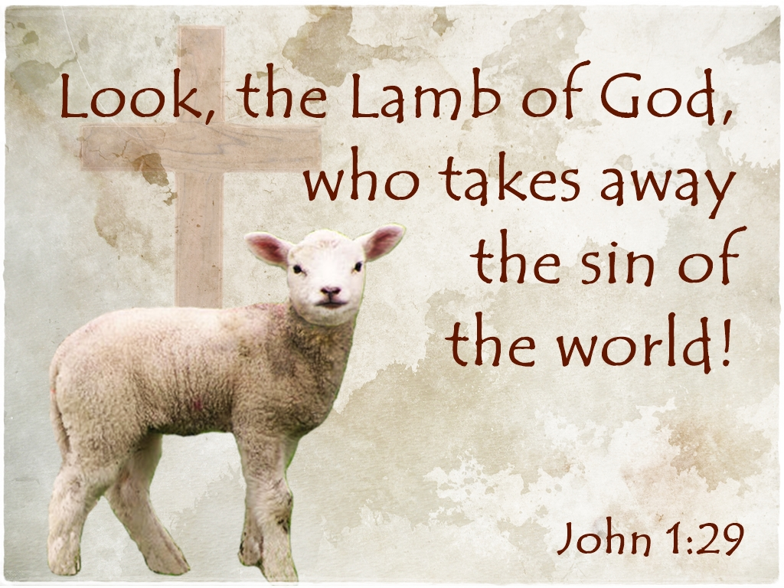

Grace Lutheran Church
310 West Lorain Street
Oberlin, Ohio 44074
www.grace-church-oberlin.org
440-775-3271
January 18, 2026
Vicar: Chris Streeper
Organist: Harold Slocum

