Grace Lutheran Church
310 West Lorain Street, Oberlin, Ohio 44074
February 28, 2026
5:00 PM

THE SECOND SUNDAY IN LENT
Divine Worship Service
Grace Evangelical Lutheran Church of Oberlin, Ohio
Setting 1 from LSB (CPH, 2006) p. 151-166

Prelude:

Welcome:
Opening Hymn: ROCK OF AGES, CLEFT FOR ME LSB 761

- Rock of Ages, cleft for me, Let me hide myself in Thee;
Let the water and the blood, From Thy riven side which flowed,
Be of sin the double cure: Cleanse me from its guilt and pow’r.

- Not the labors of my hands Can fulfill Thy Law’s demands;
Could my zeal no respite know, Could my tears forever flow,
All for sin could not atone; Thou must save, and Thou alone.

- Nothing in my hand I bring; Simply to Thy cross I cling.
Naked, come to Thee for dress; Helpless, look to Thee for grace;
Foul, I to the fountain fly; Wash me, Savior, or I die.

- While I draw this fleeting breath, When mine eyelids close in death,
When I soar to worlds unknown, See Thee on Thy judgment throne,
Rock of Ages, cleft for me, Let me hide myself in Thee.
Invocation:
P: In the Name of the Father and of the Son+ and of the Holy Spirit.
C: Amen.
instructed in the meaning of Holy Communion, and agree with these teachings. If you have any questions, please speak with the Pastor. As we eat and drink, we remember our Lord’s suffering, death, resurrection, ascension, and the promise of His coming again. Both Common and individual cups are available. When using the individual cup, please place the empty cup in the
basket at either end of the communion rail. The non-alcoholic wine is in the center of the tray. If the Common cup is used, please help the server by holding the base of the cup when you are served.
Nunc Dimittis: (sung) LSB 165

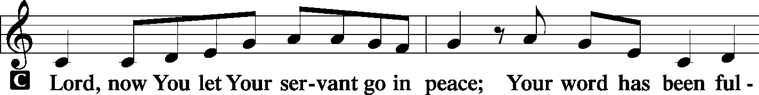
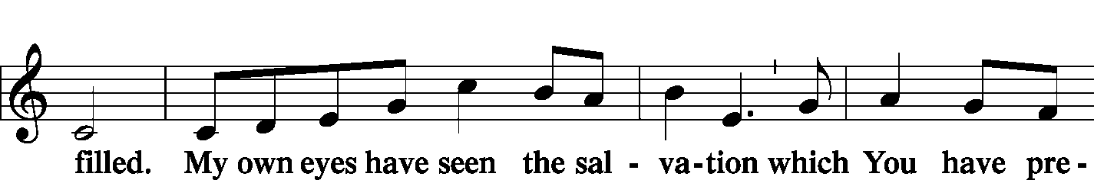
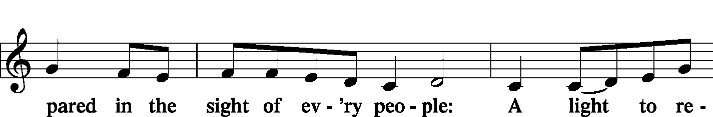
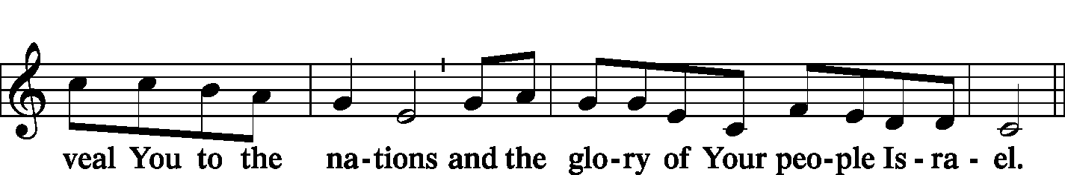
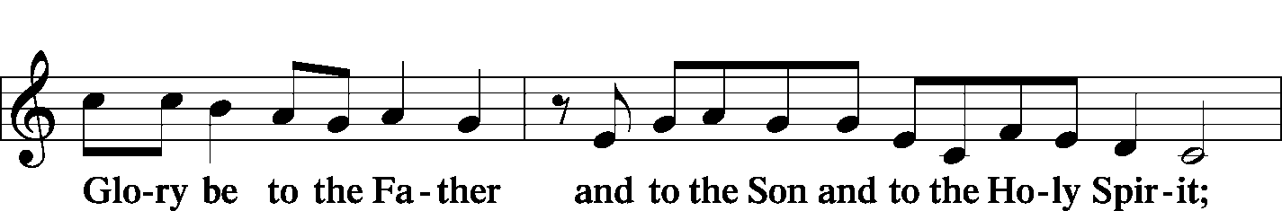
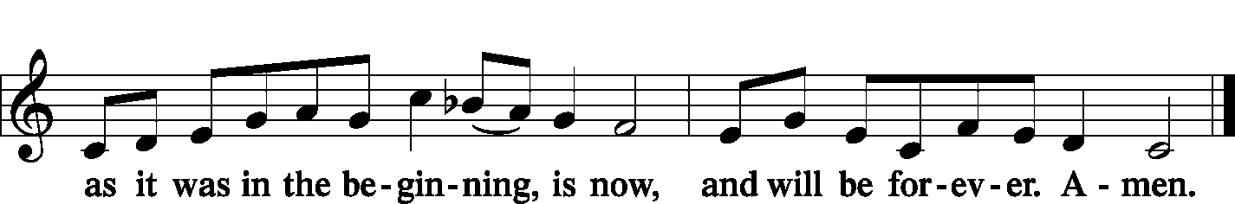
Post-Communion Collect: LSB 166
P: Let us Pray….
We give thanks to You, almighty God, that You have refreshed us through this salutary gift, and we implore You that of Your mercy You would strengthen us through the same in faith toward You and fervent love toward one another; through Jesus Christ, Your Son, our Lord, who lives and reigns with You and the Holy Spirit, one God, now and forever.
C: Amen.
Benediction: LSB 166
P: The Lord bless you and keep you.
The Lord make His face to shine upon you
and be gracious to you.
The Lord lift up His favor upon you and give you Peace.
C: Amen.

Closing Hymn: THE LAMB LSB 547

- The Lamb, the Lamb, O Father, where's the sacrifice?
Faith sees, believes God will provide the Lamb of price!

REFRAIN: Worthy is the Lamb whose death makes me His own!
The Lamb is reigning on His throne!

- The Lamb, the Lamb, One perfect final offering.
The Lamb, the Lamb, Let earth join heav'n His praise to sing. Refrain

- The Lamb, the Lamb, As wayward sheep their shepherd kill
So still, His will On our behalf the Law to fill. Refrain

- He sighs, He dies, He takes my sin and wretchedness.
He lives, forgives, He gives me His own righteousness. Refrain

- He rose, He rose, My heart with thanks now overflows Refrain
His song prolong Till ev'ry heart to Him belong.

P: Go in peace. Serve the Lord.
C: Thanks be to God.

Postlude:
+ + +

Pastor: Robert Weldon:
Organist: Holly Bogle
Order of Worship: Divine Service Setting 1 from LSB (CPH, 2006) p. 151-166
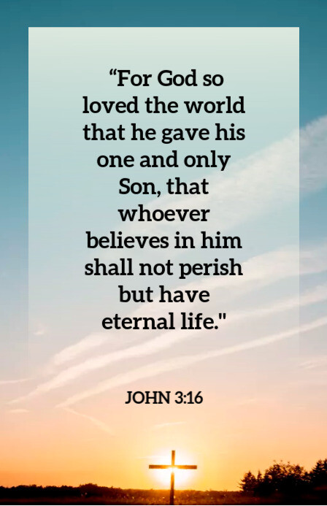

Grace Lutheran Church
310 West Lorain Street
Oberlin, Ohio 44074
www.grace-church-oberlin.org
440-775-3271
February 28, 2026
Pastor: Robert Weldon
Organist: Holly Bogle
Kyrie: LSB 152

P: In Peace let us Pray to the Lord.
C: Lord, have mercy.
P: For the Peace from above and for our salvation let us Pray to the Lord.
C: Lord, have mercy.
P: For the Peace of the whole world, for the well-being of the Church of
God and for the unity of all let us Pray to the Lord.
C: Lord, have mercy.
P: For this holy house and for all who offer here their worship and praise
let us pray to the Lord.
C: Lord, have mercy.
P: Help, save, comfort, and defend us, gracious Lord.
C: Amen.
Salutation and Collect: LSB 156
P: The Lord be with you.
C: And also with you.
P: Let us pray.
O God, You see that of ourselves we have no strength. By Your mighty power defend us from all adversities that may happen to the body and from all evil thoughts that may assault and hurt the soul; through Jesus Christ, Your Son, our Lord, who lives and reigns with You and the Holy Spirit, one God, now and forever.
C: Amen.
Old Testament Reading: Genesis 12:1–9
Abram, later renamed Abraham by God, is commended to move his family and see the promised land. God promises Abram that his offspring will one day inherit the land. He follows God’s command by faith, more on that in our Epistle reading.

¹Now the Lord said to Abram, “Go from your country and your kindred and your father’s house to the land that I will show you. ²And I will make of you a great nation,
and I will bless you and make your name great, so that you will be a blessing. ³I will bless those who bless you, and him who dishonors you I will curse, and in you all the families of the earth shall be blessed.”
⁴So Abram went, as the Lord had told him, and Lot went with him. Abram was seventy-five years old when he departed from Haran. ⁵And Abram took Sarai his wife, and Lot his brother’s son, and all their possessions that they had gathered, and the people that they had acquired in Haran, and they set out to go to the land of Canaan. When they came to the land of Canaan,

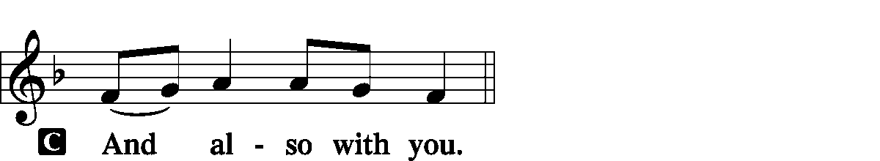



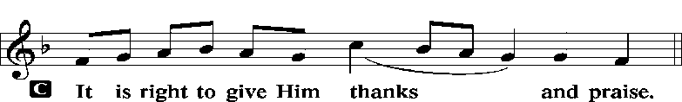

Proper Preface:
P: It is truly good, right, and salutary that we should at all times and in all places give thanks to You, holy Lord, almighty Father, everlasting God, through Jesus Christ, our Lord, who overcame the assaults of the devil and gave His life as a ransom for many that with cleansed hearts we might be prepared joyfully to celebrate the paschal feast in sincerity and truth. Therefore with angels and archangels and with all the company of heaven we laud and magnify Your glorious name, evermore praising You and singing:
Sanctus: (sung) LSB 161

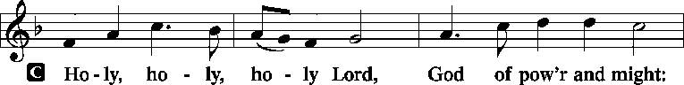
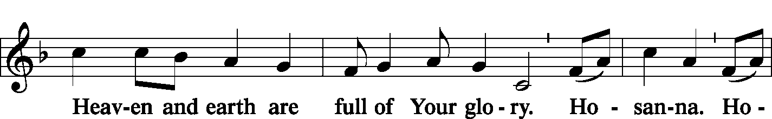
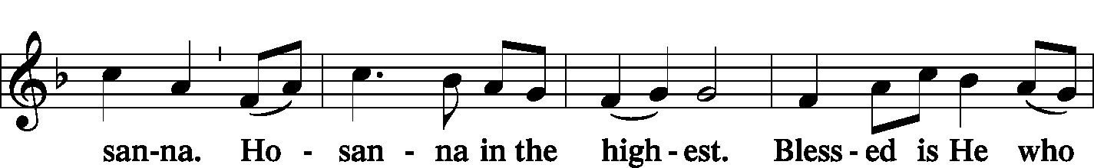

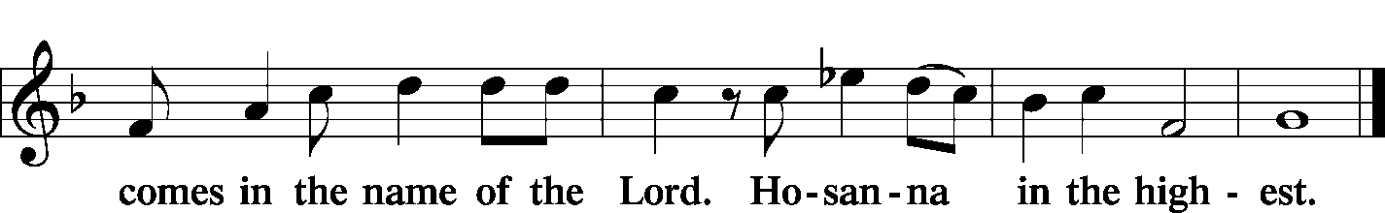

P: Lord, remember us in Your Kingdom and teach us to pray:
Lord’s Prayer:
Our Father who art in heaven, hallowed be Thy name, Thy kingdom come, Thy will be done, on earth as it is in heaven. Give us this day our daily bread; and forgive us our trespasses as we forgive those who trespass against us; and lead us not into temptation, but deliver us from evil.
For Thine is the kingdom and the power and the glory forever and ever. Amen.
Words of Institution:
P: Our Lord Jesus Christ, on the night when He was betrayed, took bread, and when He had given thanks, He broke it and gave it to the disciples and said: “Take, eat; this is My +body, which is given for you. This do in remembrance of Me.”
In the same way also He took the cup after supper, and when He had given thanks, He gave it to them, saying: “Drink of it, all of you; this cup is the new testament in my +blood, which is shed for you for the forgiveness of sins. This do, as often as you drink it, in remembrance of Me.”
Pax Domini:
P: The Peace of the Lord be with you always.
C: Amen.
Agnus Dei: (sung)
ALL: Lamb of God, You take away the sin of the world; have mercy on us.
Lamb of God, You take away the sin of the world; have mercy on us.
Lamb of God, You take away the sin of the world; grant us Peace.
Distribution of Holy Communion:
In Holy Communion we believe Jesus gives us His real presence, in and with the bread and the wine, for the forgiveness of sins. We celebrate this forgiveness, which comes through faith, and we are strengthened in our personal faith and in our love for one another. We invite to Holy Communion all who believe in Jesus as their Savior, are a baptized believer, have been

Confession and Absolution: LSB 151
P: If we say we have no sin, we deceive ourselves, and the truth is not in us.
C: But if we confess our sins, God, Who is faithful and just, will forgive our sins and cleanse us from all unrighteousness.
(Silence for personal self-examination.)
P: Let us then confess our sins to God our Father.
C: Most merciful God, we confess that we are by nature sinful and unclean. We have sinned against You in thought, word, and deed, by what we have done and by what we have left undone. We have not loved You with our whole heart; we have not loved our neighbors as ourselves. We justly deserve Your present and eternal punishment. For the sake of Your Son, Jesus Christ, have mercy on us. Forgive us, renew us, and lead us, so that we may delight in Your will and walk in Your ways to the glory of Your Holy Name. Amen
P: Almighty God in His mercy has given His Son to die for you and for His sake
forgives you all your sins. As a called and ordained servant of Christ, and by His
authority, I therefore forgive you all your sins in the name of the Father and of the T Son
and of the Holy Spirit.
C: Amen.

Introit: Ps. 105:4–7; antiphon: Ps. 105:8
P: He remembers His covenant forever,
C: the word that He commanded, for a thousand generations.
P: Seek the Lord and His strength;
C: seek His Presence continually!
P: Remember the wondrous works that He has done,
C: His miracles, and the judgments He uttered,
P: O offspring of Abraham, His servant,
C: children of Jacob, His chosen ones!
P: He is the Lord our God;
C: His judgments are in all the earth.
P: Glory be to the Father and to the Son and to the Holy Spirit;
C: as it was in the beginning, is now, and will be forever. Amen.
P: He remembers His covenant forever,
C: the word that He commanded, for a thousand generations.

Verse for Lent: (please rise and sing) LSB 156 LSB 157
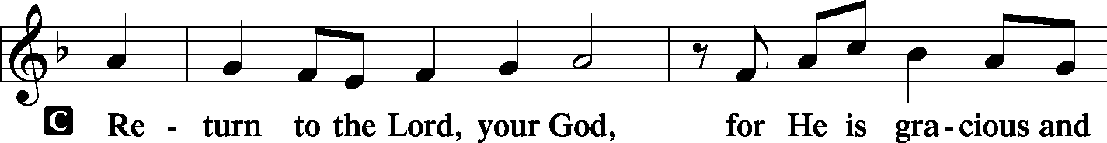
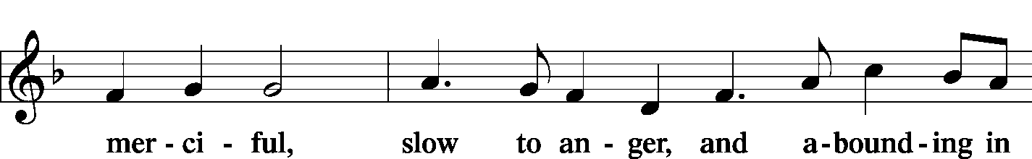
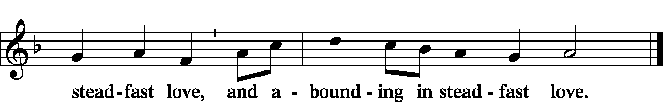

Gospel Reading: John 3:1–17
P: The Holy Gospel according to St. John, the third chapter.
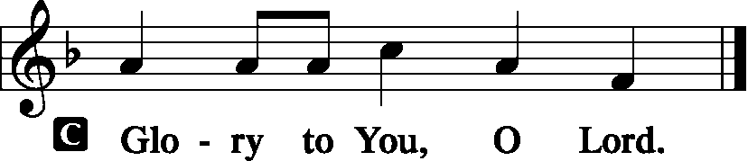

In this detailed and intense account of Jesus’ exchange with Nicodemus, a Jewish leader, we learn about God’s plan for our salvation, how we can obtain it, and hear one of the most famous and beloved verses in the Bible. We celebrate this simple fact today: God loves us and proved it through Jesus Christ.

¹Now there was a man of the Pharisees named Nicodemus, a ruler of the Jews. ²This man came to Jesus by night and said to him, “Rabbi, we know that you are a teacher come from God, for no one can do these signs that you do unless God is with him.” ³Jesus answered him, “Truly, truly, I say to you, unless one is born again he cannot see the kingdom of God.” ⁴Nicodemus said to him, “How can a man be born when he is old? Can he enter a second time into his mother’s womb and be born?” ⁵Jesus answered, “Truly, truly, I say to you, unless one is born of water and the Spirit, he cannot enter the kingdom of God. ⁶That which is born of the flesh is flesh, and that which is born of the Spirit is spirit. ⁷Do not marvel that I said to you, ‘You must be born again.’ ⁸The wind blows where it wishes, and you hear its sound, but you do not know where it comes from or where it goes. So it is with everyone who is born of the Spirit.”
⁹Nicodemus said to him, “How can these things be?” ¹⁰Jesus answered him, “Are you the teacher of Israel and yet you do not understand these things? ¹¹Truly, truly, I say to you, we speak of what we know, and bear witness to what we have seen, but you do not receive our testimony. ¹²If I have told you earthly things and you do not believe, how can you believe if I tell you heavenly things? ¹³No one has ascended into heaven except he who descended from heaven, the Son of Man. ¹⁴And as Moses lifted up the serpent in the wilderness, so must the Son of Man be lifted up, ¹⁵that whoever believes in him may have eternal life.

¹⁶[Jesus said:] “For God so loved the world, that he gave his only Son, that whoever believes in him should not perish but have eternal life. ¹⁷For God did not send his Son into the world to condemn the world, but in order that the world might be saved through him.
P: This is the Gospel of the Lord.
C: Praise to You, O Christ.

Apostles’ Creed:
I believe in God, the Father almighty,
Maker of heaven and earth.
And in Jesus Christ, His only Son, our Lord,
who was conceived by the Holy Spirit, born of the Virgin Mary,
suffered under Pontius Pilate, was crucified, died, and was buried.
He descended into hell.
The third day He rose again from the dead.
He ascended into heaven and sits at the right hand of God the Father Almighty.
From thence He will come to judge the living and the dead.
I believe in the Holy Spirit, the Holy Christian Church, the communion of saints, the
forgiveness of sins, the resurrection of the body, and the life everlasting. Amen.

Hymn of the Day: GOD LOVED THE WORLD SO THAT HE GAVE LSB 571

- God loved the world so that He gave His only Son the lost to save,
That all who would in Him believe Should everlasting life receive.

- Christ Jesus is the ground of faith, Who was made flesh and suffered death;
All then who trust in Him alone Are built on this chief cornerstone.

- God would not have the sinner die, His Son with saving grace is nigh;
His Spirit in the Word declares How we in Christ are heaven's heirs.

- Be of good cheer, for God's own Son Forgives all sins which you have done;
And, justified by Jesus' blood, Your Baptism grants the highest good.

- If you are sick, if death is near, This truth your troubled heart can cheer:
Christ Jesus saves your soul from death; That is the firmest ground of faith.

- Glory to God the Father, Son, And Holy Spirit, Three in One!
To Thee, O blessed Trinity, Be praise now and eternally!

Sermon:

Offering: (Offerings are brought forward)
Offertory: (stand and sing) Psalm 51:10-12 LSB 159

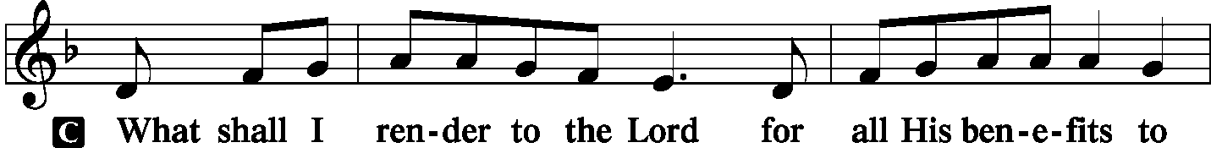
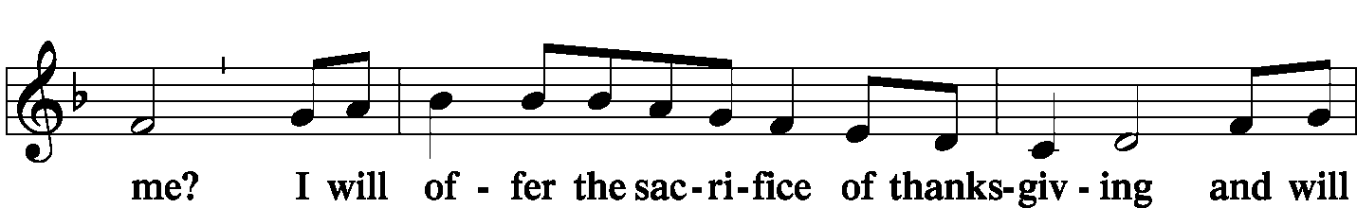
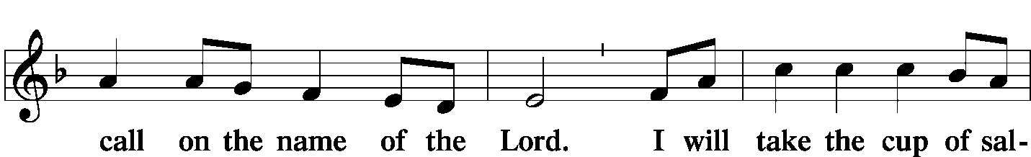
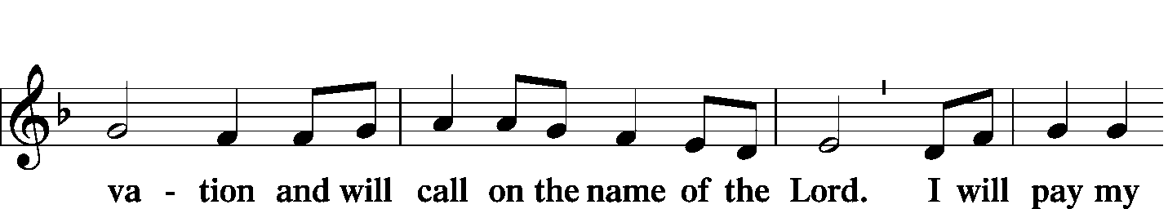
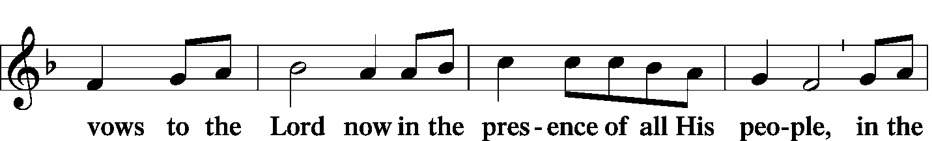
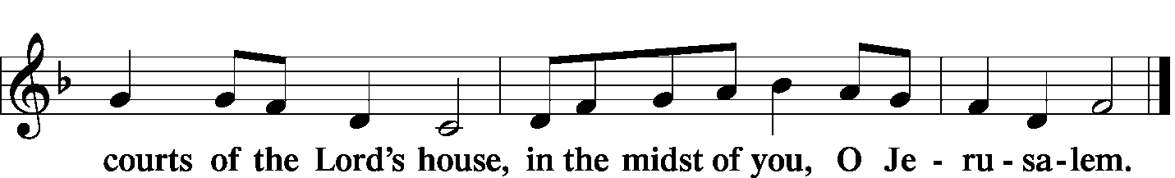Amen.

Prayer of the Church: (Each Petition of the Prayers concludes with the response:)
P: Lord, in your mercy,
C: hear our prayer.

Preface: (sung)


⁶Abram passed through the land to the place at Shechem, to the oak of Moreh. At that time the Canaanites were in the land. ⁷Then the Lord appeared to Abram and said, “To your offspring I will give this land.” So he built there an altar to the Lord, who had appeared to him. ⁸From there he moved to the hill country on the east of Bethel and pitched his tent, with Bethel on the west and Ai on the east. And there he built an altar to the Lord and called upon the name of the Lord. ⁹And Abram journeyed on, still going toward the Negeb.

R This is the Word of the Lord
C: Thanks be to God.

Gradual: Heb. 12:2

[O come, let us fix our eyes on] Jesus,
the founder and perfecter of our faith,
who for the joy that was set before him endured the cross, despising the shame,
and is seated at the right hand of the throne of God.

Epistle: Romans 4:1–8, 13–17
Faith is gifted to us by God so that we can obtain salvation. This has always been the way people have connected to God, from Abraham until now. We are connected to God’s grace through faith, and here Paul lays out Abraham as an example for us.
¹What then shall we say was gained by Abraham, our forefather according to the flesh? ²For if Abraham was justified by works, he has something to boast about, but not before God. ³For what does the Scripture say? “Abraham believed God, and it was counted to him as righteousness.” ⁴Now to the one who works, his wages are not counted as a gift but as his due. ⁵And to the one who does not work but trusts him who justifies the ungodly, his faith is counted as righteousness, ⁶just as David also speaks of the blessing of the one to whom God counts righteousness apart from works:⁷“Blessed are those whose lawless deeds are forgiven, and whose sins are covered; ⁸blessed is the man against whom the Lord will not count his sin.”
¹³ The promise to Abraham and his offspring that he would be heir of the world did not come through the law but through the righteousness of faith.
¹⁴For if it is the adherents of the law who are to be the heirs, faith is null and the promise is void. ¹⁵For the law brings wrath, but where there is no law there is no transgression.
¹⁶That is why it depends on faith, in order that the promise may rest on grace and be guaranteed to all his offspring—not only to the adherent of the law but also to the one who shares the faith of Abraham, who is the father of us all, ¹⁷as it is written, “I have made you the father of many nations”—in the presence of the God in whom he believed, who gives life to the dead and calls into existence the things that do not exist.

R: This is the Word of the Lord
C: Thanks be to God.

