Grace Lutheran Church
310 West Lorain Street, Oberlin, Ohio 44074
March 14, 2026
5:00 PM

THE FOURTH SUNDAY IN LENT
Divine Worship Service
Grace Evangelical Lutheran Church of Oberlin, Ohio
Setting 1 from LSB (CPH, 2006) p. 151-166

Prelude:
Welcome:
Opening Hymn: AWAKE, MY SOUL, AND WITH THE SUN LSB 868

Awake, my soul, and with the sun Thy daily stage of duty run;
Shake off dull sloth and joyful rise To pay thy morning sacrifice.

In conversation be sincere, Thy conscience as the noonday clear;
Think how the_all-seeing God thy ways And all thy secret thoughts surveys.

All praise to Thee, who safe hast kept And hast refreshed me while I slept;
Grant, Lord, when I from death shall wake, I may of endless light partake.

Lord, I my vows to Thee renew; Disperse my sins as morning dew;
Guard my first springs of thought and will And with Thyself my spirit fill.

Direct, control, suggest this day All I design or do or say
That all my pow’rs with all their might In Thy sole glory may unite.

Praise God, from whom all blessings flow; Praise Him, all creatures here below;
Praise Him above, ye heav’nly host: Praise Father, Son, and Holy Ghost.

Invocation:
P: In the Name of the Father and of the T Son and of the Holy Spirit.
C: Amen.
Confession and Absolution: LSB 151
P: This is the day that the Lord has made!
C: We will rejoice and be glad in it!
P: If we say we have no sin, we deceive ourselves, and the truth is not in us.
C: But if we confess our sins, God, who is faithful and just, will forgive our sins and cleanse
us from all unrighteousness.
Silence for reflection on God's Word and for self-examination.
P: Let us then confess our sins to God our Father.
C: Most merciful God, we confess that we are by nature sinful and unclean. We have
sinned against You in thought, word, and deed, by what we have done and by what
we have left undone. We have not loved You with our whole heart; we have not
loved our neighbors as ourselves. We justly deserve Your present and eternal
punishment. For the sake of Your Son, Jesus Christ, have mercy on us. Forgive us,
renew us, and lead us, so that we may delight in Your will and walk in Your ways to
the glory of Your holy name. Amen.
P: Almighty God in His mercy has given His Son to die for you and for His sake forgives you all
your sins. As a called and ordained servant of Christ, and by His authority, I therefore forgive
you all your sins in the name of the Father and of the T Son and of the Holy Spirit.
C: Amen.

Introit: Ps. 27:4–6; antiphon: Ps. 25:15
P: My eyes are ever toward the Lord,
C: for he will pluck my feet out of the net.
P One thing have I asked of the Lord, that will I seek after:
C that I may dwell in the house of the Lord all the days of my life, to gaze upon the beauty of the
Lord and to inquire in his temple.
P For he will hide me in his shelter in the day of trouble;
C he will conceal me under the cover of his tent; he will lift me high upon a rock.
P And now my head shall be lifted up above my enemies all around me, and I will offer in his tent sacrifices
with shouts of joy;
C I will sing and make melody to the Lord.
P Glory be to the Father and to the Son and to the Holy Spirit;
C as it was in the beginning, is now, and will be forever. Amen.
P: My eyes are ever toward the Lord,
C for he will pluck my feet out of the net.

Kyrie: LSB 152 lsb LSB 152


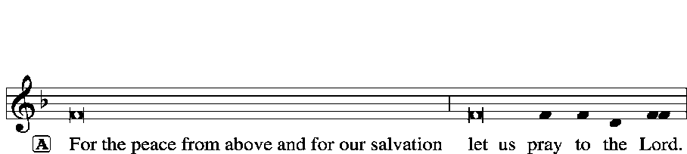

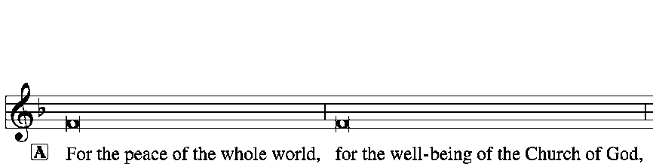


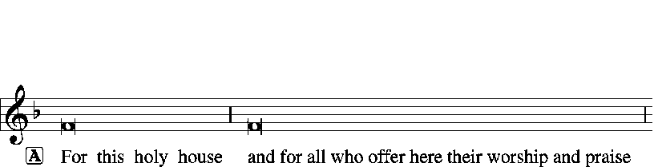





Salutation and Collect: LSB 156
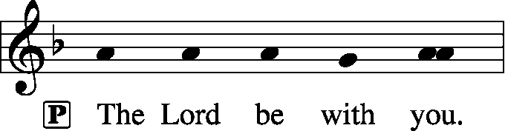
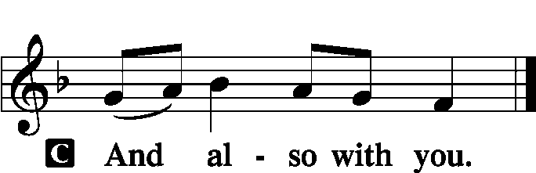

P: Let us pray.
Almighty God, our Heavenly Father, Your mercies are new every morning; and though we deserve only punishment, You receive us as Your children and provide for all our needs of body and soul. Grant that we may heartily acknowledge Your merciful goodness, give thanks for all Your benefits, and serve You in willing obedience; through Jesus Christ, Your Son, our Lord, who lives and reigns with You and the Holy Spirit, one God, now and forever.
C: Amen.
Old Testament Reading: Isaiah 42:14–21
The words of the Lord through the prophet Isaiah. Here we hear the warning of impending doom the Lord will bring against the people who have turned from Him. Conversely, those who humble themselves will be saved.

¹⁴For a long time I have held my peace; I have kept still and restrained myself; now I will cry out like a woman in labor; I will gasp and pant. ¹⁵I will lay waste mountains and hills, and dry up all their vegetation; I will turn the rivers into islands, and dry up the pools. ¹⁶And I will lead the blind in a way that they do not know, in paths that they have not known I will guide them. I will turn the darkness before them into light, the rough places into level ground. These are the things I do, and I do not forsake them. ¹⁷They are turned back and utterly put to shame, who trust in carved idols, who say to metal images, “You are our gods.” ¹⁸Hear, you deaf, and look, you blind, that you may see! ¹⁹Who is blind but my servant, or deaf as my messenger whom I send? Who is blind as my dedicated one, or blind as the servant of the Lord? ²⁰He sees many things, but does not observe them; his ears are open, but he does not hear. ²¹The Lord was pleased, for his righteousness’ sake, to magnify his law and make it glorious.

R: This is the Word of the Lord
C: Thanks be to God.

Gradual: Heb. 12:2

[O come, let us fix our eyes on] Jesus,
the founder and perfecter of our faith,
who for the joy that was set before him endured the cross, despising the shame,
and is seated at the right hand of the throne of God.

Epistle: Ephesians 5:8–14

In Paul’s letter to the Ephesians, he expands on the teaching of being the light of the world. If we are the light, we who have Christ, then sin is exposed and Christ will overcome it.

⁸For at one time you were darkness, but now you are light in the Lord. Walk as children of light ⁹(for the fruit of light is found in all that is good and right and true), ¹⁰and try to discern what is pleasing to the Lord. ¹¹Take no part in the unfruitful works of darkness, but instead expose them. ¹²For it is shameful even to speak of the things that they do in secret. ¹³But when anything is exposed by the light, it becomes visible, ¹⁴for anything that becomes visible is light. Therefore, it says, “Awake, O sleeper, and arise from the dead, and Christ will shine on you.”
R: This is the Word of the Lord
C: Thanks be to God.

Verse for Lent: (please rise and sing) LSB 157
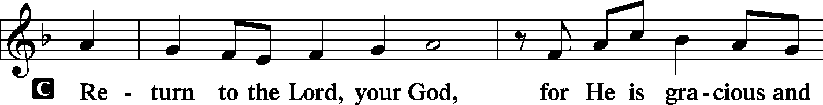
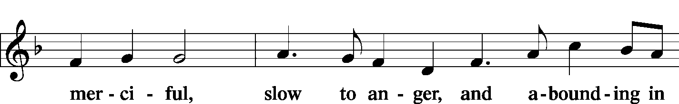
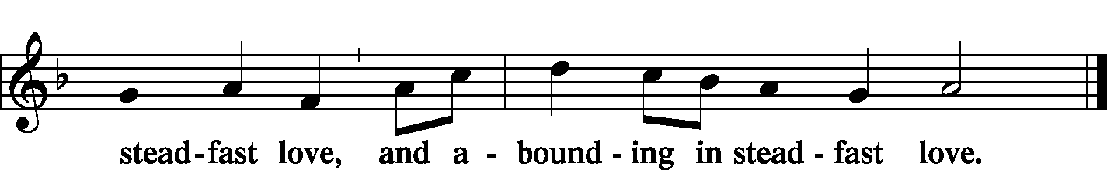
Gospel Reading: John 9:1–41

P The Holy Gospel according to St. John, the ninth chapter.
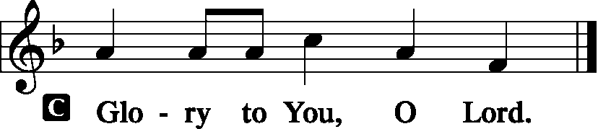

Jesus heals a blind man and we hear the issues that arise around the miracle. In the end, the blind man receives his sight but is cast out due to the religious leaders’ issues with faith in Jesus.

¹As [Jesus] passed by, he saw a man blind from birth. ²And his disciples asked him, “Rabbi, who sinned, this man or his parents, that he was born blind?” ³Jesus answered, “It was not that this man sinned, or his parents, but that the works of God might be displayed in him. ⁴We must work the works of him who sent me while it is day; night is coming, when no one can work. ⁵As long as I am in the world, I am the light of the world.” ⁶Having said these things, he spat on the ground and made mud with the saliva. Then he anointed the man’s eyes with the mud ⁷and said to him, “Go, wash in the pool of Siloam” (which means Sent). So he went and washed and came back seeing.
⁸The neighbors and those who had seen him before as a beggar were saying, “Is this not the man who used to sit and beg?” ⁹Some said, “It is he.” Others said, “No, but he is like him.” He kept saying, “I am the man.” ¹⁰So they said to him, “Then how were your eyes opened?” ¹¹He answered, “The man called Jesus made mud and anointed my eyes and said to me, ‘Go to Siloam and wash.’ So I went and washed and received my sight.” ¹²They said to him, “Where is he?” He said, “I do not know.”
¹³They brought to the Pharisees the man who had formerly been blind. ¹⁴Now it was a Sabbath day when Jesus made the mud and opened his eyes. ¹⁵So the Pharisees again asked him how he had received his sight. And he said to them, “He put mud on my eyes, and I washed, and I see.” ¹⁶Some of the Pharisees said, “This man is not from God, for he does not keep the Sabbath.” But others said, “How can a man who is a sinner do such signs?” And there was a division among them. ¹⁷So they said again to the blind man, “What do you say about him, since he has opened your eyes?” He said, “He is a prophet.”
¹⁸The Jews did not believe that he had been blind and had received his sight, until they called the parents of the man who had received his sight ¹⁹and asked them, “Is this your son, who you say was born blind? How then does he now see?” ²⁰His parents answered, “We know that this is our son and that he was born blind. ²¹But how he now sees we do not know, nor do we know who opened his eyes. Ask him; he is of age. He will speak for himself.” ²²(His parents said these things because they feared the Jews, for the Jews had already agreed that if anyone should confess Jesus to be Christ, he was to be put out of the synagogue.) ²³Therefore his parents said, “He is of age; ask him.” ²⁴So for the second time they called the man who had been blind and said to him, “Give glory to God. We know that this man is a sinner.” ²⁵He answered, “Whether he is a sinner I do not know. One thing I do know, that though I was blind, now I see.” ²⁶They said to him, “What did he do to you? How did he open your eyes?” ²⁷He answered them, “I have told you already, and you would not listen. Why do you want to hear it again? Do you also want to become his disciples?” ²⁸And they reviled him, saying, “You are his disciple, but we are disciples of Moses. ²⁹We know that God has spoken to Moses, but as for this man, we do not know where he comes from.” ³⁰The man answered, “Why, this is an amazing thing! You do not know where he comes from, and yet he opened my eyes. ³¹We know that God does not listen to sinners, but if anyone is a worshiper of God and does his will, God listens to him. ³²Never since the world began has it been heard that anyone opened the eyes of a man born blind. ³³If this man were not from God, he could do nothing.” ³⁴They answered him, “You were born in utter sin, and would you teach us?” And they cast him out. ³⁵Jesus heard that they had cast him out, and having found him he said, “Do you believe in the Son of Man?” ³⁶He answered, “And who is he, sir, that I may believe in him?” ³⁷Jesus said to him, “You have seen him, and it is he who is speaking to you.” ³⁸He said, “Lord, I believe,” and he worshiped him. ³⁹Jesus said, “For judgment I came into this world, that those who do not see may see, and those who see may become blind.” ⁴⁰Some of the Pharisees near him heard these things, and said to him, “Are we also blind?” ⁴¹Jesus said to them, “If you were blind, you would have no guilt; but now that you say, ‘We see,’ your guilt remains.

P: This is the Gospel of the Lord.

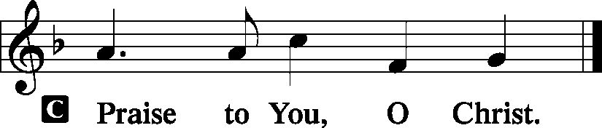

Apostles’ Creed:

I believe in God, the Father almighty,
Maker of heaven and earth.
And in Jesus Christ, His only Son, our Lord,
who was conceived by the Holy Spirit, born of the Virgin Mary,
suffered under Pontius Pilate, was crucified, died, and was buried.
He descended into hell.
The third day He rose again from the dead.
He ascended into heaven and sits at the right hand of God the Father Almighty.
From thence He will come to judge the living and the dead.
I believe in the Holy Spirit, the Holy Christian Church, the communion of saints, the
forgiveness of sins, the resurrection of the body, and the life everlasting. Amen.

Hymn of the Day: AMAZING GRACE LSB 744

Amazing grace--how sweet the sound-- That saved a wretch like me!
I once was lost but now am found, Was blind, but now I see!

The Lord has promised good to me, His Word my hope secures;
He will my shield and portion be As long as life endures.

Through many dangers, toils and snares, I have already come;
His grace has brought me safe thus far, His grace will lead me home.

Yes, when this flesh and heart shall fail And mortal life shall cease,
Amazing grace shall then prevail In heaven's joy and peace.

When we’ve been there ten thousand years, Bright shining as the sun,
We’ve no less days to sing God’s praise Than when we’d first begun.
Sermon:
Offering: (Offerings are brought forward)
Offertory: (stand and sing) Psalm 51:10-12 LSB 192

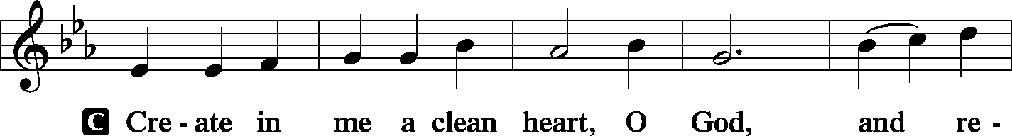
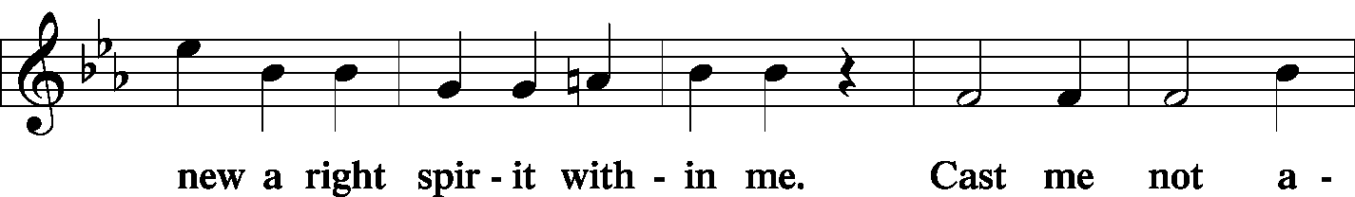

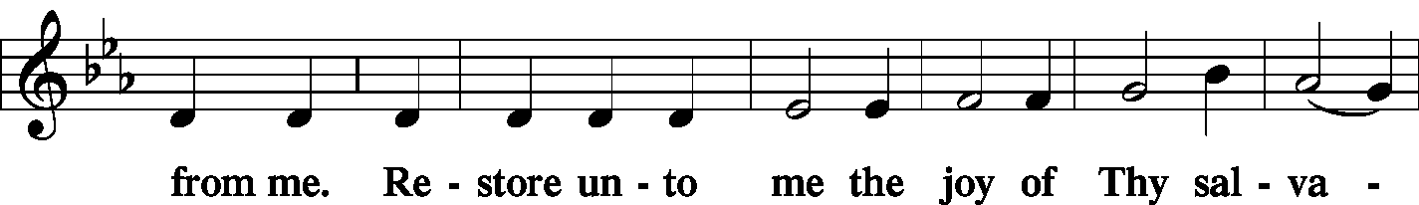
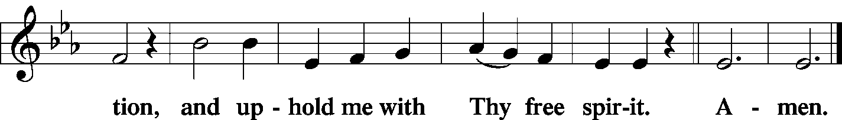

Prayer of the Church: (Each Petition of the Prayers concludes with the response:)
P: Lord, in your mercy,
C: hear our prayer.

Preface: LSB 160





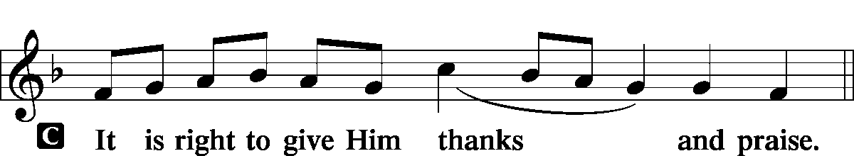

Proper Preface:
P It is truly good, right, and salutary that we should at all times and in all places give thanks to You, holy Lord, almighty Father, everlasting God, through Jesus Christ, our Lord, who overcame the assaults of the devil and gave His life as a ransom for many that with cleansed hearts we might be prepared joyfully to celebrate the paschal feast in sincerity and truth. Therefore, with angels and archangels and with all the company of heaven we laud and magnify Your glorious name, evermore praising You and singing:
Sanctus: LSB 161
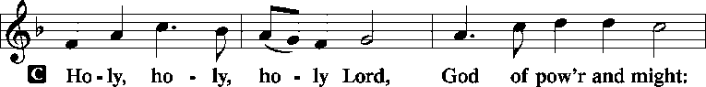
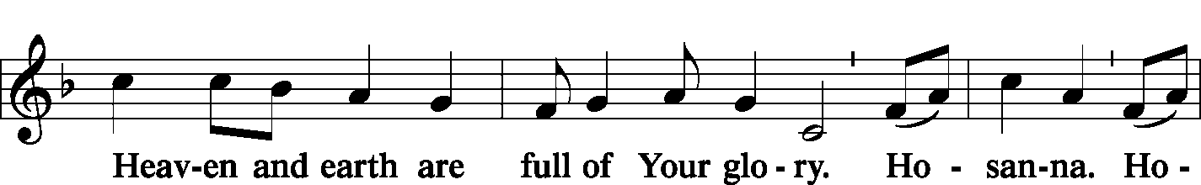
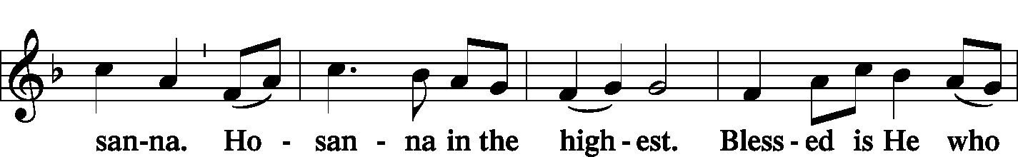
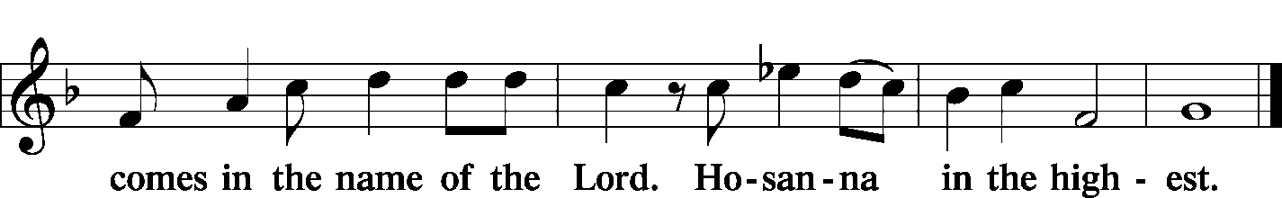

P: Lord, remember us in Your Kingdom and teach us to pray:
Lord’s Prayer:
Our Father who art in heaven, hallowed be Thy name, Thy kingdom come, Thy will be done, on earth as it is in heaven. Give us this day our daily bread; and forgive us our trespasses as we forgive those who trespass against us; and lead us not into temptation, but deliver us from evil.
For Thine is the kingdom and the power and the glory forever and ever. Amen.
Words of Institution:
P Our Lord Jesus Christ, on the night when He was betrayed…
Pax Domini: LSB 163
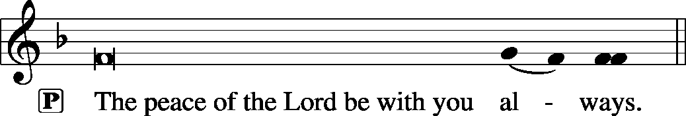


Agnus Dei: LSB 163
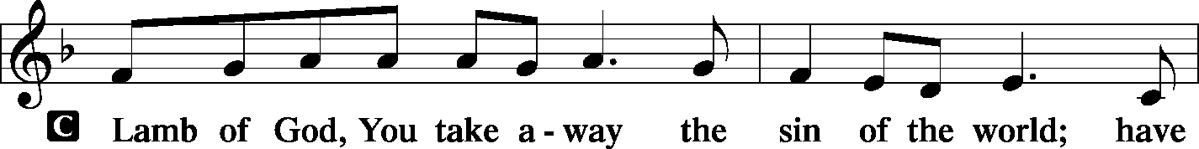
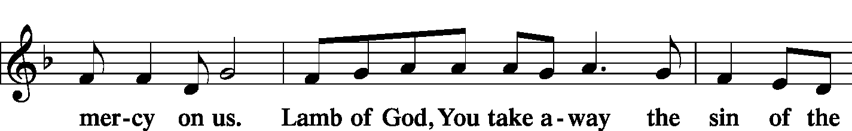
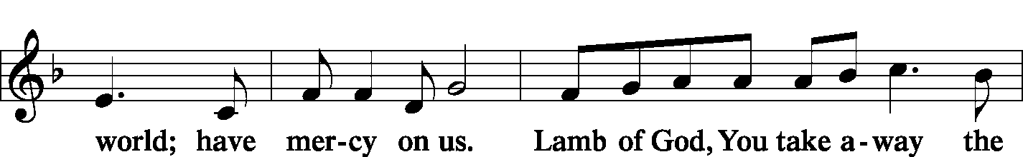
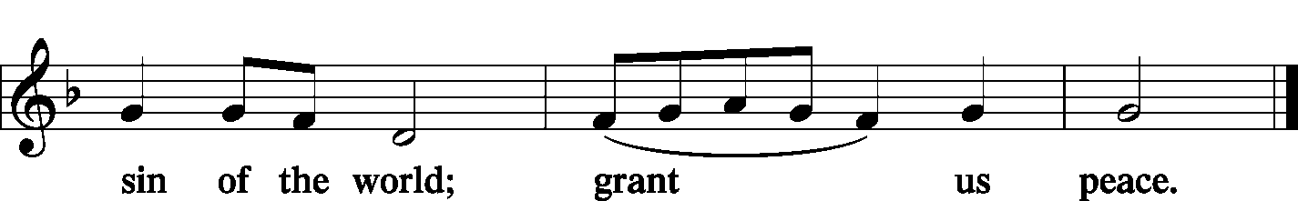
Distribution of Holy Communion:
In Holy Communion we believe Jesus gives us His real presence, in and with the bread and the wine, for the forgiveness of sins. We celebrate this forgiveness, which comes through faith, and we are strengthened in our personal faith and in our love for one another. We invite to Holy Communion all who believe in Jesus as their Savior, are a baptized believer, have been instructed in the meaning of Holy Communion, and agree with these teachings. If you have any questions, please speak with the Pastor. As we eat and drink, we remember our Lord’s suffering, death, resurrection, ascension, and the promise of His coming again. Both Common and individual cups are available. When using the individual cup, please place the empty cup in the basket at either end of the communion rail. The non-alcoholic wine is in the center of the tray. If the Common cup is used, please help the server by holding the base of the cup when you are served.
If you are unable to attend communion, due to health/physical limitations, please inform an usher and we will gladly serve you by bringing communion to you.
Nunc Dimittis: LSB 165
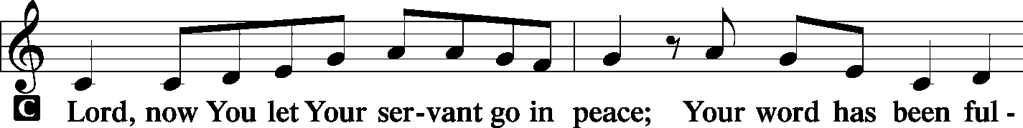
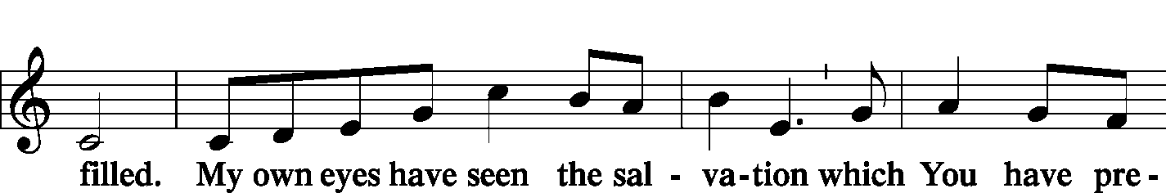
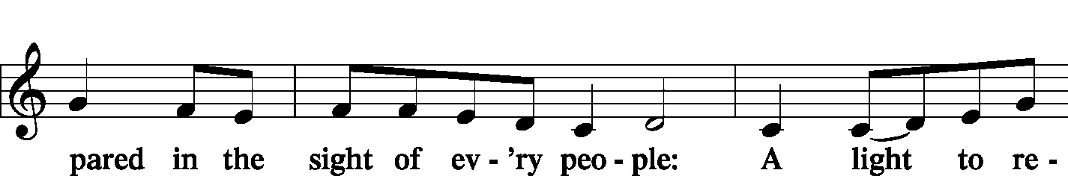
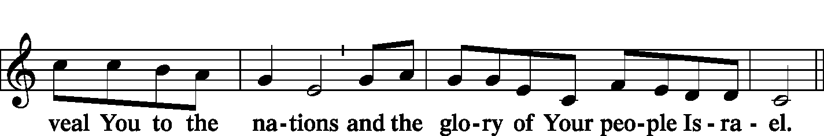
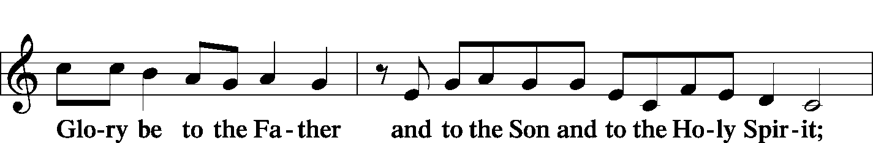
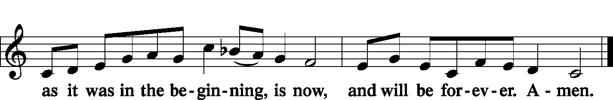
Post-Communion Collect:
P Let us pray.
We give thanks to You, almighty God, that You have refreshed us through this salutary gift, and we implore You that of Your mercy You would strengthen us through the same in faith toward You and fervent love toward one another; through Jesus Christ, Your Son, our Lord, who lives and reigns with You and the Holy Spirit, one God, now and forever.
C Amen.

Benediction: LSB 166
P The Lord bless you and keep you…
C: A-men

Closing Hymn: ON EAGLES’ WINGS LSB 727

You who dwell in the shelter of the Lord,
Who abide in His shadow for life,
Say to the Lord: "My refuge, my rock in whom I trust!"
Refrain: And He will raise you up on eagles’ wings, bear you on the breath of dawn,
Make you to shine like the sun, and hold you in the palm of His hand.

The snare of the fowler will never capture you,
And famine will bring you no fear:
Under His wings your refuge, His faithfulness your shield.
Refrain
You need not fear the terror of the night,
Nor the arrow that flies by day;
Though thousands fall about you, near you it shall not come.
Refrain
For to His angels He's given a command
To guard you in all of your ways;
Upon their hands they will bear you up, lest you dash your foot against a stone.
Refrain

P: Go in peace. Serve the Lord.
C: Thanks be to God.

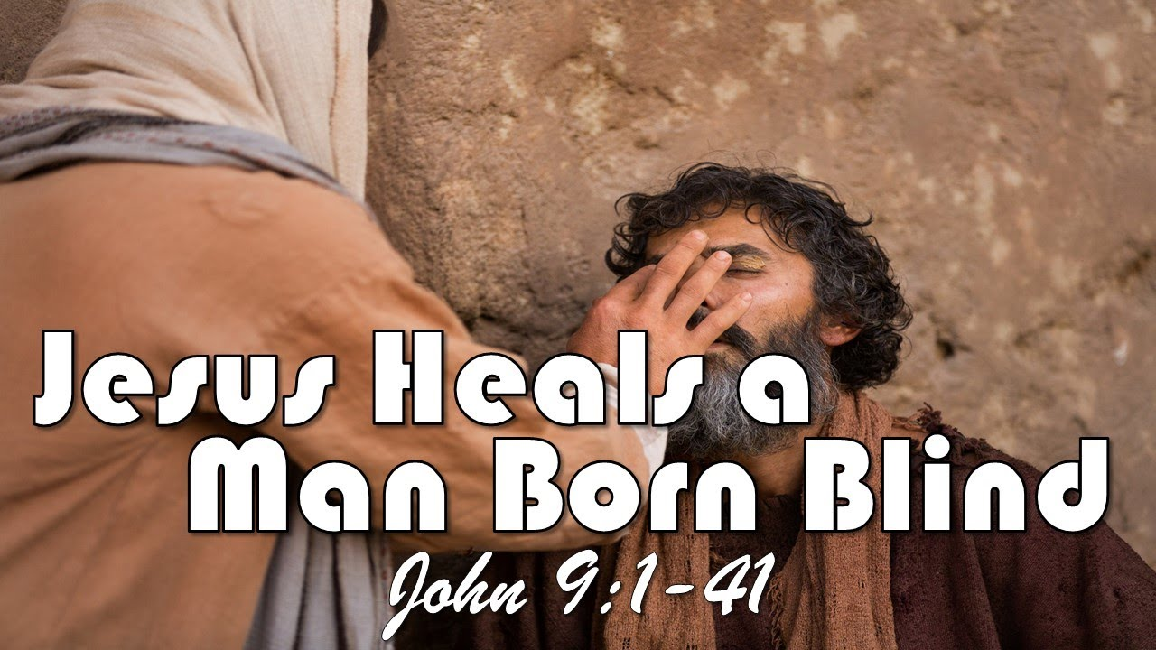

Grace Lutheran Church
310 West Lorain Street
Oberlin, Ohio 44074
www.grace-church-oberlin.org
440-775-3271
March 14, 2026
Pastor: Rev. Robert Weldon, Sr.
Organist: Holly Bogle

