Grace Lutheran Church
310 West Lorain Street, Oberlin, Ohio 44074
March 21, 2026 THE FIFTH SUNDAY IN LENT 5:00 PM
Divine Worship Service
Grace Evangelical Lutheran Church of Oberlin, Ohio
Setting 1 from LSB (CPH, 2006) p. 151-166

Prelude:
Welcome:
Opening Hymn: ALL GLORY BE TO GOD ON HIGH LSB 947

All glory be to God on high And thanks for all His favor;
No harm can touch or terrify A child of God forever.
God shows His good and gracious will And grants His peace the world to fill
All strife at last has ended.

We praise and laud and worship You; We give You thanks for ever,
O Father, for Your rule is true And just and changes never.
With boundless pow'r, your mighty reign Fulfills whatever You ordain.
Lord, grant us ev'ry blessing!

O Jesus Christ, the only Son Begotten of the Father,
Your saving death has made us one With God and with each other.
O Lamb of God, to You on high In our distress we sinners cry,
Have mercy on us, amen!

O Holy Spirit, our delight And source of consolation,
protect us from the devil's might Through Jesus, our salvation,
Who by His death upon a tree Has rescued us from misery:
To this we hold forever!

Invocation:
P: In the Name of the Father and of the T Son and of the Holy Spirit.
C: Amen.

Pax Domini: LSB 163
P The peace of the Lord be with you always. (sung)
C A – men.

Agnus Dei: (sung) LSB 163
ALL: Lamb of God, You take away the sin of the world; have mercy on us.
Lamb of God, You take away the sin of the world; have mercy on us.
Lamb of God, You take away the sin of the world; grant us Peace.
Distribution of Holy Communion:
In Holy Communion we believe Jesus gives us His real presence, in and with the bread and the wine, for the forgiveness of sins. We celebrate this forgiveness, which comes through faith, and we are strengthened in our personal faith and in our love for one another. We invite to Holy Communion all who believe in Jesus as their Savior, are a baptized believer, have been instructed in the meaning of Holy Communion, and agree with these teachings. If you have any questions, please speak with the Pastor. As we eat and drink, we remember our Lord’s suffering, death, resurrection, ascension, and the promise of His coming again. Both Common and individual cups are available. When using the individual cup, please place the empty cup in the basket at either end of the communion rail. The non-alcoholic wine is in the center of the tray. If the Common cup is used, please help the server by holding the base of the cup when you are served.
If you are unable to attend communion, due to health/physical limitations, please inform an usher and we will gladly serve you by bringing communion to you.

Nunc Dimittis: LSB 165
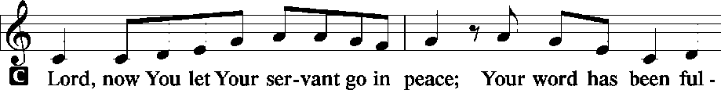
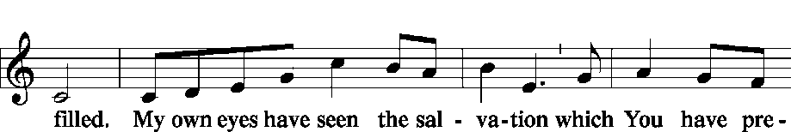
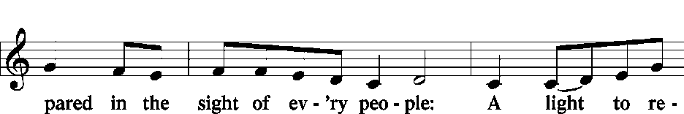
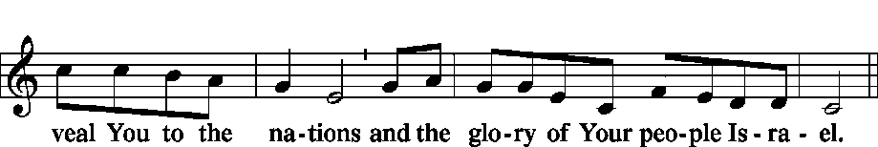

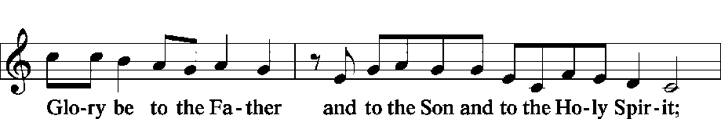
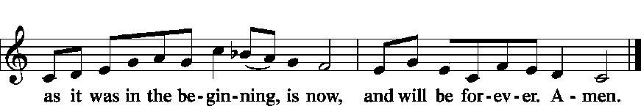
Post-Communion Collect:
P Let us pray.
We give thanks to You, almighty God, that You have refreshed us through this salutary gift, and we implore You that of Your mercy You would strengthen us through the same in faith toward You and fervent love toward one another; through Jesus Christ, Your Son, our Lord, who lives and reigns with You and the Holy Spirit, one God, now and forever.
C Amen.

Benediction: LSB 166
P The Lord bless you and keep you…
C A-men

Closing Hymn: THE LORD, MY GOD, BE PRAISED LSB 794

The Lord, my God, be praised, My light, my life from heaven;
My maker, who to me Has soul and body given;
My Father, who will shield And keep me day by day
And make each moment yield New blessings on my way.

The Lord, my God, be praised, My trust, my life from heaven,
The Father’s own dear Son, Whose life for me was given,
Who for my sin atoned With His most precious blood
And gives to me by faith The highest heav’nly good.

The Lord, my God, be praised, My hope, my life from heaven,
The Spirit, whom the Son In love to me has given.
His grace revives my heart And gives my spirit pow’r,
Help, comfort, and support In sorrow’s gloomy hour.

The Lord, my God, be praised, My God, the ever-living,
To whom the heav’nly host Their laud and praise are giving.
The Lord, my God, be praised, In whose great name I boast,
God Father, God the Son, And God the Holy Ghost.

P Go in peace. Serve the Lord.
C Thanks be to God.

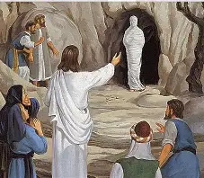

Grace Lutheran Church
310 West Lorain Street
Oberlin, Ohio 44074
www.grace-church-oberlin.org
440-775-3271
March 21, 2026
Pastor: Rev. Robert Weldon, Sr.
Organist: Dr. Harold Slocum, M.D.

Kyrie (sung) LSB 152
P In Peace let us Pray to the Lord.
C Lord, have mercy.
P For the Peace from above and for our salvation let us Pray to the Lord.
C Lord, have mercy.
P For the Peace of the whole world, for the well-being of the Church of
God and for the unity of all let us Pray to the Lord.
C Lord, have mercy.
P For this holy house and for all who offer here their worship and praise
let us pray to the Lord.
C Lord, have mercy.
P Help, save, comfort, and defend us, gracious Lord.
C Amen.
Salutation and Collect: LSB 156
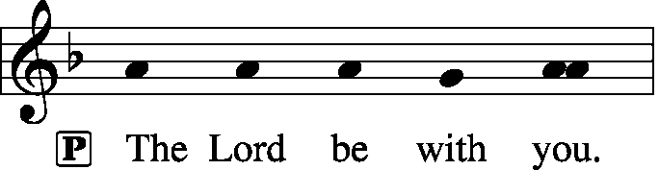
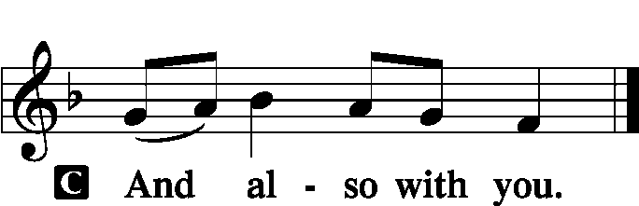

P: Let us pray.
Almighty God, by Your great goodness mercifully look upon Your people that we may be governed and preserved evermore in body and soul; through Jesus Christ, Your Son, our Lord, who lives and reigns with You and the Holy Spirit, one God, now and forever
C: Amen.
Old Testament Reading: Ezekiel 37:1–14
¹The hand of the Lord was upon me, and he brought me out in the Spirit of the Lord and set me down in the middle of the valley; it was full of bones. ²And he led me around among them, and behold, there were very many on the surface of the valley, and behold, they were very dry. ³And he said to me, “Son of man, can these bones live?” And I answered, “O Lord God, you know.” ⁴Then he said to me, “Prophesy over these bones, and say to them, O dry bones, hear

To God and to the Lamb I will sing, I will sing;
To God and to the Lamb I will sing;
To God and to the Lamb, Who is the great I AM,
While millions join the theme, I will sing, I will sing,
While millions join the theme, I will sing.

And when from death I’m free, I’ll sing on, I’ll sing on;
And when from death I’m free, I’ll sing on;
And when from death I’m free, I’ll sing his love for me,
And through eternity I’ll sing on, I’ll sing on
And through eternity I’ll sing on.

Sermon:
Offering: (Offerings are brought forward)
Offertory: (stand and sing) Psalm 51:10-12 LSB 192
Create in me a clean heart, O God, and renew a right spirit within me. Cast me not away from Thy Presence, and take not Thy Holy Spirit from me. Restore unto me the joy of Thy salvation, and uphold me with Thy free spirit. Amen.

Prayer of the Church: (Each Petition of the Prayers concludes with the response:)
P: Lord, in your mercy,
C: hear our prayer.

Preface: LSB 160






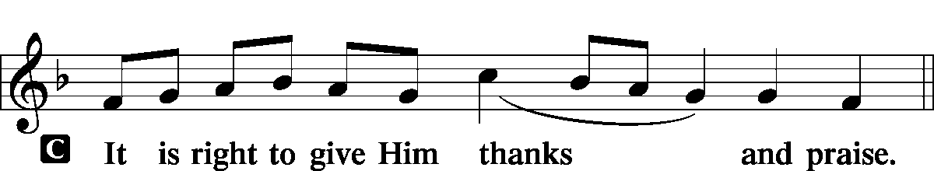

Proper Preface:
P It is truly good, right, and salutary … evermore praising You and singing: (sung)
Sanctus: LSB 161
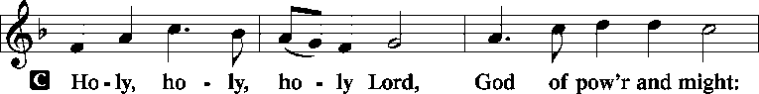
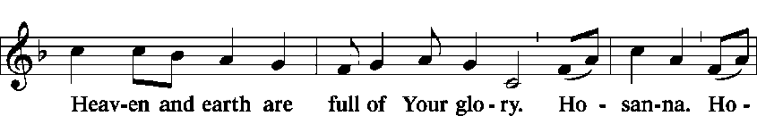
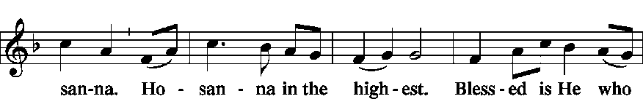
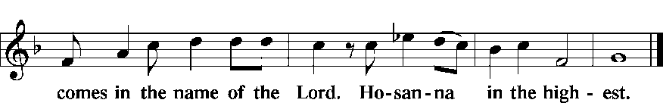

P: Lord, remember us in Your Kingdom and teach us to pray:

Lord’s Prayer:
Our Father who art in heaven, hallowed be Thy name, Thy kingdom come, Thy will be done, on earth as it is in heaven. Give us this day our daily bread; and forgive us our trespasses as we forgive those who trespass against us; and lead us not into temptation, but deliver us from evil.
For Thine is the kingdom and the power and the glory forever and ever. Amen.
Words of Institution:
P Our Lord Jesus Christ, on the night when He was betrayed…
Confession and Absolution: LSB 151
P: This is the day that the Lord has made!
C: We will rejoice and be glad in it!
P: If we say we have no sin, we deceive ourselves, and the truth is not in us.
C: But if we confess our sins, God, who is faithful and just, will forgive our
sins and cleanse us from all unrighteousness.
Silence for reflection on God's Word and for self-examination.
P: Let us then confess our sins to God our Father.
C: Most merciful God, we confess that we are by nature sinful and unclean. We have sinned against You in thought, word, and deed, by what we have done and by what we have left undone. We have not loved You with our whole heart; we have not loved our neighbors as ourselves. We justly deserve Your present and eternal punishment. For the sake of Your Son, Jesus Christ, have mercy on us. Forgive us, renew us, and lead us, so that we may delight in Your will and walk in Your ways to the glory of Your holy name. Amen.
P: Almighty God in His mercy has given His Son to die for you and for His sake forgives you all your sins. As a called and ordained servant of Christ, and by His authority, I therefore forgive you all your sins in the name of the Father and of the Son and of the Holy Spirit.
C: Amen.

Introit: Ps. 116:1–4, 8; antiphon: Ps. 116:15 LSB 152
P: Precious in the sight of the Lord
C is the death of his saints.
P I love the Lord, because he has heard
C my voice and my pleas for mercy.
P Because he inclined his ear to me,
C therefore I will call on him as long as I live.
P The snares of death encompassed me; the pangs of Sheol laid hold on me; C I suffered distress and anguish.
P Then I called on the name of the Lord:
C "O Lord, I pray, deliver my soul!"
P For you have delivered my soul from death,
C my eyes from tears, my feet from stumbling.
P Glory be to the Father and to the Son and to the Holy Spirit;
C as it was in the beginning, is now, and will be forever. Amen.
P Precious in the sight of the Lord
C is the death of his saints.

is life and peace. ⁷For the mind that is set on the flesh is hostile to God, for it does not submit to God’s law; indeed, it cannot. ⁸Those who are in the flesh cannot please God.
⁹You, however, are not in the flesh but in the Spirit, if in fact the Spirit of God dwells in you. Anyone who does not have the Spirit of Christ does not belong to him. ¹⁰But if Christ is in you, although the body is dead because of sin, the Spirit is life because of righteousness. ¹¹If the Spirit of him who raised Jesus from the dead dwells in you, he who raised Christ Jesus from the dead will also give life to your mortal bodies through his Spirit who dwells in you.

R: This is the Word of the Lord
C: Thanks be to God.

Verse for Lent: (please rise and sing) LSB 157
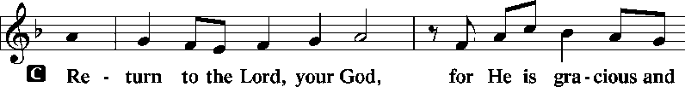
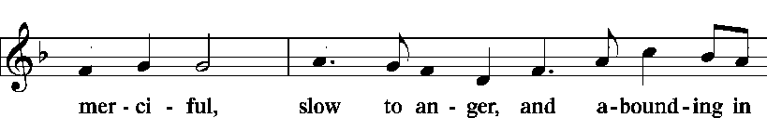
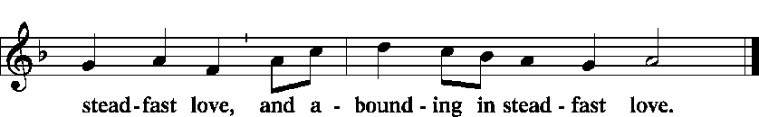
Gospel Reading: John 11:1–45
R The Holy Gospel according to St. John, the eleventh chapter.
C Glory to You, O Lord.
¹Now a certain man was ill, Lazarus of Bethany, the village of Mary and her sister Martha. ²It was Mary who anointed the Lord with ointment and wiped his feet with her hair, whose brother Lazarus was ill. ³So the sisters sent to him, saying, “Lord, he whom you love is ill.” ⁴But when Jesus heard it he said, “This illness does not lead to death. It is for the glory of God, so that the Son of God may be glorified through it.”
⁵Now Jesus loved Martha and her sister and Lazarus. ⁶So, when he heard that Lazarus was ill, he stayed two days longer in the place where he was. ⁷Then after this he said to the

disciples, “Let us go to Judea again.” ⁸The disciples said to him, “Rabbi, the Jews were just now seeking to stone you, and are you going there again?” ⁹Jesus answered, “Are there not twelve hours in the day? If anyone walks in the day, he does not stumble, because he sees the light of this world. ¹⁰But if anyone walks in the night, he stumbles, because the light is not in him.” ¹¹After saying these things, he said to them, “Our friend Lazarus has fallen asleep, but I go to awaken him.” ¹²The disciples said to him, “Lord, if he has fallen asleep, he will recover.” ¹³Now Jesus had spoken of his death, but they thought that he meant taking rest in sleep. ¹⁴Then Jesus told them plainly, “Lazarus has died, ¹⁵and for your sake I am glad that I was not there, so that you may believe. But let us go to him.” ¹⁶So Thomas, called the Twin, said to his fellow disciples, “Let us also go, that we may die with him.”
¹⁷Now when Jesus came, he found that Lazarus had already been in the tomb four days. ¹⁸Bethany was near Jerusalem, about two miles off, ¹⁹and many of the Jews had come to Martha and Mary to console them concerning their brother. ²⁰So when Martha heard that Jesus was coming, she went and met him, but Mary remained seated in the house. ²¹Martha said to Jesus, “Lord, if you had been here, my brother would not have died. ²²But even now I know that whatever you ask from God, God will give you.” ²³Jesus said to her, “Your brother will rise again.” ²⁴Martha said to him, “I know that he will rise again in the resurrection on the last day.” ²⁵Jesus said to her, “I am the resurrection and the life. Whoever believes in me, though he die, yet shall he live, ²⁶and everyone who lives and believes in me shall never die. Do you believe this?” ²⁷She said to him, “Yes, Lord; I believe that you are the Christ, the Son of God, who is coming into the world.”
²⁸When she had said this, she went and called her sister Mary, saying in private, “The Teacher is here and is calling for you.” ²⁹And when she heard it, she rose quickly and went to him. ³⁰Now Jesus had not yet come into the village, but was still in the place where Martha had met him. ³¹When the Jews who were with her in the house, consoling her, saw Mary rise quickly and go out, they followed her, supposing that she was going to the tomb to weep there. ³²Now when Mary came to where Jesus was and saw him, she fell at his feet, saying to him, “Lord, if you had been here, my brother would not have died.” ³³When Jesus saw her weeping, and the Jews who had come with her also weeping, he was deeply moved in his spirit and greatly troubled. ³⁴And he said, “Where have you laid him?” They said to him, “Lord, come and see.” ³⁵Jesus wept. ³⁶So the Jews said, “See how he loved him!” ³⁷But some of them said, “Could not he who opened the eyes of the blind man also have kept this man from dying?”
³⁸Then Jesus, deeply moved again, came to the tomb. It was a cave, and a stone lay against it. ³⁹Jesus said, “Take away the stone.” Martha, the sister of the dead man, said to
him, “Lord, by this time there will be an odor, for he has been dead four days.” ⁴⁰Jesus said to her, “Did I not tell you that if you believed you would see the glory of God?” ⁴¹So they took away the stone. And Jesus lifted up his eyes and said, “Father, I thank you that you have heard me. ⁴²I knew that you always hear me, but I said this on account of the people standing around, that they may believe that you sent me.” ⁴³When he had said these things, he cried out with a loud voice, “Lazarus, come out.” ⁴⁴The man who had died came out, his hands and feet bound with linen strips, and his face wrapped with a cloth. Jesus said to them, “Unbind him, and let him go.”
⁴⁵Many of the Jews therefore, who had come with Mary and had seen what he did, believed in him.

R This is the Gospel of the Lord.
C Praise to you, O Christ.

Apostles’ Creed:

I believe in God, the Father almighty,
Maker of heaven and earth.
And in Jesus Christ, His only Son, our Lord,
who was conceived by the Holy Spirit, born of the Virgin Mary,
suffered under Pontius Pilate, was crucified, died, and was buried.
He descended into hell.
The third day He rose again from the dead.
He ascended into heaven and sits at the right hand of God the Father Almighty.
From thence He will come to judge the living and the dead.
I believe in the Holy Spirit, the Holy Christian Church, the communion of saints, the
forgiveness of sins, the resurrection of the body, and the life everlasting. Amen.

Hymn of the Day: WHAT WONDROUS LOVE IS THIS LSB 543

What wondrous love is this, O my soul. O my soul!
What wondrous love is this, O my soul!
What wondrous love is this That caused the Lord of bliss
To bear the dreadful curse for my soul, for my soul,
To bear the dreadful curse for my soul?

When I was sinking down, sinking down, sinking down
When I was sinking down, sinking down,
When I was sinking down Beneath God’s righteous frown,
Christ laid aside His crown for my soul, for my soul,
Christ laid aside His crown for my soul.

the word of the Lord. ⁵Thus says the Lord God to these bones: Behold, I will cause breath to enter you, and you shall live. ⁶And I will lay sinews upon you, and will cause flesh to come upon you, and cover you with skin, and put breath in you, and you shall live, and you shall know that I am the Lord.”
⁷So I prophesied as I was commanded. And as I prophesied, there was a sound, and behold, a rattling, and the bones came together, bone to its bone. ⁸And I looked, and behold, there were sinews on them, and flesh had come upon them, and skin had covered them. But there was no breath in them. ⁹Then he said to me, “Prophesy to the breath; prophesy, son of man, and say to the breath, Thus says the Lord God: Come from the four winds, O breath, and breathe on these slain, that they may live.” ¹⁰So I prophesied as he commanded me, and the breath came into them, and they lived and stood on their feet, an exceedingly great army.
¹¹Then he said to me, “Son of man, these bones are the whole house of Israel. Behold, they say, ‘Our bones are dried up, and our hope is lost; we are clean cut off.’ ¹²Therefore prophesy, and say to them, Thus says the Lord God: Behold, I will open your graves and raise you from your graves, O my people. And I will bring you into the land of Israel. ¹³And you shall know that I am the Lord, when I open your graves, and raise you from your graves, O my people. ¹⁴And I will put my Spirit within you, and you shall live, and I will place you in your own land. Then you shall know that I am the Lord; I have spoken, and I will do it, declares the Lord.”
R: This is the Word of the Lord
C: Thanks be to God.

Gradual: Heb. 12:2

[O come, let us fix our eyes on] Jesus,
the founder and perfecter of our faith,
who for the joy that was set before him endured the cross, despising the shame,
and is seated at the right hand of the throne of God.

Epistle: Romans 8:1–11
¹There is therefore now no condemnation for those who are in Christ Jesus. ²For the law of the Spirit of life has set you free in Christ Jesus from the law of sin and death. ³For God has done what the law, weakened by the flesh, could not do. By sending his own Son in the likeness of sinful flesh and for sin, he condemned sin in the flesh, ⁴in order that the righteous requirement of the law might be fulfilled in us, who walk not according to the flesh but according to the Spirit. ⁵For those who live according to the flesh set their minds on the things of the flesh, but those who live according to the Spirit set their minds on the things of the Spirit. ⁶To set the mind on the flesh is death, but to set the mind on the Spirit

