THE THIRD SUNDAY OF EASTER
Divine Worship Service
Setting 1 from LSB (CPH, 2006) p. 151-166
Grace Evangelical Lutheran Church of Oberlin, Ohio
April 19, 2026

Prelude:

Welcome:

We kindly ask everyone attending service to sign their name on the top sheet in the
red pads at the end of each pew; tear off the page and leave it on top of the Pad. They
will be collected after the service.
Visitors, we are so happy that you have joined us for worship, and we encourage you
to please sign our Visitor’s Book in the Narthex
Please silence all cell phones as we worship together in God’s House.

Opening Hymn: “Alleluia! Jesus is Risen! (LSB 474)

- Alleluia! Jesus is risen! Trumpets resounding in glorious light!
Splendor, the Lamb, heaven forever! Oh, what a miracle God has in sight!

Refrain: Jesus is risen and we shall arise: Give God the glory! Alleluia!

- Walking the way, Christ in the center Telling the story to open our eyes;
Breaking the bread, Giving us glory: Jesus our blessing, our constant surprise. Refrain:
- Jesus the vine, We are the branches; Life in the Spirit the fruit of the tree;
Heaven to earth, Christ to the people, Gift of the future now flowing to me. Refrain:
Benediction: (sung)
P: The Lord bless you and keep you.
The Lord make His face to shine upon you
and be gracious to you.
The Lord lift up His countenance upon you and give+ you Peace.
C: Amen.

Closing Hymn: Abide, O Dearest Jesus (LSB 919)

- Abide, O dearest Jesus, Among us with Your grace
That Satan may not harm us Nor we to sin give place.

- Abide, O dear Redeemer, Among us with Your Word,
And thus now and hereafter True peace and joy afford.

- Abide with heav’nly brightness Among us, precious Light;
Your truth direct and keep us From error’s gloomy night.

- Abide with richest blessings Among us, bounteous Lord;
Let us in grace and wisdom Grow daily through Your Word.

- Abide with Your protection Among us, Lord, our strength,
Lest world and Satan fell us And overcome at length.

- Abide, O faithful Savior, Among us with Your love;
Grant steadfastness and help us To reach our home above.

P: Go in peace. Serve the Lord.
C: Thanks be to God.

Postlude:

+ + +

Pastor: Rev. Dr. Christian F. Just
Organist: Holly Bogle
Order of Worship: Divine Service Setting 1 from LSB (CV.H, 2006) V. 151-166

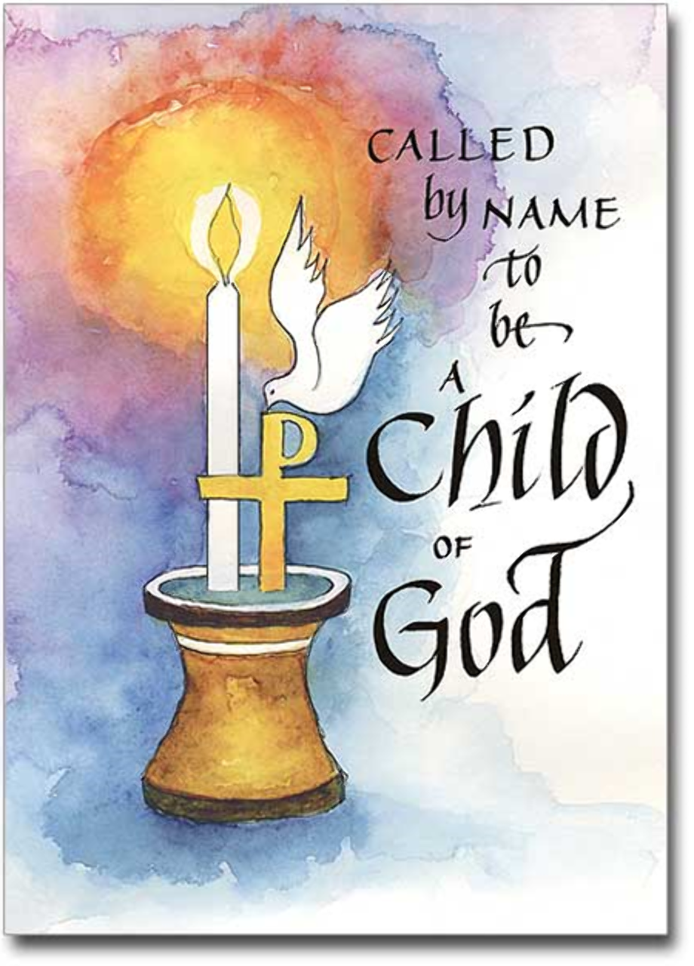
Grace Lutheran Church
310 West Lorain Street
Oberlin, Ohio 44074
www.grace-church-oberlin.org
440-775-3271
April 19, 2026
Pastor: Rev. Dr. Christian F. Just
Organist: Holly Bogle

Confession and Absolution: (LSB151)
P: If we say we have no sin, we deceive ourselves, and the truth is not in us.
C: But if we confess our sins, God, who is faithful and just, will forgive our sins and cleanse us from all unrighteousness.

(Silence for personal self-examination.)
P: Let us then confess our sins to God our Father.
C: Most merciful God, we confess that we are by nature sinful and unclean. We have sinned against You in thought, word, and deed, by what we have done and by what we have left undone. We have not loved You with our whole heart; we have not loved our neighbors as ourselves. We justly deserve Your present and eternal punishment. For the sake of Your Son, Jesus Christ, have mercy on us. Forgive us, renew us, and lead us, so that we may delight in Your will and walk in Your ways to the glory of Your holy name. Amen
P: In the mercy of almighty God, Jesus Christ was given to die for us, and for His sake God forgives us all our sins. To those who believe
in Jesus Christ He gives the power to become the children of God and bestows on them the Holy Spirit. May the Lord, who has begun this good work in us, bring it to completion in the day of our Lord Jesus Christ.
C: Amen.

Introit (LSB 152)
Ps. 133; antiphon: Ps. 133:1
P: Behold, how good and pleasant it is
C: when brothers dwell in unity!
P: It is like the precious oil on the head, running down on the beard, on the
beard of Aaron,
C: running down on the collar of his robes!
P: It is like the dew of Hermon, which falls on the mountains of Zion!
C: For there the Lord has commanded the blessing, life forevermore.
P: Glory be to the Father and to the Son and to the Holy Spirit;
C: as it was in the beginning, is now, and will be forever. Amen.
P: Behold, how good and pleasant it is
C: when brothers dwell in unity!
within us while he talked to us on the road, while he opened to us the Scriptures?” ³³And they rose that same hour and returned to Jerusalem. And they found the eleven and those who were with them gathered together, ³⁴saying, “The Lord has risen indeed, and has appeared to Simon!” ³⁵Then they told what had happened on the road, and how he was known to them in the breaking of the bread.

P: This is the Gospel of the Lord.
C: Praise to You, O Christ.
Sermon:
Hymn of the Day: Who Are You who Walk in Sadness (LSB 476)

- Who are you who walk in sor-row Down Em – ma- us’
bar-ren road, Hearts distraught and hope defeated,
Bent beneath grief’s crushing load? Nameless mourners,
we will join you, We who also mourn our dead;
We have stood by graves unyielding,
Eaten death’s bare bitter bread.

- Who is this who joins our journey, Walking with us
stride by stride. Unknown Stranger, can You fathom
Depths of grief for one who died? Then the wonder!
When we told You How our dreams to dust have turned,
Then You opened wide the scriptures
Till our hearts within us burned.

- Who are You? Our hearts are opened In the breaking
of the bread—Christ the victim, now the victor
Living, risen from the dead! Great companion
on our journey, Still surprise us with Your grace!
Make each day a new Emmaus;
On our hearts Your image trace

- Who are we who travel with You
On our way through life to death?
Women, men, the young, the aging,
Wakened by the Spirit’s breath!
At the font You claim and name us,
Born of water and the Word;
At the table still You feed us,
Host us as our risen Lord!

- “Alleluia! Alleluia!” Is the Easter hymn we sing!
Take our life, our joy, our worship
As the gift of love we bring,
You have formed us all one people
Called from ev’ry land and race.
Make the Church Your servant body,
Sent to share Your healing grace!

Offering: (Offerings are brought forward)
Offertory: (stand and sing) “Psalm 51:10-12” (LSB 192)

Create in me a clean heart O God, and renew a right spirit within me.
Cast me not away from Thy Presence, and take not Thy Holy Spirit from me. Restore unto me the joy of Thy salvation, and uphold me with Thy free Spirit. Amen.

Prayer of the Church:
(Each Petition of the Prayers concludes with the response:) (spoken)
P: Lord, in your mercy,
C: hear our prayer.

- Weeping, be gone; Sorrow, be silent: Death put asunder, and Easter is bright.
Cherubim sing: “O grave, be open!” Clothe us in wonder, adorn us in light. Refrain:

- City of God, Easter forever, Golden Jerusalem, Jesus the Lamb,
River of life, Saints and archangels, Sing with creation to God the I AM!
Refrain:

Invocation:
P: In the Name of the Father and of the Son+ and of the Holy Spirit.
C: Amen.

The Rite of Holy Baptism (LSB 268)

The Baptism of Eleanor Kathleen Jones

Song of Response: See this Wonder in the Making (LSB 593)

- See this wonder in the making; God Himself this child is taking
As a lamb safe in His keeping, His to be, awake or sleeping.

- Miracle each time it happens As the door to heaven opens
And the Father beams, "Beloved, Heir of gifts a king would covet"!

- Far more tender than a mother, Far more caring than a father,
God, into Your arms we place him, With Your love and peace embrace him.

- Here we bring a child of nature; Home we take a newborn creature,
Now God's precious son or daughter, Born again by Word and water.

P: Let us pray.
O God, through the humiliation of Your Son You raised up the fallen world. Grant to Your faithful people, rescued from the peril of everlasting death, perpetual gladness and eternal joys; through Jesus Christ, our Lord, who lives and reigns with You and the Holy Spirit, one God, now and forever.
C: Amen.

First Reading: Acts 2:14a, 36–41
Following Peter’s sermon, the people ask him, “what should we do?” and Peter clearly tells them that they need to be baptized and repent of their sins – showing that they have faith and hope.

¹⁴But Peter, standing with the eleven, lifted up his voice and addressed them, “Men of Judea and all who dwell in Jerusalem, let this be known to you, and give ear to my words.
³⁶Let all the house of Israel therefore know for certain that God has made him both Lord and Christ, this Jesus whom you crucified.”
³⁷Now when they heard this they were cut to the heart, and said to Peter and the rest of the apostles, “Brothers, what shall we do?” ³⁸And Peter said to them, “Repent and be baptized every one of you in the name of Jesus Christ for the forgiveness of your sins, and you will receive the gift of the Holy Spirit. ³⁹For the promise is for you and for your children and for all who are far off, everyone whom the Lord our God calls to himself.”
⁴⁰And with many other words he bore witness and continued to exhort them, saying, “Save yourselves from this crooked generation.” ⁴¹So those who received his word were baptized, and there were added that day about three thousand souls.

R: This is the Word of the Lord.
C: Thanks be to God.

Gradual: adapt. from Matt. 28:7; Heb. 2:7; Ps. 8:6
Christ has risen from the dead.
[God the Father] has crowned him with glory and honor,
He has given him dominion over the works of his hands;
he has put all things under his feet.

Epistle: I Peter 1:17-25

Peter quotes Isaiah 40:6-8 to remind believers that everything in life will finally fade away and disappear and that only God’s word and work will remain forever.

¹⁷And if you call on him as Father who judges impartially according to each one’s deeds, conduct yourselves with fear throughout the time of your exile, ¹⁸knowing that you were ransomed from the futile ways inherited from your forefathers, not with perishable things such as silver or gold, ¹⁹but with the precious blood of Christ, like that of a lamb without blemish or spot. ²⁰He was foreknown before the foundation of the world but was made manifest in the last times for your sake, ²¹who through him are believers in God, who raised him from the dead and gave him glory, so that your faith and hope are in God.
²²Having purified your souls by your obedience to the truth for a sincere brotherly love, love one another earnestly from a pure heart, ²³since you have been born again, not of perishable seed but of imperishable, through the living and abiding word of God; ²⁴for “All flesh is like grass and all its glory like the flower of grass. The grass withers, and the flower falls, ²⁵but the word of the Lord remains forever.” And this word is the good news that was preached to you.

R: This is the Word of the Lord.
C: Thanks be to God.

Alleluia and Verse: (stand and sing)
Alleluia. Lord, to whom shall we go? You have the words of eternal life.
Alleluia, Alleluia.

Gospel Reading: (stand and sing) Luke 24:13–35

P: The Holy Gospel according to St. Luke, the twenty-fourth chapter.
C: Glory to You, O Lord.

Jesus appears to two travelers on the road to Emmaus and has a brief conversation with them and learns that they failed to embrace Christ’s suffering as his path to glory and means for salvation.

¹³That very day two of them were going to a village named Emmaus, about seven miles from Jerusalem, ¹⁴and they were talking with each other about all these things that had happened. ¹⁵While they were talking and discussing together, Jesus himself drew near and went with them. ¹⁶But their eyes were kept from recognizing him. ¹⁷And he said to them, “What is this conversation that you are holding with each other as you walk?” And they stood still, looking sad. ¹⁸Then one of them, named Cleopas, answered him, “Are you the only visitor to Jerusalem who does not know the things that have happened there in these days?” ¹⁹And he said to them, “What things?” And they said to him, “Concerning Jesus of Nazareth, a man who was a prophet mighty in deed and word before God and all the people, ²⁰and how our chief priests and rulers delivered him up to be condemned to death, and crucified him. ²¹But we had hoped that he was the one to redeem Israel. Yes, and besides all this, it is now the third day since these things happened. ²²Moreover, some women of our company amazed us. They were at the tomb early in the morning, ²³and when they did not find his body, they came back saying that they had even seen a vision of angels, who said that he was alive. ²⁴Some of those who were with us went to the tomb and found it just as the women had said, but him they did not see.” ²⁵And he said to them, “O foolish ones, and slow of heart to believe all that the prophets have spoken! ²⁶Was it not necessary that the Christ should suffer these things and enter into his glory?” ²⁷And beginning with Moses and all the Prophets, he interpreted to them in all the Scriptures the things concerning himself.
²⁸So they drew near to the village to which they were going. He acted as if he were going farther, ²⁹but they urged him strongly, saying, “Stay with us, for it is toward evening and the day is now far spent.” So he went in to stay with them. ³⁰When he was at table with them, he took the bread and blessed and broke it and gave it to them. ³¹And their eyes were opened, and they recognized him. And he vanished from their sight. ³²They said to each other, “Did not our hearts burn
Kyrie: (sung) (LSB 152)

P: In Peace let us Pray to the Lord.
C: Lord, have mercy.
P: For the Peace from above and for our salvation let us Pray to the Lord.
C: Lord, have mercy.
P: For the Peace of the whole world, for the well-being of the Church of
God and for the unity of all let us Pray to the Lord.
C: Lord, have mercy.
P: For this holy house and for all who offer here their worship and praise
let us pray to the Lord.
C: Lord, have mercy.
P: Help, save, comfort, and defend us, gracious Lord.
C: Amen.

Gloria in Excelsis: (sung) (LSB V. 154)
P: Glory to God in the highest, and Peace to his People on earth.
C: Lord God, heavenly King, almighty God and Father,
We worship you, we give you thanks, we praise you for your glory.
Lord Jesus Christ, only Son of the Father, Lord God, Lamb of God,
You take away the sin of the world, have mercy on us;
You are seated at the right hand of the Father: receive our Prayer.
For you alone are the Holy One, you alone are the Lord,
You alone are the Most High, Jesus Christ, with the Holy Spirit,
in the glory of God the Father. Amen.

Salutation and Collect: (sung) (LSB V. 156)
P: The Lord be with you.
C: And al - so with you.

