Grace Lutheran Church
310 West Lorain Street, Oberlin, Ohio 44074
May 31, 2026
10:00 AM

HOLY TRINITY SUNDAY
Divine Worship Service
Grace Evangelical Lutheran Church of Oberlin, Ohio
Setting 1 from LSB (CPH, 2006) p. 151-166

Prelude: Tocatta on Holy, Holy, Holy (Nicaea) James Pethel

Welcome:
Opening Hymn: HOLY, HOLY, HOLY (LSB 507)

- Holy, holy, holy! Lord God Almighty! Early in the morning our song shall rise to Thee.
Holy, holy, holy! Merciful and mighty! God in three Persons, blessed Trinity!

- Holy, holy, holy! All the saints adore Thee, Casting down their golden crowns around the glassy sea. Cherubim and seraphim falling down before Thee, Which wert, and art, and evermore shalt be.

- Holy, holy, holy! Though the darkness hide Thee, Though the eye of sinful man Thy glory may not see, Only Thou art holy; there is none beside Thee, Perfect in power, in love, and purity.

- Holy, holy, holy! Lord God Almighty! All Thy works shall praise Thy name in earth and sky and sea. Holy, holy, holy, merciful and mighty! God in three persons, blessed Trinity!

Confession and Absolution: (LSB 151)

P In the name of the Father, and of the T Son, and of the Holy Spirit!
C Amen.

P This is the day that the Lord has made!
C We will rejoice and be glad in it!
P If we say we have no sin, we deceive ourselves, and the truth is not in us.
C But if we confess our sins, God, who is faithful and just, will forgive our sins and cleanse us from all unrighteousness.
Silence for reflection on God's Word and for self-examination.

P Let us then confess our sins to God our Father.
C Most merciful God, we confess that we are by nature sinful and unclean. We have sinned against You in thought, word, and deed, by what we have done and by what we have left undone. We have not loved You with our whole heart; we have not loved our neighbors as ourselves. We justly deserve Your present and eternal punishment. For the sake of Your Son, Jesus Christ, have mercy on us. Forgive us, renew us, and lead us, so that we may delight in Your will and walk in Your ways to the glory of Your holy name. Amen.
P Almighty God in His mercy has given His Son to die for you and for His sake forgives you all your sins. As a called and ordained servant of Christ, and by His authority, I therefore forgive you all your sins in the name of the Father and of the T Son and of the Holy Spirit.
C Amen.

Introit: (LSB 152)
Ps. 16:8–11; antiphon: Liturgical Text
P Blessèd be the Holy Trinity and the undivided Unity.
C Let us give glory to him because he has shown his mercy to us.
P I have set the Lord always before me;
C because he is at my right hand, I shall not be shaken.
P Therefore my heart is glad, and my whole being rejoices;
C my flesh also dwells secure.
P For you will not abandon my soul to Sheol,
C or let your holy one see corruption.
P You make known to me the path of life;
C in your presence there is fullness of joy; at your right hand are pleasures forevermore.
P Glory be to the Father and to the Son and to the Holy Spirit;
C as it was in the beginning, is now, and will be forever. Amen.
P Blessèd be the Holy Trinity and the undivided Unity.
C Let us give glory to him because he has shown his mercy to us.

Kyrie: (sung) (LSB 186)

P In Peace let us Pray to the Lord.
C Lord, have mercy.
P For the Peace from above and for our salvation let us Pray to the Lord.
C Lord, have mercy.
P For the Peace of the whole world, for the well-being of the Church of
God and for the unity of all let us Pray to the Lord.
C Lord, have mercy.
P For this holy house and for all who offer here their worship and praise
let us pray to the Lord.
C Lord, have mercy.
P Help, save, comfort, and defend us, gracious Lord.
C Amen.

Gloria in Excelsis: (sung) (LSB 154)
P Glory to God in the highest, and Peace to his People on earth.

ALL: Lord God, heavenly King, almighty God and Father,
We worship you, we give you thanks, we praise you for your glory.
Lord Jesus Christ, only Son of the Father, Lord God, Lamb of God,
You take away the sin of the world, have mercy on us;
You are seated at the right hand of the Father: receive our Prayer.
For you alone are the Holy One,you alone are the Lord,
You alone are the Most High, Jesus Christ, with the Holy Spirit,
in the glory of God the Father. Amen.

Salutation and Collect: (sung) (LSB 156)
P The Lord be with you.
C And also with you.
P Let us pray.
Almighty and everlasting God, You have given us grace to acknowledge the glory of the eternal Trinity by the confession of a true faith and to worship the Unity in the power of the Divine Majesty. Keep us steadfast in this faith and defend us from all adversities; for You, O Father, Son, and Holy Spirit, live and reign, one God, now and forever.
C Amen.

First Reading: Genesis 1:1—2:4a
Artist God creates from the once empty and formless world an earth booming with all kinds of goodness and breathing life. In just seven days, God transformed darkness into light and breathed His very breath into mankind. What an amazing way to begin!

¹ In the beginning, God created the heavens and the earth. ²The earth was without form and void, and darkness was over the face of the deep. And the Spirit of God was hovering over the face of the waters.
³And God said, “Let there be light,” and there was light. ⁴And God saw that the light was good. And God separated the light from the darkness. ⁵God called the light Day, and the darkness he called Night. And there was evening and there was morning, the first day.
⁶And God said, “Let there be an expanse in the midst of the waters, and let it separate the waters from the waters.” ⁷And God made the expanse and separated the waters that were under the expanse from the waters that were above the expanse. And it was so. ⁸And God called the expanse Heaven. And there was evening and there was morning, the second day.
⁹And God said, “Let the waters under the heavens be gathered together into one place, and let the dry land appear.” And it was so. ¹⁰God called the dry land Earth, and the waters that were gathered together he called Seas. And God saw that it was good.
¹¹And God said, “Let the earth sprout vegetation, plants yielding seed, and fruit trees bearing fruit in which is their seed, each according to its kind, on the earth.” And it was so. ¹²The earth brought forth vegetation, plants yielding seed according to their own kinds, and trees bearing fruit in which is their seed, each according to its kind. And God saw that it was good. ¹³And there was evening and there was morning, the third day.
¹⁴And God said, “Let there be lights in the expanse of the heavens to separate the day from the night. And let them be for signs and for seasons, and for days and years, ¹⁵and let them be lights in the expanse of the heavens to give light upon the earth.” And it was so. ¹⁶And God made the two great lights—the greater light to rule the day and the lesser light to rule the night—and the stars. ¹⁷And God set them in the expanse of the heavens to give light on the earth, ¹⁸to rule over the day and over the night, and to separate the light from the darkness. And God saw that it was good. ¹⁹And there was evening and there was morning, the fourth day.
²⁰And God said, “Let the waters swarm with swarms of living creatures, and let birds fly above the earth across the expanse of the heavens.” ²¹So God created the great sea creatures and every living creature that moves, with which the waters swarm, according to their kinds, and every winged bird according to its kind. And God saw that it was good. ²²And God blessed them, saying, “Be fruitful and multiply and fill the waters in the seas, and let birds multiply on the earth.” ²³And there was evening and there was morning, the fifth day.
²⁴And God said, “Let the earth bring forth living creatures according to their kinds—livestock and creeping things and beasts of the earth according to their kinds.” And it was so. ²⁵And God made the beasts of the earth according to their kinds and the livestock according to their kinds, and everything that creeps on the ground according to its kind. And God saw that it was good.
²⁶Then God said, “Let us make man in our image, after our likeness. And let them have dominion over the fish of the sea and over the birds of the heavens and over the livestock and over all the earth and over every creeping thing that creeps on the earth.”
²⁷So God created man in his own image, in the image of God he created him; male and female he created them.
²⁸And God blessed them. And God said to them, “Be fruitful and multiply and fill the earth and subdue it and have dominion over the fish of the sea and over the birds of the heavens and over every living thing that moves on the earth.” ²⁹And God said, “Behold, I have given you every plant yielding seed that is on the face of all the earth, and every tree with seed in its fruit. You shall have them for food. ³⁰And to every beast of the earth and to every bird of the heavens and to everything that creeps on the earth, everything that has the breath of life, I have given every green plant for food.” And it was so. ³¹And God saw everything that he had made, and behold, it was very good. And there was evening and there was morning, the sixth day.
¹Thus the heavens and the earth were finished, and all the host of them. ²And on the seventh day God finished his work that he had done, and he rested on the seventh day from all his work that he had done. ³So God blessed the seventh day and made it holy, because on it God rested from all his work that he had done in creation.
⁴These are the generations of the heavens and the earth when they were created, in the day that the Lord God made the earth and the heavens.

R This is the Word of the Lord
C Thanks be to God.

Gradual: adapt. from Ps. 145:3, 5b, 6b

Great is the Lord, and greatly to be praised,
And his greatness is unsearchable.
On your wondrous works, I will meditate,
and I will declare your greatness.

Epistle: Acts 2:14a, 22–36
Peter addressed the disciples and the Israelites in a speech reminding them that Jesus was sent by God and filled with the Holy Spirit as the Messiah. This perfect plan of salvation was imagined and set in motion by God.
Even David spoke of the coming Messiah.

¹⁴But Peter, standing with the eleven, lifted up his voice and addressed them, “Men of Judea and all who dwell in Jerusalem, let this be known to you, and give ear to my words.
²²“Men of Israel, hear these words: Jesus of Nazareth, a man attested to you by God with mighty works and wonders and signs that God did through him in your midst, as you yourselves know— ²³this Jesus, delivered up according to the definite plan and foreknowledge of God, you crucified and killed by the hands of lawless men. ²⁴God raised him up, loosing the pangs of death, because it was not possible for him to be held by it. ²⁵For David says concerning him, “‘I saw the Lord always before me, for he is at my right hand that I may not be shaken; ²⁶therefore my heart was glad, and my tongue rejoiced; my flesh also will dwell in hope. ²⁷For you will not abandon my soul to Hades, or let your Holy One see corruption. ²⁸You have made known to me the paths of life; you will make me full of gladness with your presence.’
²⁹“Brothers, I may say to you with confidence about the patriarch David that he both died and was buried, and his tomb is with us to this day. ³⁰Being therefore a prophet, and knowing that God had sworn with an oath to him that he would set one of his descendants on his throne, ³¹he foresaw and spoke about the resurrection of the Christ, that he was not abandoned to Hades, nor did his flesh see corruption. ³²This Jesus God raised up, and of that we all are witnesses. ³³Being therefore exalted at the right hand of God, and having received from the Father the promise of the Holy Spirit, he has poured out this that you yourselves are seeing and hearing. ³⁴For David did not ascend into the heavens, but he himself says, “‘The Lord said to my Lord, Sit at my right hand, ³⁵until I make your enemies your footstool.’ ³⁶Let all the house of Israel therefore know for certain that God has made him both Lord and Christ, this Jesus whom you crucified.”

R This is the Word of the Lord
C Thanks be to God.

Gospel Reading: Matthew 28:16-20
P The Holy Gospel according to St. Matthew, the twenty-eighth chapter.
C Glory to You, O Lord. (sung)

After His resurrection, some disciples doubted His presence even though Jesus was standing right in front of them! Even in their disbelief, Jesus reminded them that He would always be with them and that they had a large task to accomplish - to make disciples of all nations and baptize them in the name of the Holy Trinity.

¹⁶Now the eleven disciples went to Galilee, to the mountain to which Jesus had directed them. ¹⁷And when they saw him they worshiped him, but some doubted. ¹⁸And Jesus came and said to them, “All authority in heaven and on earth has been given to me. ¹⁹Go therefore and make disciples of all nations, baptizing them in the name of the Father and of the Son and of the Holy Spirit, ²⁰teaching them to observe all that I have commanded you. And behold, I am with you always, to the end of the age.”

P This is the Gospel of the Lord.
C Praise to You, O Christ. (sung)

Athanasian Creed: Please turn to page 319 in the LSB (hymnal in pew)

Sermon: “While We Own the Mystery”

Hymn of the Day: “Holy God, We Praise Thy Name”
(LSB 940)
- Holy God, we praise Thy name; Lord of all, we bow before Thee. All on earth Thy scepter claim, All in heav'n above adore Thee. Infinite Thy vast domain, Everlasting is Thy reign.

- Hark! the glad celestial hymn Angel choirs above are raising; Cherubim and seraphim, In unceasing chorus praising, Fill the heav'ns with sweet accord: Holy, holy, holy Lord!

3. Lo, th'apostles' holy train Join Thy sacred name to hallow; Prophets swell the glad refrain,
And the white-robed martyrs follow, And from morn to set of sun Through the Church
the song goes on.

4. Thou art King of Glory, Christ; Son of God, yet born of Mary. For us sinners sacrificed, As to
death a Tributary, First to break the bars of death, Thou hast opened heav’n to faith.

5. Holy Father, holy Son, Holy Spirit, three we name Thee;
Though in essence only one, Undivided God we claim Thee
And adoring bend the knee While we own the mystery.

Offering: (Offerings are brought forward)

Offertory: (stand and sing) (LSB 192)
ALL: Create in me a clean heart, O God, and renew a right spirit within me. Cast me not away from Thy Presence, and take not Thy Holy Spirit from me. Restore unto me the joy of Thy salvation, and uphold me with Thy free spirit. Amen.

Prayer of the Church: (Each Petition of the Prayers concludes with the response:)
P Lord, in your mercy,
C Hear our prayer.

Preface: (sung)
P The Lord be with you.
C And also with you.
P Lift up your hearts
C We lift them to the Lord.
P Let us give thanks to the Lord our God.
C It is right to give Him thanks and praise.

P It is truly good, right, and salutary…
…Your glorious name, evermore praising You and singing:
Sanctus: (sung) (LSB 161)
ALL: Holy, holy, holy Lord God of Pow’r and might:
Heaven and earth are full of Your glory.
Hosanna. Hosanna. Hosanna in the highest.
Blessed is He who comes in the name of the Lord.
Hosanna in the highest.

P Lord, remember us in Your Kingdom and teach us to pray:

Lord’s Prayer: (LSB 162)
Our Father who art in heaven, hallowed be Thy name, Thy kingdom come, Thy will be done, on earth as it is in heaven. Give us this day our daily bread; and forgive us our trespasses as we forgive those who trespass against us; and lead us not into temptation, but deliver us from evil.
For Thine is the kingdom and the power and the glory forever and ever. Amen.

Words of Institution:
P Our Lord Jesus Christ, on the night when He was betrayed, took bread, and when He had given thanks, He broke it and gave it to the disciples and said: “Take, eat; this is My +body, which is given for you. This do in remembrance of Me.”
In the same way also He took the cup after supper, and when He had given thanks, He gave it to them, saying: “Drink of it, all of you; this cup is the new testament in my +blood, which is shed for you for the forgiveness of sins. This do, as often as you drink it, in remembrance of Me.”
Pax Domini: (sung)
P The Peace of the Lord be with you always.
C Amen.
Agnus Dei: (sung) (LSB 163)

ALL: Lamb of God, You take away the sin of the world; have mercy on us.
Lamb of God, You take away the sin of the world; have mercy on us.
Lamb of God, You take away the sin of the world; grant us Peace.
Distribution of Holy Communion:
In Holy Communion we believe Jesus gives us His real presence, in and with the bread and the wine, for the forgiveness of sins. We celebrate this forgiveness, which comes through faith, and we are strengthened in our personal faith and in our love for one another. We invite
to Holy Communion all who believe in Jesus as their Savior, are a baptized believer, have been
instructed in the meaning of Holy Communion, and agree with these teachings. If you have any questions, please speak with Pastor Just. As we eat and drink, we remember our Lord’s suffering, death, resurrection, ascension, and the promise of His coming again. Both Common and individual cups are available. When using the individual cup, please place the empty cup in the basket at either end of the communion rail. The non-alcoholic wine is in the center of the tray. If the Common cup is used, please help the server by holding the base of the cup when you are served.

Post-Communion Canticle: (sung) (LSB 164)
ALL: Thank the Lord and sing His praise; tell ev’ryone what He has done.
Let all who seek the Lord rejoice and proudly bear His name.
He recalls His promises and leads His people forth in joy
with shouts of thanksgiving. Alleluia, alleluia.

Post-Communion Collect: (LSB 166)
P Let us Pray….
O God the Father, the fountain and source of all goodness, who in loving kindness sent Your only-begotten Son into the flesh, we thank You that for His sake You have given us pardon and peace in this sacrament, and we ask You not to forsake Your children but always to rule our hearts and minds by Your Holy Spirit that we may be enabled constantly to serve You; through Jesus Christ, Your Son, our Lord, who lives and reigns with You and the Holy Spirit, one God, now and forever.
C Amen. (sung)
Benediction:

P The Lord bless you and keep you.
The Lord make His face to shine upon you
and be gracious to you.
The Lord lift up His favor upon you and give you Peace.
C Amen. (sung)

Closing Hymn: Forth in the Peace of Christ We Go (LSB 920)
1. Forth in the peace of Christ we go; Christ to the world with joy we bring;
Christ in our minds, Christ on our lips, Christ in our hearts, the world's true
King.
2. King of our hearts, Christ makes us kings; kingship with him his servants gain;
with Christ, the Servant-Lord of all, Christ's world we serve to share Christ's
reign.
3. Priests of the world, Christ sends us forth the world of time to consecrate,
the world of sin by grace to heal, Christ's world in Christ to re-create.
4. Christ's are our lips, his word we speak; prophets are we whose deeds proclaim
Christ's truth in love, that we may be Christ in the world, to spread Christ's
name.
5. We are the church; Christ bids us show that in his church all nations find
their hearth and home, where Christ restores true peace, true love, to all
mankind.

P Go in peace. Serve the Lord.
C Thanks be to God.

Postlude: Andante conmoto Johann K.F. Fisher

+ + +

Pastor: Rev. Dr. Christian F. Just
Organist: Dr. Harold Slocum
Order of Worship: Divine Service Setting 1 from LSB (CPH, 2006) p. 151-166

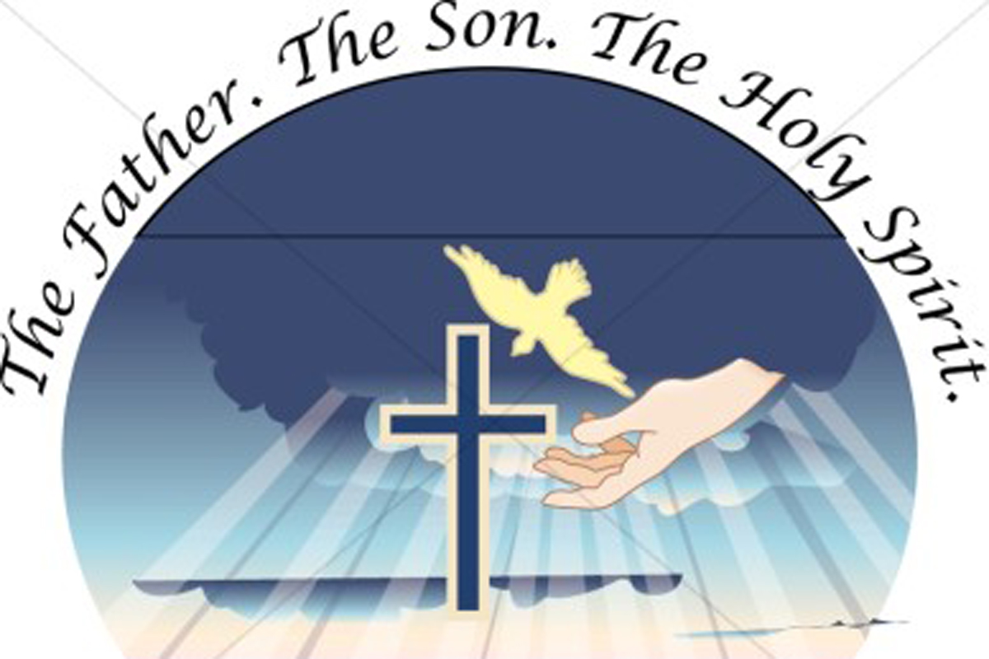

Grace Lutheran Church
310 West Lorain Street
Oberlin, Ohio 44074
www.grace-church-oberlin.org
440-775-3271
May 31, 2026
Pastor: Rev. Dr. Christian F. Just
Organist: Dr. Harold Slocum

