Grace Announcements

May 10, 2026



IN OUR PRAYERS THIS WEEK
Please pray for Tom & Barb Hathaway; Marcia Metzger; Mike & Melissa Bennett (son-in-law and daughter of John and Kathy Knipper) and Bev & Ray Hines.
Please remember to keep Grace’s shut-ins, widows and widowers in your prayers. A phone call or greeting card can go a long way in lifting one’s spirits. It is also a way to share our Savior’s love.


MAY BIRTHDAYS MAY ANNIVERSARIES
Beverly Hines 5/04 Ron and Jan Mertz 5/29/1953

Kathy Sklarek 5/18

Sue Walker 5/20

Kathy Knipper 5/27

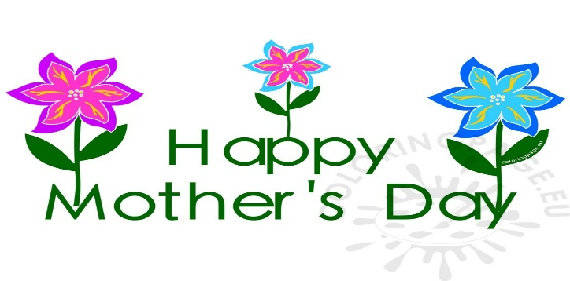

COMING UP AT GRACE

Sun. 05/10 Divine Worship Service 10:00 am

Mon. 05/11 GLC Council Meeting 4:00pm

****ADULT BIBLE STUDY****

Wed. 05/13 Bible Study w/Pastor Weldon 1:30 pm
(Studying the book of Philippians)

Wed. 05/13 Bible Study w/Harriett Thomas 7:00 pm*
(Studying the book of Galatians)

****

Sun. 05/17 Divine Worship Service 10:00 am

* The 7:00 pm Wednesday Evening Bible Study will be on Zoom for
the months of April, May, and June. Anyone that is interested in
joining our Study can contact Harriett Thomas
at hthomas@oberlin.net or 440-935-2349, with their email address.
Harriett will forward the Zoom link, which will be active for all three
months. All are welcome to join us.

ATTENTION: Voter’s Meeting has been re-scheduled for Sunday, 05/24/26, to start immediately after the church service.

SERVING THE LORD
Grace Service Schedule
DATE | USHER | Counters | Altar Guild | Lay Reader | Comm. Assist.
May 10  10 am Sun | Andy Karp | Bonnie & Lisa | Robin Turnbull | Paul Castle | Paul Castle
May 17  10 am Sun | Andy Karp | Bonnie & Lisa | Kathy Knipper | Paul Castle | Paul Castle
May 24  10 am Sun | Tom Monroe | Fred C. & Gregg | Kathy Knipper | Harriett Thomas | Bob  Izold

NOTES FOR WORSHIP

Welcome GUESTS! We are SO GLAD that you have joined us today to worship our Lord together.
We would love for you to sign our Guest Book in the Narthex. Today we will be using the Divine Service Setting 1 Liturgy. If you might be unfamiliar with it, please turn to page 151 in the pew hymnal to follow along.
Announcements and worship service bulletins can be picked up from the table in the narthex. Please help yourself.
Children’s Bulletins are available on the table in the narthex for kids ages 3 & up and 7 & up.
Offering will be collected and the Ushers will bring the offering plates forward during the Offertory.

Do you need to speak to a Pastor?
Contact Pastor Weldon on his cell phone at
(270) 792-0570 or at his office at (440) 322-5497

WELCOME PASTOR JUST!

Rev. Dr. Christian Frederic Just was born in Boston, Massachusetts, and grew up in the Boston suburb of Weymouth, with his parents and two sisters. He graduated from Weymouth High School in 1965,then attended Concordia Collegiate Institute in Bronxville, New York (A.A., 1967) and Concordia Senior College in Ft, Wayne, Indiana (B.A. in Biblical languages and philosophy, 1969). He is a 1973 graduate of Concordia Seminary in St. Louis (M.Div.) and holds a doctorate from Ashland (Ohio) Seminary (D. Min. in Formational Counseling, 2009). He served Epiphany Lutheran Church in Northfield from 1993 to 2018, Shore Haven Lutheran Church in Euclid, Ohio from 1979 to 1993; Epiphany Lutheran Church in East Avon, New York from 1973 to 1979. He began serving as part-time Pastor for St. Thomas Lutheran Church in Streetsboro in 2016, and continued until his retirement on June 8, 2023.
He served as Chairman of the Board for Youth Ministry in the Eastern District of the LCMS. He served the Ohio District of the LCMS as Chair of the Board for Parish Services and as a member of the Board of Directors. He remains active with Lutheran Metropolitan Ministry of Cleveland (Emeritus on the Board of Directors; Chair of the Advisory Board for the Adult Support and Advocacy programs). He completed and then served on the board (as Chairman from 1993-94) for the Pastoral Psychology Institute at Case Western Reserve University. He has taught part-time at Ashland Seminary in the Doctor of Ministry program for Formational Counseling. He continues to be involved with Healing Care Ministries International, especially in their Formational Prayer Seminars, and has been active in counseling pastors and other professional church workers for the last ten years. He continues to serve on the Ministerial Health Commission of the English District, LCMS.
Pastor and his wife, Kristine, were married in Kristine’s home town of Decatur, Indiana, in 1969. They have three grown children, daughters Gretchen and Rachel, son Levi, and two granddaughters, Selby and Sophia.. They live in Macedonia, Ohio. Pastor and Kristine are members of the Cleveland Museum of Art, regular subscr Word word and you check the dates I appreciate that because that’s usually perfect 310-1724 OK good lookie there Came down again ibers to the Cleveland Orchestra, and enjoy the many arts and music offerings in the Greater Cleveland area. Although he has been unable to do so over the past three years because of injuries and other medical problems, he would love to be able once again to play golf.

