Grace Lutheran Church
310 West Lorain Street, Oberlin, Ohio 44074
July 19, 2026
10:00 AM

THE EIGHTH SUNDAY AFTER PENTECOST
Divine Worship Service
Grace Evangelical Lutheran Church of Oberlin, Ohio
Setting 1 from LSB (CPH, 2006) p. 151-166

Prelude:

3:50 "Adagio" from "Modale Suite" by Flor Peeters
Welcome:
Opening Hymn: Feed Thy Children, God Most Holy (LSB 774)

- Feed Thy children, God most holy: Comfort sinners poor and lowly.
O Thou Bread of Life from Heaven, Bless the food Thou here hast given!
As these gifts the body nourish, May our souls in graces flourish
Till with saints in heav’nly splendor At Thy feast due thanks we render.
Confession and Absolution: (LSB 151)
P In the name of the Father, and of the T Son, and of the Holy Spirit!
C Amen.
P This is the day that the Lord has made!
C We will rejoice and be glad in it!
P If we say we have no sin, we deceive ourselves, and the truth is not in us.

C But if we confess our sins, God, who is faithful and just, will forgive our sins and cleanse us from all unrighteousness.
Silence for reflection on God's Word and for self-examination.
P Let us then confess our sins to God our Father.
C Most merciful God, we confess that we are by nature sinful and unclean. We have sinned against You in thought, word, and deed, by what we have done and by what we have left undone. We have not loved You with our whole heart; we have not loved our neighbors as ourselves. We justly deserve Your present and eternal punishment. For the sake of Your Son, Jesus Christ, have mercy on us. Forgive us, renew us, and lead us, so that we may delight in Your will and walk in Your ways to the glory of Your holy name. Amen.
P Almighty God in His mercy has given His Son to die for you and for His sake forgives you all your sins. As a called and ordained servant of Christ, and by His authority, I therefore forgive you all your sins in the name of the Father and of the T Son and of the Holy Spirit.
C Amen.
Introit: Ps. 86:11–15; antiphon: Ps. 86:6
P Give ear, O Lord, to my prayer;
C listen to my plea for grace.
P Teach me your way, O Lord, that I may walk in your truth;
C unite my heart to fear your name.
P I give thanks to you, O Lord my God, with my whole heart,
C and I will glorify your name forever.
P For great is your steadfast love toward me;
C you have delivered my soul from the depths of Sheol.
P O God, insolent men have risen up against me; a band of ruthless men seek my life,
C and they do not set you before them.
P But you, O Lord, are a God merciful and gracious,
C slow to anger and abounding in steadfast love and faithfulness.

P Glory be to the Father and to the Son and to the Holy Spirit;
C as it was in the beginning, is now, and will be forever. Amen.
P Give ear, O Lord, to my prayer;
C listen to my plea for grace.
Kyrie: (sung) (LSB 186)

P In Peace let us Pray to the Lord.
C Lord, have mercy.
P For the Peace from above and for our salvation let us Pray to the Lord.
C Lord, have mercy.
P For the Peace of the whole world, for the well-being of the Church of
God and for the unity of all let us Pray to the Lord.
C Lord, have mercy.
P For this holy house and for all who offer here their worship and praise
let us pray to the Lord.
C Lord, have mercy.
P Help, save, comfort, and defend us, gracious Lord.
C Amen.
Gloria in Excelsis: (sung) (LSB 154)
P Glory to God in the highest, and Peace to his People on earth.

ALL: Lord God, heavenly King, almighty God and Father,
We worship you, we give you thanks, we praise you for your glory.
Lord Jesus Christ, only Son of the Father, Lord God, Lamb of God,
You take away the sin of the world, have mercy on us;
You are seated at the right hand of the Father: receive our Prayer.
For you alone are the Holy One,you alone are the Lord,
You alone are the Most High, Jesus Christ, with the Holy Spirit,
in the glory of God the Father. Amen.
Salutation and Collect: (sung) (LSB 156)
P The Lord be with you.
C And also with you.
P Let us pray.
Loving Father, Your dear Son Jesus Christ came down from heaven to be the true bread which gives life to the world. Give us this bread, so that He may live in us and we in Him; for He lives and reigns with You and the Holy Spirit, one God, now and forever. .
C Amen.
Old Testament Reading: Isaiah 55: 1-5
¹“Come, everyone who thirsts, come to the waters; and he who has no money,
come, buy and eat! Come, buy wine and milk without money and without price.
² Why do you spend your money for that which is not bread, and your labor for that which does not satisfy? Listen diligently to me, and eat what is good, and delight yourselves in rich food. ³ Incline your ear, and come to me; hear, that your soul may live;
and I will make with you an everlasting covenant, my steadfast, sure love for David.
⁴ Behold, I made him a witness to the peoples, a leader and commander for the peoples.
⁵ Behold, you shall call a nation that you do not know, and a nation that did not know you shall run to you, because of the Lord your God, and of the Holy One of Israel, for he has glorified you.

R This is the Word of the Lord
C Thanks be to God.

Gradual: adapt. from Rom. 11:33, 36

Oh, the depth of the riches and wisdom and knowledge of God!
How unsearchable are his judgments and how inscrutable his ways!
For from him and through him and to him are all things.
To him be glory forever. Amen.

Epistle: Romans 9:1-5
¹I am speaking the truth in Christ—I am not lying; my conscience bears me witness in the Holy Spirit— ² that I have great sorrow and unceasing anguish in my heart. ³ For I could wish that I myself were accursed and cut off from Christ for the sake of my brothers,^{[a]} my kinsmen according to the flesh. ⁴ They are Israelites, and to them belong the adoption, the glory, the covenants, the giving of the law, the worship, and the promises. ⁵ To them belong the patriarchs, and from their race, according to the flesh, is the Christ, who is God over all, blessed forever. Amen.

R This is the Word of the Lord
C Thanks be to God.
Alleluia and Verse: (stand and sing) (LSB 156)
Alleluia. Lord, to whom shall we go? You have the words of eternal life.
Alleluia, Alleluia.
Gospel Reading: Matthew 14:13-21
P The Holy Gospel according to St. Matthew, the fourteenth chapter.
C Glory to You, O Lord.

¹³ Now when Jesus heard this, he withdrew from there in a boat to a desolate place by himself. But when the crowds heard it, they followed him on foot from the towns. ¹⁴ When he went ashore he saw a great crowd, and he had compassion on them and healed their sick. ¹⁵ Now when it was evening, the disciples came to him and said, “This is a desolate place, and the day is now over; send the crowds away to go into the villages and buy food for themselves.” ¹⁶ But Jesus said, “They need not go away; you give them something to

eat.” ¹⁷ They said to him, “We have only five loaves here and two fish.” ¹⁸ And he said, “Bring them here to me.” ¹⁹ Then he ordered the crowds to sit down on the grass, and taking the five loaves and the two fish, he looked up to heaven and said a blessing. Then he broke the loaves and gave them to the disciples, and the disciples gave them to the crowds. ²⁰ And they all ate and were satisfied. And they took up twelve baskets full of the broken pieces left over. ²¹ And those who ate were about five thousand men, besides women and children.

P This is the Gospel of the Lord.
C Praise to You, O Christ. (sung)
Apostle’s Creed:

I believe in God, the Father almighty,
Maker of heaven and earth.
And in Jesus Christ, His only Son, our Lord,
who was conceived by the Holy Spirit, born of the Virgin Mary, suffered
under Pontius Pilate, was crucified, died, and was buried.
He descended into hell.
The third day He rose again from the dead.
He ascended into heaven and sits at the right hand of God the Father Almighty. From thence He will come to judge the living and the dead.
I believe in the Holy Spirit, the Holy Christian Church, the communion of saints, the forgiveness of sins, the resurrection of the body, and the life everlasting. Amen.
Sermon: “Eat Up”

Hymn of the Day: “Lord Jesus Christ, We Humbly Pray” (LSB 623)

- Lord Jesus Christ, we humbly pray
That we may feast on You today;
Beneath these forms of bread and wine
Enrich us with Your grace divine.
- Give us, who share this wondrous food,
Your body broken and Your blood,
The grateful peace of sins forgiv'n,
The certain joys of heirs of heav'n.
- By faith Your Word has made us bold
To seize the gift of love retold;
All that You are we here receive,
And all we are to You we give.
- One bread, one cup, one body, we,
Rejoicing in our unity,
Proclaim Your love until You come
To bring Your scattered loved ones home.
- Lord Jesus Christ, we humbly pray:
O keep us steadfast till that day
When each will be Your welcomed guest
In heaven's high and holy feast.
Offering: (Offerings are brought forward)

Offertory: (stand and sing) (LSB 192)
ALL: Create in me a clean heart, O God, and renew a right spirit within me. Cast me not away from Thy Presence, and take not Thy Holy Spirit from me. Restore unto me the joy of Thy salvation, and uphold me with Thy free spirit. Amen.
Prayer of the Church: (Each Petition of the Prayers concludes with the response:)
P Lord, in your mercy,
C Hear our prayer.
The Preface: (sung)

P The Lord be with you.
C And also with you.
P Lift up your hearts.
C We lift them to the Lord
P Let us give thanks to the Lord our God.
C It is right to give Him thanks and praise.

P It is truly good, right, and salutary that we should at all times and in all places give thanks to You, holy Lord, almighty Father, everlasting God, through Jesus Christ, our Lord, who on this day overcame death and the grave and by His glorious resurrection opened to us the way of everlasting life. Therefore, with angels and archangels and with all the company of heaven we laud and magnify Your glorious name, evermore praising You and singing:

Sanctus: (sung) (LSB 161)
ALL: Holy, holy, holy Lord God of Pow’r and might:
Heaven and earth are full of Your glory.
Hosanna. Hosanna. Hosanna in the highest.
Blessed is He who comes in the name of the Lord.
Hosanna in the highest.
P Lord, remember us in Your Kingdom and teach us to pray:

Lord’s Prayer: (LSB 162)
Our Father who art in heaven, hallowed be Thy name, Thy kingdom come, Thy will be done, on earth as it is in heaven. Give us this day our daily bread; and forgive us our trespasses as we forgive those who trespass against us; and lead us not into temptation, but deliver us from evil.
For Thine is the kingdom and the power and the glory forever and ever. Amen.
Words of Institution:
P Our Lord Jesus Christ, on the night when He was betrayed, took bread, and when He had given thanks, He broke it and gave it to the disciples and said: “Take, eat; this is My +body, which is given for you. This do in remembrance of Me.”
In the same way also He took the cup after supper, and when He had given thanks, He gave it to them, saying: “Drink of it, all of you; this cup is the new testament in my +blood, which is shed for you for the forgiveness of sins. This do, as often as you drink it, in remembrance of Me.”
Pax Domini: (sung)
P The Peace of the Lord be with you always.
C Amen.
Agnus Dei: (sung) (LSB 163)
ALL: Lamb of God, You take away the sin of the world; have mercy on us.
Lamb of God, You take away the sin of the world; have mercy on us.
Lamb of God, You take away the sin of the world; grant us Peace.

Distribution of Holy Communion:
In Holy Communion we believe Jesus gives us His real presence, in and with the bread and the wine, for the forgiveness of sins. We celebrate this forgiveness, which comes through faith, and we
are strengthened in our personal faith and in our love for one another. We invite to Holy Communion all who believe in Jesus as their Savior, are a baptized believer, have been instructed in the meaning of Holy Communion, and agree with these teachings. If you have any questions, please
speak with Pastor Just. As we eat and drink, we remember our Lord’s suffering, death, resurrection, ascension, and the promise of His coming again. Both Common and individual cups are available. When using the individual cup, please place the empty cup in the basket at either end of the communion rail. Please note that all wine is alcoholic. Should you plan on attending on a regular basis and require a non-alcoholic beverage, please let the usher or Pastor Just know, and we will provide it at the following services. If the Common cup is used, please help the server by holding the base of the cup when you are served.
Post-Communion Canticle: (sung) (LSB 164)
ALL: Thank the Lord and sing His praise; tell ev’ryone what He has done.
Let all who seek the Lord rejoice and proudly bear His name.
He recalls His promises and leads His people forth in joy
with shouts of thanksgiving. Alleluia, alleluia.
Post-Communion Collect: (LSB 166)
P Let us Pray….
O God the Father, the fountain and source of all goodness, who in loving kindness sent Your only-begotten Son into the flesh, we thank You that for His sake You have given us pardon and peace in this sacrament, and we ask You not to forsake Your children but always to rule our hearts and minds by Your Holy Spirit that we may be enabled constantly to serve You; through Jesus Christ, Your Son, our Lord, who lives and reigns with You and the Holy Spirit, one God, now and forever.
C Amen. (sung)

Benediction:
P The Lord bless you and keep you.
The Lord make His face to shine upon you
and be gracious to you.
The Lord lift up His favor upon you and give you Peace.
C Amen. (sung)

Closing Hymn: “Praise and Thanksgiving, Father We Offer” (LSB 789)

1. Praise and thanksgiving, Father we offer
For all things living, Created good
Harvest of sown fields, Fruits of the orchard,
Hay from the mown fields, blossom and wood.

2. Bless, Lord, the labor We bring to serve You
That with our neighbor We may be fed.
Sowing or tilling, We would work with You.
Harvesting, milling, For daily bread.

3. Father, providing, Food for Your children,
By Your wise guiding Teach us to share
One with another, So that, rejoicing
With us, all others May know Your care.

P Go in peace. Serve the Lord.
C Thanks be to God.

Postlude: Allegro by G. F. Handel

+ + +

Pastor: Rev. Dr. Christian F. Just
Organist: Dr. Harold Slocum
Order of Worship: Divine Service Setting 1 from LSB (CPH, 2006) p. 151-166
Matthew 14:13-21
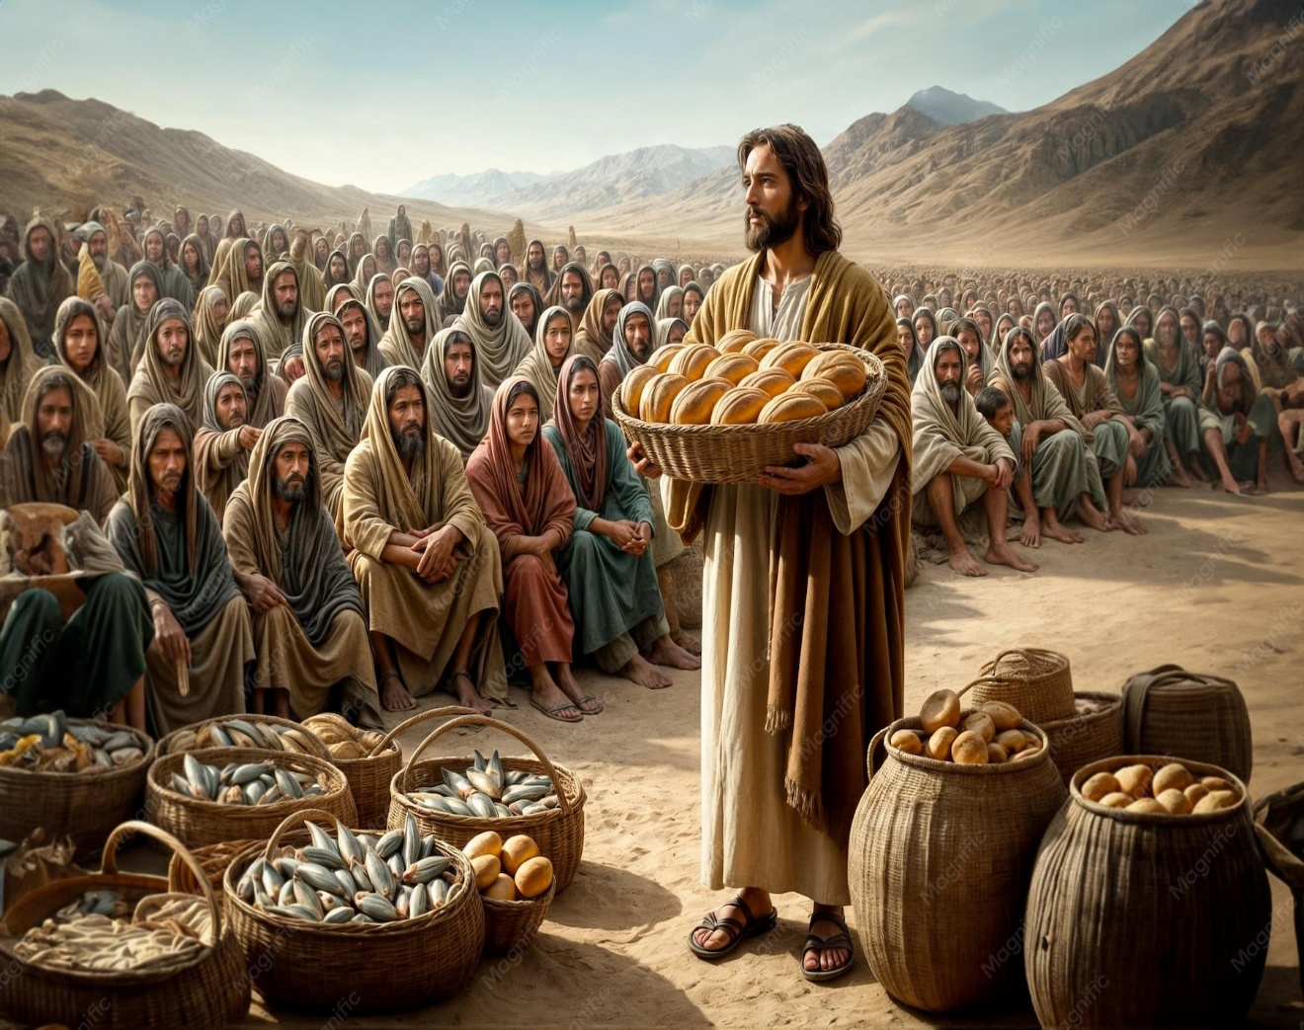

Grace Lutheran Church
310 West Lorain Street
Oberlin, Ohio 44074
www.grace-church-oberlin.org
440-775-3271
July 19, 2026
Pastor: Rev. Dr. Christian F. Just
Organist: Dr. Harold Slocum

