Grace Lutheran Church
310 West Lorain Street, Oberlin, Ohio 44074
August 9, 2026
10:00 AM

THE ELEVENTH SUNDAY AFTER PENTECOST
Divine Worship Service
Grace Evangelical Lutheran Church of Oberlin, Ohio
Setting 1 from LSB (CPH, 2006) p. 151-166

Prelude:

Welcome:

Opening Hymn: Praise My Soul, the King of Heaven (LSB 793)

1. Praise, my soul, the King of heaven; To His feet your tribute bring;
Ransomed, healed, restored, forgiven, Evermore His praises sing:
Alleluia, alleluia! Praise the everlasting King.
2. Praise Him for His grace and favor To His people in distress;
Praise Him still the same as ever, Slow to chide and swift to bless:
Alleluia, alleluia! Glorious in His faithfulness.
3. Father-like He tends and spares us; Well our feeble frame He knows;
In His hand He gently bears us, Rescues us from all our foes.
Alleluia, alleluia! Widely yet His mercy flows.
4. Angels, help us to adore Him; You behold Him face to face;
Sun and moon, bow down before Him, All who dwell in time and space.
Alleluia, alleluia! Praise with us the God of grace.

Confession and Absolution: (LSB151)
P In the name of the Father, and of the T Son, and of the Holy Spirit!
C Amen.
P This is the day that the Lord has made!
C We will rejoice and be glad in it!
P If we say we have no sin, we deceive ourselves, and the truth is not in us.
C But if we confess our sins, God, who is faithful and just, will forgive our sins and
cleanse us from all unrighteousness.

Silence for reflection on God's Word and for self-examination.

P Let us confess our sins to God our Father.
C Most merciful God, we confess that we are sinful and unclean. We have sinned against you in thought, word, and deed, by what we have done, and by what we have left undone. We have not loved you with our whole hearts; we have not loved our neighbors as ourselves. We justly deserve Your present and eternal punishment. For the sake of Your Son, Jesus Christ, have mercy on us. Forgive us, renew us, and lead us, so that we may delight in Your will and walk in Your ways to the glory of Your holy name. Amen.
P Almighty God in His mercy has given His Son to die for you and for His sake forgives you all
your sins. As a called and ordained servant of Christ, and by His authority, I therefore forgive
you all your sins in the name of the Father and of the T Son and of the Holy Spirit.
C Amen.

Introit Ps. 34:4–8; antiphon: Ps. 34:1
P I will bless the Lord at all times;
C His praise shall continually be in my mouth.
P I sought the Lord, and he answered me
C and delivered me from all my fears.
P Those who look to him are radiant,
C and their faces shall never be ashamed.
P This poor man cried, and the Lord heard him
C and saved him out of all his troubles.
P The angel of the Lord encamps around those who fear him,
C and delivers them.
P Oh, taste and see that the Lord is good!
C Blessèd is the man who takes refuge in him!
P Glory be to the Father and to the Son and to the Holy Spirit;
C as it was in the beginning, is now, and will be forever. Amen.
P I will bless the Lord at all times;
C His praise shall continually be in my mouth.

Kyrie: (sung) (LSB 186)
P In Peace let us Pray to the Lord.
C Lord, have mercy.
P For the Peace from above and for our salvation let us Pray to the Lord.
C Lord, have mercy.
P For the Peace of the whole world, for the well-being of the Church of
God and for the unity of all let us Pray to the Lord.
C Lord, have mercy.
P For this holy house and for all who offer here their worship and praise
let us pray to the Lord.
C Lord, have mercy.
P Help, save, comfort, and defend us, gracious Lord.
C Amen.

Gloria in Excelsis: (sung) (LSB 154)
P Glory to God in the highest, and Peace to his People on earth.

ALL: Lord God, heavenly King, almighty God and Father,
We worship you, we give you thanks, we praise you for your glory.
Lord Jesus Christ, only Son of the Father, Lord God, Lamb of God,
You take away the sin of the world, have mercy on us;
You are seated at the right hand of the Father: receive our Prayer.
For you alone are the Holy One,you alone are the Lord,
You alone are the Most High, Jesus Christ, with the Holy Spirit,
in the glory of God the Father. Amen.
Salutation and Collect: (sung) (LSB 156)

P The Lord be with you.
C And also with you.
P Let us pray.
Almighty and most merciful God, You have fulfilled our human longing for justice and peace in
the coming of Your Son as a human being. May He shine in our lives, so that all who see us are
drawn to Him as their Savior; for He lives and reigns with You and the Holy Spirit, one God,
now and forever.
C Amen.

Old Testament Reading: Isaiah 51:1-6

“Listen to me, you who pursue righteousness, you who seek the Lord: look to the rock from which you were hewn, and to the quarry from which you were dug. ² Look to Abraham your father and to Sarah who bore you; for he was but one when I called him, that I might bless him and multiply him. ³ For the Lord comforts Zion; he comforts all her waste places
and makes her wilderness like Eden, her desert like the garden of the Lord; joy and gladness will be found in her, thanksgiving and the voice of song. ⁴ “Give attention to me, my people, and give ear to me, my nation; for a law will go out from me, and I will set my justice for a light to the peoples. ⁵ My righteousness draws near, my salvation has gone out, and my arms will judge the peoples; the coastlands hope for me, and for my arm they wait. ⁶ Lift up your eyes to the heavens, and look at the earth beneath; for the heavens vanish like smoke, the earth will wear out like a garment, and they who dwell in it will die in like manner; but my salvation will be forever, and my righteousness will never be dismayed.
R This is the Word of the Lord
C Thanks be to God.

Gradual: Ps. 34:9, 19, alt.

Fear the Lord, you his saints,
for those who fear him lack nothing!
Many are the afflictions of the righteous,
but the Lord delivers him out of them all.

Epistle: Romans 12:1–8
I appeal to you therefore, brothers, by the mercies of God, to present your bodies as a living sacrifice, holy and acceptable to God, which is your spiritual worship. ² Do not be conformed to this world, but be transformed by the renewal of your mind, that by testing you may discern what is the will of God, what is good and acceptable and perfect. ³ For by the grace given to me I say to everyone among you not to think of himself more highly than he ought to think, but to think with sober judgment, each according to the measure of faith that God has assigned. ⁴ For as in one body we have many members, and the members do not all have the same function, ⁵ so we, though many, are one body in Christ, and individually members one of another. ⁶ Having gifts that differ according to the grace given to us, let us use them: if prophecy, in proportion to our faith; ⁷ if service, in our serving; the one who teaches, in his teaching; ⁸ the one who exhorts, in his exhortation; the one who contributes, in generosity; the one who leads, with zeal; the one who does acts of mercy, with cheerfulness.

R This is the Word of the Lord
C Thanks be to God.

Alleluia and Verse: (stand and sing) (LSB 156)

Alleluia. Lord, to whom shall we go? You have the words of eternal life. Alleluia, Alleluia.

Gospel Reading : Matthew 16:13-20
P The Holy Gospel according to St. Matthew, the sixteenth chapter.
C Glory to You, O Lord. (sung)

¹³ Now when Jesus came into the district of Caesarea Philippi, he asked his disciples, “Who do people say that the Son of Man is?” ¹⁴ And they said, “Some say John the Baptist, others say Elijah, and others Jeremiah or one of the prophets.” ¹⁵ He said to them, “But who do you say that I am?” ¹⁶ Simon Peter replied, “You are the Christ, the Son of the living God.” ¹⁷ And Jesus answered him, “Blessed are you, Simon Bar-Jonah! For flesh and blood has not revealed this to you, but my Father who is in heaven. ¹⁸ And I tell you, you are Peter, and on this rock I will build my church, and the gates of hell shall not prevail against it. ¹⁹ I will give you the keys of the kingdom of heaven, and whatever you bind on earth shall be bound in heaven, and whatever you loose on earth shall be loosed in heaven.” ²⁰ Then he strictly charged the disciples to tell no one that he was the Christ.

P This is the Gospel of the Lord.
C Praise to You, O Christ. (sung)

Apostle’s Creed:

I believe in God, the Father almighty,
Maker of heaven and earth.
And in Jesus Christ, His only Son, our Lord,
who was conceived by the Holy Spirit, born of the Virgin Mary, suffered
under Pontius Pilate, was crucified, died, and was buried.
He descended into hell.
The third day He rose again from the dead.
He ascended into heaven and sits at the right hand of God the Father Almighty. From thence He will come to judge the living and the dead.
I believe in the Holy Spirit, the Holy Christian Church, the communion of saints, the forgiveness of sins, the resurrection of the body, and the life everlasting. Amen.

Sermon: “Transformed”

Hymn of the Day : I Know My Faith Is Founded (LSB 587)

1. I know my faith is founded On Jesus Christ, my God and Lord;
And this my faith confessing, Unmoved I stand on His sure Word.
Our reason cannot fathom The truth of God profound;
Who trusts in human wisdom Relies on shifting ground.
God's Word is all-sufficient, It makes divinely sure;
And trusting in its wisdom, My faith shall rest secure.

2. Increase my faith, dear Savior, For Satan seeks by night and day
To rob me of this treasure And take my hope of bliss away.
But, Lord, with You beside me, I shall be undismayed;
And led by Your good Spirit, I shall be unafraid.
Abide with me, O Savior, A firmer faith bestow;
Then I shall bid defiance To ev'ry evil foe.
3. In faith, Lord, let me serve You; Through persecution, grief, and pain
Should seek to overwhelm me, Let me a steadfast trust retain;
And then at my departure, Lord, take me home to You,
Your riches to inherit As all You said holds true.
In life and death, Lord, keep me Until Your heav’n I gain,
Where I by Your great mercy The end of faith attain.
Offering: (Offerings are brought forward)

Offertory: (stand and sing) (LSB 192)

ALL: Create in me a clean heart, O God, and renew a right spirit within me. Cast me not away from Thy Presence, and take not Thy Holy Spirit from me. Restore unto me the joy of Thy salvation, and uphold me with Thy free spirit. Amen.

Prayer of the Church: (Each Petition of the Prayers concludes with the response:)
P Lord, in your mercy,
C Hear our prayer.

The Preface: (sung)

P The Lord be with you.
C And also with you.
P Lift up your hearts.
C We lift them to the Lord
P Let us give thanks to the Lord our God.
C It is right to give Him thanks and praise.
P It is truly good, right, and salutary that we should at all times and in all places give thanks to You, holy Lord, almighty Father, everlasting God, through Jesus Christ, our Lord, who on this day overcame death and the grave and by His glorious resurrection opened to us the way of everlasting life. Therefore, with angels and archangels and with all the company of heaven we laud and magnify Your glorious name, evermore praising You and singing:

Sanctus: (sung) (LSB 161)
ALL: Holy, holy, holy Lord God of Pow’r and might:
Heaven and earth are full of Your glory.
Hosanna. Hosanna. Hosanna in the highest.
Blessed is He who comes in the name of the Lord.
Hosanna in the highest.
P Lord, remember us in Your Kingdom and teach us to pray:
Lord’s Prayer: (LSB 162)
Our Father who art in heaven, hallowed be Thy name, Thy kingdom come, Thy will be done, on earth as it is in heaven. Give us this day our daily bread; and forgive us our trespasses as we forgive those who trespass against us; and lead us not into temptation, but deliver us from evil.
For Thine is the kingdom and the power and the glory forever and ever. Amen.

Pax Domini: (sung)
P The Peace of the Lord be with you always.
C Amen.

Agnus Dei: (sung) (LSB 163)
ALL: Lamb of God, You take away the sin of the world; have mercy on us.
Lamb of God, You take away the sin of the world; have mercy on us.
Lamb of God, You take away the sin of the world; grant us Peace.
Benediction:
P The Lord bless you and keep you.
The Lord make His face to shine upon you
and be gracious to you.
The Lord lift up His favor upon you and give you Peace.
C Amen. (sung)

Closing Hymn: Renew Me, O Eternal Light (LSB 704)

1. Renew me, O eternal Light, And let my heart and soul be bright,
Illumined with the light of grace That issues from Your holy face.

2. Remove the pow'r of sin from me And cleanse all my impurity
That I may have the strength and will Temptations of the flesh to still.

3. Create in me a new heart, Lord, That gladly I obey Your Word.
Let what You will be my desire, And with new life my soul inspire.

4. Grant that I only You may love And seek those things which are above
Till I behold You face to face, O Light eternal, through Your grace.

P Go in peace. Serve the Lord.
C Thanks be to God.

Postlude:

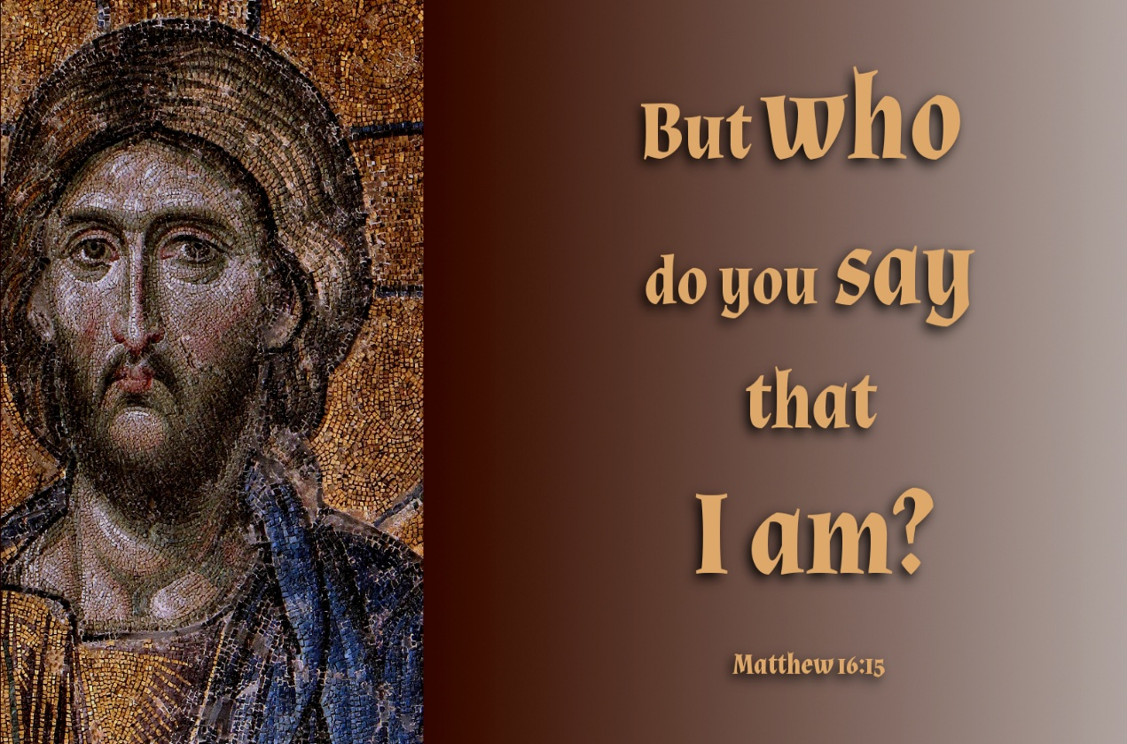

Grace Lutheran Church
310 West Lorain Street
Oberlin, Ohio 44074
www.grace-church-oberlin.org
440-775-3271
August 09, 2026
Pastor: Rev. Dr. Christian F. Just
Organist: James Feddeck

