Grace Lutheran Church
310 West Lorain Street, Oberlin, Ohio 44074
August 23, 2026
10:00 AM

THE THIRTEENTH SUNDAY AFTER PENTECOST
Divine Worship Service
Grace Evangelical Lutheran Church of Oberlin, Ohio
Service of Prayer & Preaching from LSB (CPH, 2006) p. 260-267

Prelude

Welcome
Opening Hymn: Awake, My Soul, and with the Sun (LSB 868)
(Please Stand)

1. Awake, my soul, and with the sun Thy daily stage of duty run;
Shake off dull sloth and joyful rise To pay thy morning sacrifice.

2. In conversation be sincere, Thy conscience as the noon-day clear;
Think how the all-see-ing God thy ways And all thy secret thoughts surveys.

3. All praise to Thee, who safe hast kept And hast re-freshed me while I slept;
Grant, Lord, when I from death wake, I may of endless light partake.

4. Lord, I my vows to Thee re-new; Dis-perse my sins as morning dew;
Guard my first springs of thought and will And with Thyself my spirit fill.

New Testament Canicle (sung) (LSB 266)

Christ has been raised from the dead!
Alleluia. Alleluia.
Christ our Passover Lamb has been sacrificed.
Raised from the dead, He will never die again.
Death has no more dominion over Him.
Christ has been raised from the dead!
Alleluia. Alleluia.
Dying, Christ dies to sin, once for all.
Living, He lives to God.
Count yourselves as dead to sin and alive to God in Christ Jesus, Our Lord.
Christ has been raised from the dead!
Alleluia. Alleluia.

Blessing (LSB 267)

P Let us bless the Lord.
C Thanks be to God.

Benediction
P The almighty and merciful Lord, the Father, the Son, and the Holy Spirit, bless and
preserve us.
C Amen.

Postlude:

+ + +

Pastor: Rev. Dr. Christian F. Just
Organist: James Feddeck
Order of Worship: Service of Prayer and Preaching from LSB (CPH, 2006) p. 260-267

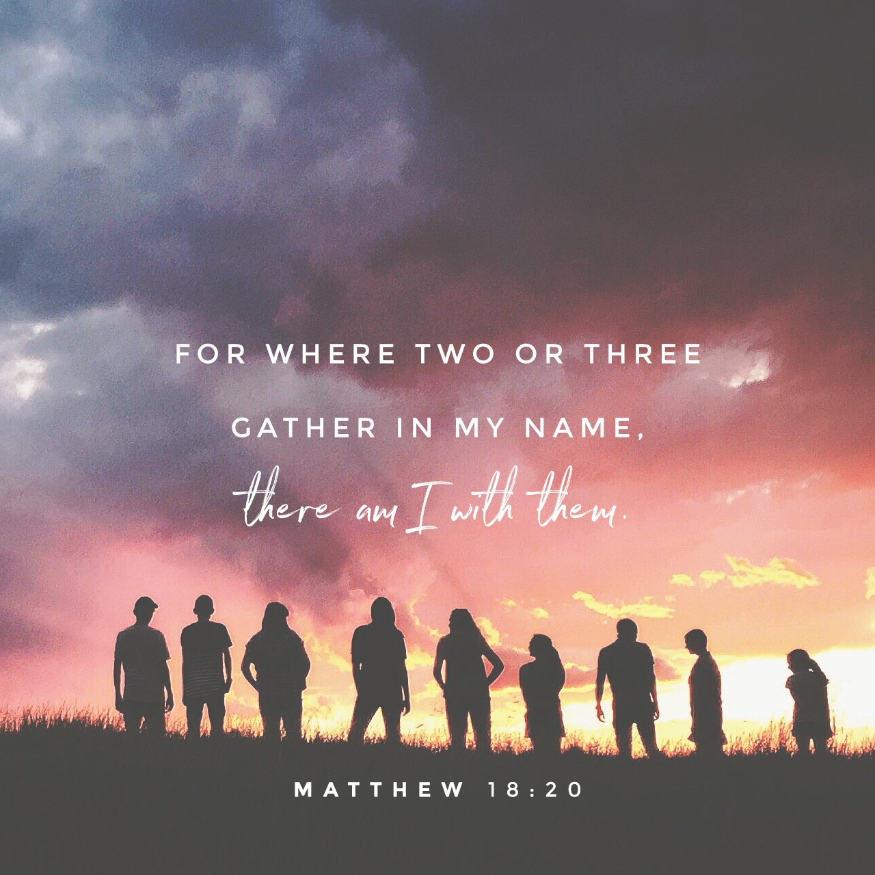
Grace Lutheran Church
310 West Lorain Street
Oberlin, Ohio 44074
www.grace-church-oberlin.org
440-775-3271
August 23, 2026
Pastor: Rev. Dr. Christian F. Just
Organist: James Feddeck

“Give thanks to the Lord, call upon His name, make known His deeds among the peoples, proclaim that His name is exalted.”
The Lord God is my strength and my song, and He has become my salvation.
Sing praises to the Lord, for He has done gloriously;
Let this be made known in all the earth.
Shout, and sing for joy, O inhabitants of Zion, for great in your midst is the Holy One of Israel.
The Lord God is my strength and my song, and he has become my salvation.
Glory be to the Father and to the Son and to the Holy Spirit;
As it was in the beginning, is now, and will be forever. Amen.
The Lord God is my strength and my song, and He has become my salvation.

Readings From Holy Scripture (LSB 263)

Old Testament Reading Ezekial 33:1-11

The word of the Lord came to me: ² “Son of man, speak to your people and say to them, If I bring the sword upon a land, and the people of the land take a man from among them, and make him their watchman, ³ and if he sees the sword coming upon the land and blows the trumpet and warns the people, ⁴ then if anyone who hears the sound of the trumpet does not take warning, and the sword comes and takes him away, his blood shall be upon his own head. ⁵ He heard the sound of the trumpet and did not take warning; his blood shall be upon himself. But if he had taken warning, he would have saved his life. ⁶ But if the watchman sees the sword coming and does not blow the trumpet, so that the people are not warned, and the sword comes and takes any one of them, that person is taken away in his iniquity, but his blood I will require at the watchman's hand. ⁷ “So you, son of man, I have made a watchman for the house of Israel. Whenever you hear a word from my mouth, you shall give them warning from me. ⁸ If I say to the wicked, O wicked one, you shall surely die, and you do not speak to warn the wicked to turn from his way, that wicked person shall die in his iniquity, but his blood I will require at your hand. ⁹ But if you warn the wicked to turn from his way, and he does not turn from his way, that person shall die

Offering: (Offerings are brought forward)

Prayer (Please stand) (LSB 265)

P In peace let us pray to the Lord:
C Lord, have mercy.
P For the gift of divine peace and of pardon, with all our heart and with all our mind,
let us pray to the Lord:
C Lord, have mercy.
P For the holy Christian Church, here and scattered throughout the world, and for the
proclamation of the Gospel and the calling of all to faith, let us pray to the Lord:
C Lord, have mercy.
P For this nation, for our cities and communities, and for the common welfare of us all,
let us pray to the Lord:
C Lord, have mercy.
P For seasonable weather and for the fruitfulness of the earth, let us pray to the Lord:
C Lord, have mercy.
P For those who labor, for those whose work is difficult or dangerous, and for all who
travel, let us pray to the Lord:
C Lord, have mercy.
P For all those in need, for the hungry and homeless, for the widowed and orphaned,
and for all those in prison, let us pray to the Lord:
C Lord, have mercy.
P For the sick and dying and for all those who care for them, let us pray to the Lord:
C Lord, have mercy.
P For . . . [additional bids for prayer may be inserted here] . . . let us pray to the Lord:
C Lord, have mercy.
P Finally, for these and for all our needs of body and soul, let us pray to the Lord:
C Lord, have mercy. Christ, have mercy. Lord, have mercy.

Collect of the Day (LSB 265)

P Thank you, heavenly Father, that through Your Son You have reconciled is to
Yourself and to one another. Teach us to follow His example by living at peace with
each other. We ask this through Jesus Christ our Lord, who lives and reigns with You
and the Holy Spirit, One God, now and forever.
C Amen.

Collect for the Word (LSB 265)

P Blessed Lord, You have caused all Holy Scriptures to be written for our learning.
Grant that we may so hear them, read, mark, learn, and take them to heart that, by
the patience and comfort of Your holy Word, we may embrace and ever hold fast
the blessed hope of everlasting life; through Jesus Christ, Your Son, our Lord, who
lives and reigns with You and the Holy Spirit, one God, now and forever.
C Amen.

Morning Prayer (LSB 266)

C I thank You, my heavenly Father, through Jesus Christ, Your dear Son, that You
have kept me this night from all harm and danger; and I pray that You would
keep me this day also from sin and every evil, that all my doings and life may
please You. For into Your hands I commend myself, my body and soul, and all
things. Let Your holy angel be with me, that the evil foe may have no power
over me. Amen.

5. Direct, control, suggest this day All I design or do or say
That all my pow’rs with all their might In Thy sole glory may unite.

6. Praise God, from whom all blessings flow; Praise Him, all creatures here below;
Praise Him above, ye heav’nly host: Praise Father, Son, and Holy Ghost.

Opening Versicles (LSB 260)

P This is the day which the Lord has made;
C let us rejoice and be glad in it.
P From the rising of the sun to its setting,
C the name of the Lord is to be praised.

Common Psalm 84:10; 25-4, John 17:17
P Better is one day in Your courts than a thousand elsewhere;
C I would rather be a doorkeeper in the house of my God than dwell in the
tents of the wicked.
P Make me to know Your ways, O Lord.
C Teach me Your paths.
P Sanctify us in Your truth.
C Your Word is truth.
P From the rising of the sun to its setting, Psalm 113:3
C the name of the Lord is to be praised.
C Glory be to the Father and to the Son and to the Holy Spirit;
as it was in the beginning, is now, and will be forever. Amen.

Old Testament Canticle (sung) (LSB 261)

The Lord God is my strength and my song, and He has become my salvation.
With joy will you draw water from the wells of salvation.
And you will say in that day:

Hymn of the Day: Love Divine, All Loves Excelling (LSB 700)

(Please Stand)

1. Love divine, all love excelling, Joy of heaven, to earth come down!
Fix in us Thy humble dwelling: All Thy faithful mercies crown.
Jesus, Thou art all compassion, Pure, unbounded love Thou art:
Visit us with Thy salvation, Enter every trembling heart.

2. Breathe, O breathe Thy loving Spirit In-to ev-’ry troubled breast;
Let us all in Thee in-her-it; Let us find Thy promised rest.
Take a-way the love of sinning; Al-pha and O-me-ga be;
End of faith, as its be-gin-ning, Set our hearts at lib-er-ty.

3. Come, almighty to deliver, Let us all Thy life receive;
Sud-en-ly return, and never, Nev-er-more Thy temples leave.
Thee we would be alway blessing; Serve Thee as Thy hosts above;
Pray, and praise Thee without ceasing, Glory in Thy perfect love.

4. Finish then Thy new creation, Pure and spotless let us be;
Let us see Thy great salvation Per-fect-ly restored in Thee:
Changed from glo-ry into glo-ry, Till in heaven we take our place;
Till we cast our crowns before Thee, Lost in wonder, love, and praise.

Gospel Reading Matthew 18:15-20

P The Holy Gospel according to St. Matthew, the eighteenth chapter.
C Glory to You, O Lord. (sung)

¹⁵ “If your brother sins against you, go and tell him his fault, between you and him alone. If he listens to you, you have gained your brother. ¹⁶ But if he does not listen, take one or two others along with you, that every charge may be established by the evidence of two or three witnesses. ¹⁷ If he refuses to listen to them, tell it to the church. And if he refuses to listen even to the church, let him be to you as a Gentile and a tax collector. ¹⁸ Truly, I say to you, whatever you bind on earth shall be bound in heaven, and whatever you loose on earth shall be loosed in heaven. ¹⁹ Again I say to you, if two of you agree on earth about anything they ask, it will be done for them by my Father in heaven. ²⁰ For where two or three are gathered in my name, there am I among them.”

P This is the word of the Lord.
C Thanks be to God.

Responsory (LSB 263)

Common Psalm 119:89; Luke 11:28

P Forever, O Lord, Your Word is firmly set in the heavens.
C Lord, I love the habitation of Your house and the place where Your glory
dwells.
P Blessed are those who hear the Word of God and keep it.
C Lord, I love the habitation of Your house and the place where Your glory
dwells.
P Glory be to the Father and to the Son and to the Holy Spirit.
C Lord, I love the habitation of Your house and the place where Your glory
dwells.

Catechism (LSB 264)

The Office of the Keys

What is the Office of the Keys?

The Office of the Keys is that special authority that Christ has given to His church on earth to forgive the sins of repentant, but to withhold forgiveness to the unrepentant as long as they do not repent.

Where is this written?

This is what St. John the Evangelist wrote in chapter 20: the Lord breathed on his disciples and said, “ Receive the Holy Spirit. If you forgive anyone his sins they are forgiven; if you do not forgive them, they are not forgiven.” (John 20:22-23)

What do you believe according to these words?

I believe that when the called ministers of Christ deal with us by His divine command, particularly when the exclude openly unrepentant sinners from the Christian congregation and absolve those who repent of their sins and want to do better, this is just as valid and certain, even in heaven, as if Christ our dear Lord dealt with us Himself.

Sermon: “The Demands of Love”

Hymn: Renew Me, O Eternal Light (LSB 704)

(Please Stand)

1. Renew me, O eternal Light, And let my heart and soul be bright,
Illumined with the light of grace That issues from Your holy face.
2. Remove the pow'r of sin from me And cleanse all my impurity
That I may have the strength and will Temptations of the flesh to still.
3. Create in me a new heart, Lord, That gladly I obey Your Word.
Let what You will be my desire, And with new life my soul inspire.
4. Grant that I only You may love And seek those things which are above
Till I behold You face to face, O Light eternal, through Your grace.

in his iniquity, but you will have delivered your soul. ¹⁰ “And you, son of man, say to the house of Israel, Thus have you said: ‘Surely our transgressions and our sins are upon us, and we rot away because of them. How then can we live?’ ¹¹ Say to them, As I live, declares the Lord God, I have no pleasure in the death of the wicked, but that the wicked turn from his way and live; turn back, turn back from your evil ways, for why will you die, O house of Israel?

P This is the word of the Lord.
C Thanks be to God.

Epistle Romans 13:8-14

⁸ Owe no one anything, except to love each other, for the one who loves another has fulfilled the law. ⁹ For the commandments, “You shall not commit adultery, You shall not murder, You shall not steal, You shall not covet,” and any other commandment, are summed up in this word: “You shall love your neighbor as yourself.” ¹⁰ Love does no wrong to a neighbor; therefore love is the fulfilling of the law. ¹¹ Besides this you know the time, that the hour has come for you to wake from sleep. For salvation is nearer to us now than when we first believed. ¹² The night is far gone; the day is at hand. So then let us cast off the works of darkness and put on the armor of light. ¹³ Let us walk properly as in the daytime, not in orgies and drunkenness, not in sexual immorality and sensuality, not in quarreling and jealousy. ¹⁴ But put on the Lord Jesus Christ, and make no provision for the flesh, to gratify its desires.
P This is the word of the Lord.
C Thanks be to God.

