Grace Lutheran Church
310 West Lorain Street, Oberlin, Ohio 44074
September 13, 2026
10:00 AM

THE SIXTEENTH SUNDAY AFTER PENTECOST
Divine Worship Service
Grace Evangelical Lutheran Church of Oberlin, Ohio
Service of Prayer & Preaching from LSB (CPH, 2006) p. 260-267

Prelude

Welcome
Opening Hymn: Lord Jesus Christ, Be Present Now (LSB 902)
(Please Stand)

1. Lord Jesus Christ, be present now, Our hearts in true devotion bow,
Your Spirit send with grace divine, And let your truth within us shine.

2. Unseal our lips to sing your praise, In endless hymns through all our days.
Increase our faith and light our minds; And set us free from doubt that blinds.

3. Then shall we join the hosts that cry, "O holy, holy Lord Most High!"
And in the light of that blest place We than shall see You face to face.

4. All glo-ry to the Father, Son, And Holy Spirit, Three in One!
To You, O blessed Trinity, Be praise through-out eternity!

Opening Versicles (LSB 260)

P This is the day which the Lord has made;
C let us rejoice and be glad in it.
P From the rising of the sun to its setting,
C the name of the Lord is to be praised.

Common Psalm 84:10; 25-4, John 17:17
P Better is one day in Your courts than a thousand elsewhere;
C I would rather be a doorkeeper in the house of my God than dwell in the
tents of the wicked.
P Make me to know Your ways, O Lord.
C Teach me Your paths.
P Sanctify us in Your truth.
C Your Word is truth.

P From the rising of the sun to its setting, Psalm 113:3
C the name of the Lord is to be praised.
C Glory be to the Father and to the Son and to the Holy Spirit;
as it was in the beginning, is now, and will be forever. Amen.

Old Testament Canticle (sung) (LSB 261)

The Lord God is my strength and my song, and He has become my salvation.
With joy will you draw water from the wells of salvation.
And you will say in that day:
“Give thanks to the Lord, call upon His name, make known His deeds among the peoples, proclaim that His name is exalted.”
The Lord God is my strength and my song, and He has become my salvation.
Sing praises to the Lord, for He has done gloriously;
Let this be made known in all the earth.

Shout, and sing for joy, O inhabitants of Zion, for great in your midst is the Holy One of Israel.
The Lord God is my strength and my song, and he has become my salvation.
Glory be to the Father and to the Son and to the Holy Spirit;
As it was in the beginning, is now, and will be forever. Amen.
The Lord God is my strength and my song, and He has become my salvation.

Readings From Holy Scripture (LSB 263)

Old Testament Reading Ezekiel 18:1-4,25-32

The word of the Lord came to me: ² “What do you mean by repeating this proverb concerning the land of Israel, ‘The fathers have eaten sour grapes, and the children's teeth are set on edge’? ³ As I live, declares the Lord God, this proverb shall no more be used by you in Israel. ⁴ Behold, all souls are mine; the soul of the father as well as the soul of the son is mine: the soul who sins shall die.
²⁵ “Yet you say, ‘The way of the Lord is not just.’ Hear now, O house of Israel: Is my way not just? Is it not your ways that are not just? ²⁶ When a righteous person turns away from his righteousness and does injustice, he shall die for it; for the injustice that he has done he shall die. ²⁷ Again, when a wicked person turns away from the wickedness he has committed and does what is just and right, he shall save his life. ²⁸ Because he considered and turned away from all the transgressions that he had committed, he shall surely live; he shall not die. ²⁹ Yet the house of Israel says, ‘The way of the Lord is not just.’ O house of Israel, are my ways not just? Is it not your ways that are not just? ³⁰ “Therefore I will judge you, O house of Israel, every one according to his ways, declares the Lord God. Repent and turn from all your transgressions, lest iniquity be your ruin. ³¹ Cast away from you all the transgressions that you have committed, and make yourselves a new heart and a new spirit! Why will you die, O house of Israel? ³² For I have no pleasure in the death of anyone, declares the Lord God; so turn, and live.”

P This is the word of the Lord.
C Thanks be to God.
Epistle Philippians 2:1-13

So if there is any encouragement in Christ, any comfort from love, any participation in the Spirit, any affection and sympathy, ² complete my joy by being of the same mind, having the same love, being in full accord and of one mind. ³ Do nothing from selfish ambition or conceit, but in humility count others more significant than yourselves. ⁴ Let each of you look not only to his own interests, but also to the interests of others. ⁵ Have this mind among yourselves, which is yours in Christ Jesus, ⁶ who, though he was in the form of God, did not count equality with God a thing to be grasped, ⁷ but emptied himself, by taking the form of a servant, being born in the likeness of men. ⁸ And being found in human form, he humbled himself by becoming obedient to the point of death, even death on a cross. ⁹ Therefore God has highly exalted him and bestowed on him the name that is above every name, ¹⁰ so that at the name of Jesus every knee should bow, in heaven and on earth and under the earth, ¹¹ and every tongue confess that Jesus Christ is Lord, to the glory of God the Father.¹² Therefore, my beloved, as you have always obeyed, so now, not only as in my presence but much more in my absence, work out your own salvation with fear and trembling, ¹³ for it is God who works in you, both to will and to work for his good pleasure.
P This is the word of the Lord.
C Thanks be to God.

Hymn of the Day: O Savior, Precious Savior (LSB 527)

1. O Savior, precious Savior, Whom yet unseen we love;
O Name of might and favor, All other names above,
We worship Thee, we bless Thee, To Thee, O Christ, we sing;
We praise Thee and confess Thee, Our holy Lord and King.
2. O bringer of salvation, Who wondrously hast wrought,
Thyself the revelation Of love beyond our thought.
We worship Thee, we bless Thee, To Thee, O Christ, we sing;
We praise Thee, and confess Thee, Our gracious Lord and King.
3. In Thee all fulness dwelleth, All grace and pow'r divine;
The glory that excelleth, O Son of God, is Thine.
We worship Thee, we bless Thee, To Thee, O Christ, we sing;
We praise Thee and confess Thee, Our glorious Lord and King.

4. O grant the consummation Of this our song above
In endless adoration And everlasting love;
Then shall we praise and bless Thee Where perfect praises ring,
And evermore confess Thee, Our Savior and our King!

Gospel Reading Matthew 21:23-32

P The Holy Gospel according to St. Matthew, the twenty-first chapter.
C Glory to You, O Lord. (sung)
²³ And when he entered the temple, the chief priests and the elders of the people came up to him as he was teaching, and said, “By what authority are you doing these things, and who gave you this authority?” ²⁴ Jesus answered them, “I also will ask you one question, and if you tell me the answer, then I also will tell you by what authority I do these things. ²⁵ The baptism of John, from where did it come? From heaven or from man?” And they discussed it among themselves, saying, “If we say, ‘From heaven,’ he will say to us, ‘Why then did you not believe him?’ ²⁶ But if we say, ‘From man,’ we are afraid of the crowd, for they all hold that John was a prophet.” ²⁷ So they answered Jesus, “We do not know.” And he said to them, “Neither will I tell you by what authority I do these things.²⁸ “What do you think? A man had two sons. And he went to the first and said, ‘Son, go and work in the vineyard today.’ ²⁹ And he answered, ‘I will not,’ but afterward he changed his mind and went. ³⁰ And he went to the other son and said the same. And he answered, ‘I will, sir,’ but did not go. ³¹ Which of the two did the will of his father?” They said, “The first.” Jesus said to them, “Truly, I say to you, the tax collectors and the prostitutes go into the kingdom of God before you. ³² For John came to you in the way of righteousness, and you did not believe him, but the tax collectors and the prostitutes believed him. And even when you saw it, you did not afterward change your minds and believe him.

P This is the word of the Lord.
C Thanks be to God.

Responsory (LSB 263)

Common Psalm 119:89; Luke 11:28

P Forever, O Lord, Your Word is firmly set in the heavens.
C Lord, I love the habitation of Your house and the place where Your glory
dwells.
P Blessed are those who hear the Word of God and keep it.
C Lord, I love the habitation of Your house and the place where Your glory
dwells.
P Glory be to the Father and to the Son and to the Holy Spirit.
C Lord, I love the habitation of Your house and the place where Your glory
dwells.

Catechism (LSB 324)

The Lord’s Prayer- The Third Petition

Thy will be done be on earth as it is in heaven.
Your will be done on earth as it is in heaven.

What Does This Mean?

The good and gracious will of God is done even without our prayer, but we pray in this petition that it may be done among us also.

How is God’s will done?
God’s will is done when He breaks and hinders every evil plan and purpose of the devil, the world, and our sinful nature, which don’t want us to hallow God’s name or let His kingdom come; and when He strengthens and keeps us firm in His Word and faith until we die. This is His good and gracious will.

Sermon: “Looking into the Mind of Christ?”

Hymn: The Will of God is Always Best (LSB 758)

(Please Stand)
1. The will of God is always best And shall be done forever;
And they who trust in Him are blest; He will forsake them never.
He helps indeed In time of need; He chastens with forbearing,
They who depend On God, their friend,
Shall not be left despairing.
2. God is my comfort and my trust, My hope and life abiding;
And to His counsel, wise and just, I yield, in Him confiding.
The very hairs, His Word declares,
Upon my head He numbers. By night and day
God is my stay; He never sleeps nor slumbers.
3. Lord, this I ask, O hear my plea, Deny me not this favor:
When Satan sorely troubles me, Then do not let me waver.
O guard me well, My fear dispel,
Fulfill Your faithful saying: All who believe
By grace receive An answer to their praying.
4. When life's brief course on earth is run And I this world am leaving,
Grant me to say, "Your will be done," Your faithful Word believing.
My dearest Friend, I now commend My soul into Your keeping;
From sin and hell, And death as well,
By You the vict'ry reaping.

Offering: (Offerings are brought forward)

Prayer (Please stand) (LSB 265)

P In peace let us pray to the Lord:
C Lord, have mercy.
P For the gift of divine peace and of pardon, with all our heart and with all our mind,
let us pray to the Lord:
C Lord, have mercy.
P For the holy Christian Church, here and scattered throughout the world, and for the
proclamation of the Gospel and the calling of all to faith, let us pray to the Lord:
C Lord, have mercy.
P For this nation, for our cities and communities, and for the common welfare of us all,
let us pray to the Lord:
C Lord, have mercy.
P For seasonable weather and for the fruitfulness of the earth, let us pray to the Lord:
C Lord, have mercy.
P For those who labor, for those whose work is difficult or dangerous, and for all who
travel, let us pray to the Lord:
C Lord, have mercy.
P For all those in need, for the hungry and homeless, for the widowed and orphaned,
and for all those in prison, let us pray to the Lord:
C Lord, have mercy.
P For the sick and dying and for all those who care for them, let us pray to the Lord:
C Lord, have mercy.
P For . . . [additional bids for prayer may be inserted here] . . . let us pray to the Lord:
C Lord, have mercy.
P Finally, for these and for all our needs of body and soul, let us pray to the Lord:
C Lord, have mercy. Christ, have mercy. Lord, have mercy.

Collect of the Day (LSB 265)

P Loving and righteous God, You are far more generous to us, and to all who work in Your kingdom, than we desire or deserve. Make us as generous to others as You have been to us. We ask this through Your Son, Jesus Christ our Lord, who lives and reigns with You and the Holy Spirit, one God, now and forever.

C Amen.

Collect for the Word (LSB 265)

P Blessed Lord, You have caused all Holy Scriptures to be written for our learning.
Grant that we may so hear them, read, mark, learn, and take them to heart that, by
the patience and comfort of Your holy Word, we may embrace and ever hold fast
the blessed hope of everlasting life; through Jesus Christ, Your Son, our Lord, who
lives and reigns with You and the Holy Spirit, one God, now and forever.

C Amen.

Morning Prayer (LSB 266)

C I thank You, my heavenly Father, through Jesus Christ, Your dear Son, that You
have kept me this night from all harm and danger; and I pray that You would
keep me this day also from sin and every evil, that all my doings and life may
please You. For into Your hands I commend myself, my body and soul, and all
things. Let Your holy angel be with me, that the evil foe may have no power
over me. Amen.

New Testament Canticle (sung) (LSB 266)

Christ has been raised from the dead!
Alleluia. Alleluia.
Christ our Passover Lamb has been sacrificed.
Raised from the dead, He will never die again.
Death has no more dominion over Him.
Christ has been raised from the dead!
Alleluia. Alleluia.
Dying, Christ dies to sin, once for all.
Living, He lives to God.
Count yourselves as dead to sin and alive to God in Christ Jesus, Our Lord.
Christ has been raised from the dead!
Alleluia. Alleluia.

Blessing (LSB 267)

P Let us bless the Lord.
C Thanks be to God.

Benediction
P The almighty and merciful Lord, the Father, the Son, and the Holy Spirit, bless and
preserve us.
C Amen.

Closing Hymn: Praise to You and Adoration (LSB 692)

1. Praise to You and adoration, Blessed Jesus, Son of God,
Who, to serve Your own creation, Came to share our flesh and blood.
Guide me that I never may From Your fold or pastures stray,
But with zeal and joy exceeding Follow where Your steps are leading.

2. Hold me ever in Your keeping; Comfort me in pain and strife.
In my laughter and my weeping Be with me throughout my life.
Give me greater love for You, And my faith and hope renew
In Your birth, Your life, and passion, In Your death and resurrection

Postlude:

+ + +

Pastor: Rev. Dr. Christian F. Just
Organist: Holly Bogle
Order of Worship: Service of Prayer and Preaching from LSB (CPH, 2006) p. 260-267
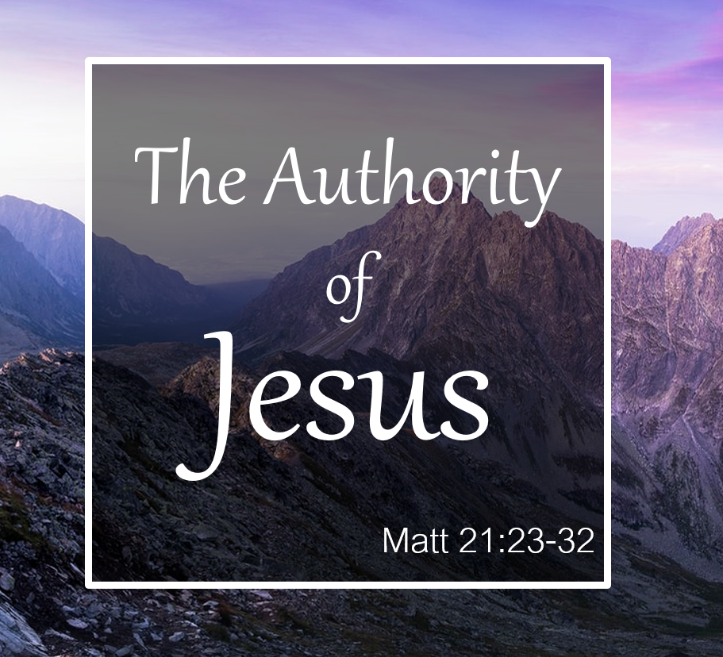

Grace Lutheran Church
310 West Lorain Street
Oberlin, Ohio 44074
www.grace-church-oberlin.org
440-775-3271
September 13, 2026
Pastor: Rev. Dr. Christian F. Just
Organist: Holly Bogle

