Grace Lutheran Church
310 West Lorain Street, Oberlin, Ohio 44074
September 20, 2026
10:00 AM

THE SEVENTEENTH SUNDAY AFTER PENTECOST
Divine Worship Service
Grace Evangelical Lutheran Church of Oberlin, Ohio
Setting 1 from LSB (CPH, 2006) p. 151-166

Prelude:

Welcome:
Opening Hymn: I Lay My Sins On Jesus (LSB 606)

1. I lay my sins on Jesus, The spotless Lamb of God;
He bears them all and frees us From the accursed load.
I bring my guilt to Jesus To wash my crimson stains
Clean in His blood most precious Till not a spot remains.
2. I lay my wants on Jesus; All fullness dwells in Him;
He heals all my diseases; My soul He does redeem.
I lay my griefs on Jesus, My burdens and my cares;
He from them all releases; He all my sorrows shares.
3. I rest my soul on Jesus, This weary soul of mine;
His right hand me embraces; I on His breast recline.
I love the name of Jesus, Immanuel, Christ, the Lord;
Like fragrance on the breezes His name abroad is poured.
the meaning of Holy Communion, and agree with these teachings. If you have any questions, please
speak with Pastor Just. As we eat and drink, we remember our Lord’s suffering, death, resurrection, ascension, and the promise of His coming again. Both Common and individual cups are available. When using the individual cup, please place the empty cup in the basket at either end of the communion rail. Please note that all wine is alcoholic. Should you plan on attending on a regular basis and require a non-alcoholic beverage, please let the usher or Pastor Just know, and we will provide it at the following services. If the Common cup is used, please help the server by holding the base of the cup when you are served.

Post-Communion Canticle: (sung) (LSB 164)

ALL: Thank the Lord and sing His praise; tell ev’ryone what He has done.
Let all who seek the Lord rejoice and proudly bear His name.
He recalls His promises and leads His people forth in joy
with shouts of thanksgiving. Alleluia, alleluia.

Post-Communion Collect: (LSB 166)

P Let us Pray….
We give thanks to You, almighty God, that You have refreshed us through this salutary
gift, and we implore You that of Your mercy You would strengthen us through the same
in faith toward You and fervent love toward one another; through Jesus Christ, Your Son,
our Lord, who lives and reigns with You and the Holy Spirit, one God, now and forever.
C Amen. (sung)

Benediction:
P The Lord bless you and keep you.
The Lord make His face to shine upon you
and be gracious to you.
The Lord lift up His favor upon you and give you Peace.
C Amen. (sung)

Closing Hymn: Lord of Glory, You Have Bought Us (LSB 851)

1. Lord of Glory, You have bought us With Your life-blood as the price,
Never grudging for the lost ones That tremendous sacrifice;
And with that have freely given Blessings countless as the sand
To the unthankful and the evil With Your own unsparing hand.
2. Grant us hearts, dear Lord, to give You Gladly, freely of Your own.
With the sunshine of Your goodness Melt our thankless hearts of stone
Till our cold and selfish natures, Warmed by You, at length believe
That more happy and more blessed 'Tis to give than to receive.
3. Wondrous honor You have given To our humblest charity
In Your own mysterious sentence, "You have done it all to Me."
Can it be, O gracious Master, That You deign for alms to sue,
Saying by Your poor and needy, "Give as I have giv'n to you"?
4. Lord of glory, You have bought us With Your life-blood as the price,
Never grudging for the lost ones That tremendous sacrifice.
Give us faith to trust You boldly, Hope, to stay our souls on You;
But, oh, best of all Your graces, With Your love our love renew.

P Go in peace. Serve the Lord.
C Thanks be to God.

Postlude:

+ + +

Pastor: Rev. Dr. Christian F. Just
Organist: Holly Bogle
Order of Worship: Divine Service Setting 1 from LSB (CPH, 2006) p. 151-166

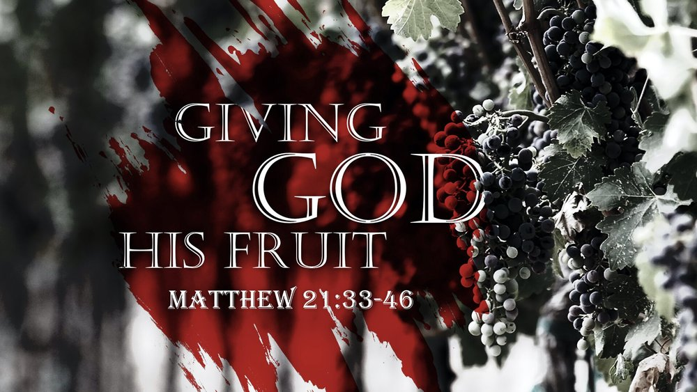

Grace Lutheran Church

310 West Lorain Street
Oberlin, Ohio 44074
www.grace-church-oberlin.org
440-775-3271
September 20, 2026
Pastor: Rev. Dr. Christian F. Just
Organist: Holly Bogle

C as it was in the beginning, is now, and will be forever. Amen.
P I will offer to you the sacrifice of thanksgiving
C and call on the name of the Lord.

Kyrie: (sung) (LSB 186)

P In Peace let us Pray to the Lord.
C Lord, have mercy.
P For the Peace from above and for our salvation let us Pray to the Lord.
C Lord, have mercy.
P For the Peace of the whole world, for the well-being of the Church of
God and for the unity of all let us Pray to the Lord.
C Lord, have mercy.
P For this holy house and for all who offer here their worship and praise
let us pray to the Lord.
C Lord, have mercy.
P Help, save, comfort, and defend us, gracious Lord.
C Amen.

Gloria in Excelsis: (sung) (LSB 154)

P Glory to God in the highest, and Peace to his People on earth.

ALL: Lord God, heavenly King, almighty God and Father,
We worship you, we give you thanks, we praise you for your glory.
Lord Jesus Christ, only Son of the Father, Lord God, Lamb of God,
You take away the sin of the world, have mercy on us;
You are seated at the right hand of the Father: receive our Prayer.
For you alone are the Holy One,you alone are the Lord, You alone are the Most High, Jesus Christ, with the Holy Spirit in the glory of God the Father. Amen.

Prayer of the Church: (Each Petition of the Prayers concludes with the response:)

P Lord, in your mercy,
C Hear our prayer.

The Preface: (sung)

P The Lord be with you.
C And also with you.
P Lift up your hearts.
C We lift them to the Lord
P Let us give thanks to the Lord our God.
C It is right to give Him thanks and praise.
P It is truly good, right, and salutary that we should at all times and in all places give
thanks to You, holy Lord, almighty Father, everlasting God, through Jesus Christ,
our Lord, who on this day overcame death and the grave and by His glorious
resurrection opened to us the way of everlasting life. Therefore, with angels and
archangels and with all the company of heaven we laud and magnify Your glorious
name, evermore praising You and singing:

Sanctus: (sung) (LSB 161)

ALL: Holy, holy, holy Lord God of Pow’r and might:
Heaven and earth are full of Your glory.
Hosanna. Hosanna. Hosanna in the highest.
Blessed is He who comes in the name of the Lord.
Hosanna in the highest.

P Lord, remember us in Your Kingdom and teach us to pray:

Lord’s Prayer: (LSB 162)
Our Father who art in heaven, hallowed be Thy name, Thy kingdom come, Thy will be done, on earth as it is in heaven. Give us this day our daily bread; and forgive us our trespasses as we forgive those who trespass against us; and lead us not into temptation, but deliver us from evil.
For Thine is the kingdom and the power and the glory forever and ever. Amen.

Words of Institution:

P Our Lord Jesus Christ, on the night when He was betrayed, took bread, and when He had given thanks, He broke it and gave it to the disciples and said: “Take, eat; this is My +body, which is given for you. This do in remembrance of Me.”
In the same way also He took the cup after supper, and when He had given thanks, He gave it to them, saying: “Drink of it, all of you; this cup is the new testament in my +blood, which is shed for you for the forgiveness of sins. This do, as often as you drink it, in remembrance of Me.”

Pax Domini: (sung)

P The Peace of the Lord be with you always.
C Amen.

Agnus Dei: (sung) (LSB 163)

ALL: Lamb of God, You take away the sin of the world; have mercy on us.
Lamb of God, You take away the sin of the world; have mercy on us.
Lamb of God, You take away the sin of the world; grant us Peace.

Distribution of Holy Communion:

In Holy Communion we believe Jesus gives us His real presence, in and with the bread and the wine, for the forgiveness of sins. We celebrate this forgiveness, which comes through faith, and we are strengthened in our personal faith and in our love for one another. We invite to Holy Communion all who believe in Jesus as their Savior, are a baptized believer, have been instructed in
Confession and Absolution: (LSB 151)

P In the name of the Father, and of the T Son, and of the Holy Spirit!
C Amen.
P This is the day that the Lord has made!
C We will rejoice and be glad in it!
P If we say we have no sin, we deceive ourselves, and the truth is not in us.
C But if we confess our sins, God, who is faithful and just, will forgive our sins
and cleanse us from all unrighteousness.
Silence for reflection on God's Word and for self-examination.
P Let us then confess our sins to God our Father.
C Most merciful God, we confess that we are by nature sinful and unclean. We
have sinned against You in thought, word, and deed, by what we have done
and by what we have left undone. We have not loved You with our whole
heart; we have not loved our neighbors as ourselves. We justly deserve Your
present and eternal punishment. For the sake of Your Son, Jesus Christ, have
mercy on us. Forgive us, renew us, and lead us, so that we may delight in
Your will and walk in Your ways to the glory of Your holy name. Amen.
P Almighty God in His mercy has given His Son to die for you and for His sake forgives
you all your sins. As a called and ordained servant of Christ, and by His authority, I
therefore forgive you all your sins in the name of the Father and of the T Son and
of the Holy Spirit.
C Amen.

Introit Psalm 116:12–13, 15–16; antiphon: v. 17

P I will offer to you the sacrifice of thanksgiving
C and call on the name of the Lord.
P What shall I render to the Lord
C for all his benefits to me?
P I will lift up the cup of salvation
C and call on the name of the Lord.
P Precious in the sight of the Lord
C is the death of his saints.
P O Lord, I am your servant;
C I am your servant, the son of your maidservant. You have loosed my bonds.
P Glory be to the Father and to the Son and to the Holy Spirit;
Epistle: Philippians 3:4b-14
^{…4b} though I myself have reason for confidence in the flesh also. If anyone else thinks he has reason for confidence in the flesh, I have more: ⁵ circumcised on the eighth day, of the people of Israel, of the tribe of Benjamin, a Hebrew of Hebrews; as to the law, a Pharisee; ⁶ as to zeal, a persecutor of the church; as to righteousness under the law, blameless. ⁷ But whatever gain I had, I counted as loss for the sake of Christ. ⁸ Indeed, I count everything as loss because of the surpassing worth of knowing Christ Jesus my Lord. For his sake I have suffered the loss of all things and count them as rubbish, in order that I may gain Christ ⁹ and be found in him, not having a righteousness of my own that comes from the law, but that which comes through faith in Christ, the righteousness from God that depends on faith— ¹⁰ that I may know him and the power of his resurrection, and may share his sufferings, becoming like him in his death, ¹¹ that by any means possible I may attain the resurrection from the dead.¹² Not that I have already obtained this or am already perfect, but I press on to make it my own, because Christ Jesus has made me his own. ¹³ Brothers, I do not consider that I have made it my own. But one thing I do: forgetting what lies behind and straining forward to what lies ahead, ¹⁴ I press on toward the goal for the prize of the upward call of God in Christ Jesus.

R This is the Word of the Lord
C Thanks be to God.

Alleluia and Verse: (stand and sing) (LSB 156)

Alleluia. Lord, to whom shall we go? You have the words of eternal life.
Alleluia, Alleluia.

Gospel Reading: Matthew 21:33-46

P The Holy Gospel according to St. Matthew, the twenty-first chapter.
C Glory to You, O Lord. (sung)

³³ “Hear another parable. There was a master of a house who planted a vineyard and put a fence around it and dug a winepress in it and built a tower and leased it to tenants, and went into another country. ³⁴ When the season for fruit drew near, he sent his servants to the tenants to get his fruit. ³⁵ And the tenants took his servants and beat one, killed another, and stoned another. ³⁶ Again he sent other servants, more than the first. And they did the same to them. ³⁷ Finally he sent his son to them, saying, ‘They will respect my son.’ ³⁸ But when the tenants saw the son, they said to themselves, ‘This is the heir. Come, let us kill him and have his inheritance.’ ³⁹ And they took him and threw him out of the vineyard and killed him. ⁴⁰ When therefore the owner of the vineyard comes, what will he do to those tenants?” ⁴¹ They said to him, “He will put those wretches to a miserable death and let out the vineyard to other tenants who will give him the fruits in their seasons.”⁴² Jesus said to them, “Have you never read in the Scriptures: “‘The stone that the builders rejected has become the cornerstone; this was the Lord's doing, and it is marvelous in our eyes’? ⁴³ Therefore I tell you, the kingdom of God will be taken away from you and given to a people producing its fruits. ⁴⁴ And the one who falls on this stone will be broken to pieces; and when it falls on anyone, it will crush him.” ⁴⁵ When the chief priests and the Pharisees heard his parables, they perceived that he was speaking about them. ⁴⁶ And although they were seeking to arrest him, they feared the crowds, because they held him to be a prophet.

P This is the Gospel of the Lord.
C Praise to You, O Christ. (sung)

Apostle’s Creed:

I believe in God, the Father almighty,
Maker of heaven and earth.
And in Jesus Christ, His only Son, our Lord,
who was conceived by the Holy Spirit, born of the Virgin Mary, suffered
under Pontius Pilate, was crucified, died, and was buried.
He descended into hell.
The third day He rose again from the dead.

He ascended into heaven and sits at the right hand of God the Father Almighty. From thence He will come to judge the living and the dead.
I believe in the Holy Spirit, the Holy Christian Church, the communion of saints, the forgiveness of sins, the resurrection of the body, and the life everlasting. Amen.

Sermon: “How Easily We See ‘Them’”

Hymn of the Day: Draw Near and Take the Body of the Lord (LSB 637)
1. Draw near and take the body of the Lord,
And drink the holy blood for you outpoured;
Offered was He for greatest and for least,
Himself the victim and Himself the priest.
2. He who His saints in this world rules and shields,
To all believers life eternal yields;
With heav'nly bread He makes the hungry whole,
Gives living waters to the thirsting soul.
3. Come forward then with faithful hearts sincere,
And take the pledges of salvation here.
O Lord, our hearts with grateful thanks endow
As in this feast of love You bless us now.
Offering: (Offerings are brought forward)

Offertory: (stand and sing) (LSB 192)

ALL: Create in me a clean heart, O God, and renew a right spirit within me. Cast me not away from Thy Presence, and take not Thy Holy Spirit from me. Restore unto me the joy of Thy salvation, and uphold me with Thy free spirit. Amen.

Salutation and Collect: (sung) (LSB 156)

P The Lord be with you.
C And also with you.
P Let us pray.
Almighty and merciful Father, You have ordered our earthly life that we may walk by
faith and not by sight. Give us such trust in Your Fatherly care that we show our faith
by our courage in the face of all perplexities. We ask this through Your Son, Jesus
Christ our Lord, who lives and reigns with You and the Holy Spirit, one God, now and
forever.
C Amen.

Old Testament Reading: Isaiah 5:1-7

Let me sing for my beloved my love song concerning his vineyard: My beloved had a vineyard on a very fertile hill. ² He dug it and cleared it of stones, and planted it with choice vines; he built a watchtower in the midst of it, and hewed out a wine vat in it; and he looked for it to yield grapes, but it yielded wild grapes. ³ And now, O inhabitants of Jerusalem and men of Judah, judge between me and my vineyard. ⁴ What more was there to do for my vineyard, that I have not done in it? When I looked for it to yield grapes, why did it yield wild grapes? ⁵ And now I will tell you what I will do to my vineyard. I will remove its hedge, and it shall be devoured I will break down its wall, and it shall be trampled down.⁶ I will make it a waste; it shall not be pruned or hoed, and briers and thorns shall grow up; I will also command the clouds that they rain no rain upon it. ⁷ For the vineyard of the Lord of hosts is the house of Israel, and the men of Judah are his pleasant planting; and he looked for justice, but behold, bloodshed; for righteousness, but behold, an outcry!

R This is the Word of the Lord
C Thanks be to God.

Gradual: Ps. 34:9, 19, alt.

Fear the Lord, you his saints,
for those who fear him lack nothing!
Many are the afflictions of the righteous,
but the Lord delivers him out of them all.

