GRACE ANNOUNCEMENTS
September 27, 2026


IN OUR PRAYERS THIS WEEK

Please pray for Karen Fridenstine; Marcia Metzger (Hospital); the
family of Joann Martin (Aunt of Sydney Wright) as they mourn her loss;
Jan Koepp; Bob Scherry; Debbie Froboto (friend of Lee Anne Christner);
and Bev & Ray Hines.

COMING UP AT GRACE

Sun. 09/27 Divine Worship Service 10:00 am

****ADULT BIBLE STUDY****

Sun. 09/27 Bible Study w/Paul Castle 11:00 am
(Every other week – next class Oct. 11th
Studying the book of Romans)

Wed. 09/30 Bible Study w/Pastor Weldon 1:30 pm
(Studying Joshua/Judges)

Wed. 09/30 Bible Study w/ Harriett
Bible Study w/Harriett Thomas 7:00 pm
(Studying Psalm 119)
Zoom Only This Week

****

Sun. 10/04 Divine Worship Service 10:00 am

Mark Your Calendars: Ladies Aid Meeting
SUNDAY, OCT. 4, 2026 Immediately after
Church service approx. 10:50 am

SERVING THE LORD
DATE | USHER | Counters | Altar Guild | Lay Reader | Comm. Assist.
Sept. 27  10 am Sun | Paul Castle | Fred C. & Lisa | Kathy Knipper | Harriett Thomas
Oct. 4  10 am Sun | Andy Karp | Fred C.& Paul | ColleenKarp | Harriett Thomas | Paul Castle
Oct. 11  10 am Sun | Andy Karp | Jan & Lisa | Colleen Karp | Fred C.

September Birthdays! september Anniversaries!
Jon Storr 9/02 Bonnie & Gary Abicht 9/02/72
Zachery Abicht 9/07 Glen & Karen Fridenstine 9/26/64
Lorraine Izold 9/13 Gary & Anita Saaforth 9/ /64
Karen Huston 9/14 Greg & LeeAnn Christner 9/27/85
Tina Harrell 9/15

Please notify the Church Office if the above info is incorrect OR we are missing anyone’s
Birthday or Anniversary. (phone: 440-775-3271 or email: secretary4grace@gmail.com)

Communion Statement of
Grace Evangelical Lutheran Church

A congregation of the Lutheran Church Missouri Synod (LCMS)

At Grace we come to the altar to receive the gift of the Lord’s Supper. In the Lord’s Supper those who are baptized receive through faith the true body and true blood of our Lord and Savior Jesus Christ “in, with and under” the bread and wine for their personal forgiveness and strengthening of faith (Matt. 26:26-28; John 6:51-55). We examine ourselves beforehand, mindful of our need for repentance (1 Cor. 11:27-79). In the Lord’s Supper we are united with Christ and His body the Church, and also reflect the unity we have as a congregation with a common Christian, biblically-based confession (1 Cor.10:16-17); see also John 6:56; Acts 2:42; and Romans 16:17. Therefore, those who come forward to receive the Lord’s Supper should be united with us in our understanding of the Lord’s Supper, the real presence of Jesus therein, and the Lutheran Faith. We ask that any visitors who wish to be our guests at the Lord’s Table please talk to Pastor Just before the worship service. Please note that all wine is alcoholic. Should you plan on attending on a regular basis and require a non-alcoholic beverage, please let the usher or Pastor Just know, and we will provide it at the following services.

NOTES FOR WORSHIP
Welcome GUESTS! We are SO GLAD that you have joined us today to worship our
Lord together.

We would love for you to sign our Guest Book in the Narthex.
Announcements and worship service bulletins can be picked up from the table in the narthex. Please help yourself.
Children’s Bulletins are available on the table in the narthex for kids ages 3 & up and 7 & up.
Offering will be collected and the Ushers will bring the offering plates forward during the Offertory.
Attention….
SYRACUSE CHINA- STRAWBERRY HILL PATTERN
Displayed in the Fellowship Hall
***additional pieces in the kitchen***
If you would like any of this China, please check with
Andy Karp or Tom Monroe.

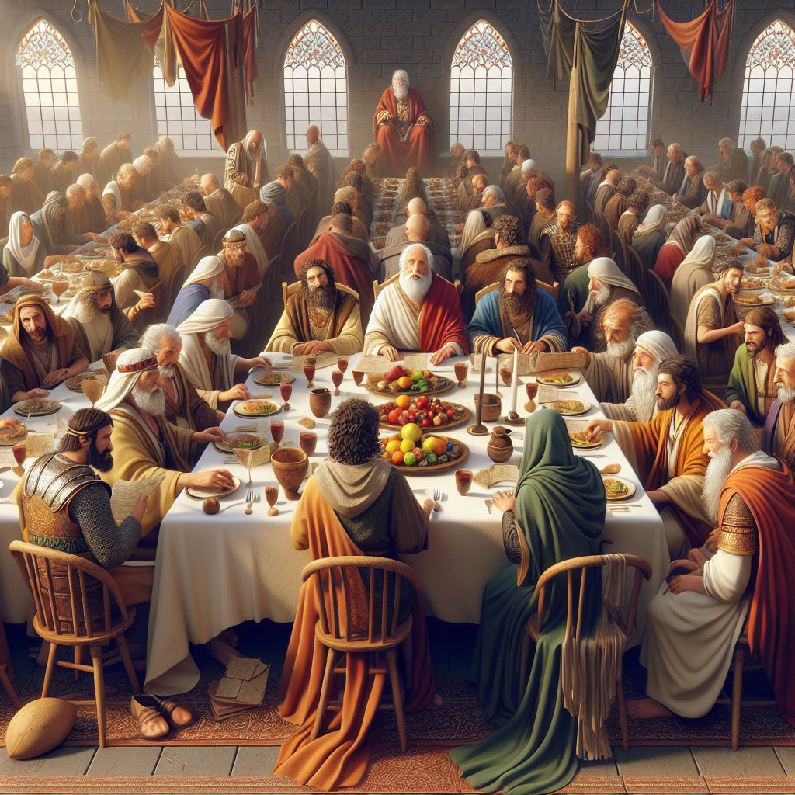
Matthew 22:1-14
And again Jesus spoke to them in parables, saying, ² “The kingdom of heaven may be compared to a king who gave a wedding feast for his son, ³ and sent his servants to call those who were invited to the wedding feast, but they would not come. ⁴ Again he sent other servants, saying, ‘Tell those who are invited, “See, I have prepared my dinner, my oxen and my fat calves have been slaughtered, and everything is ready. Come to the wedding feast.”’ ⁵ But they paid no attention and went off, one to his farm, another to his business, ⁶ while the rest seized his servants, treated them shamefully, and killed them. ⁷ The king was angry, and he sent his troops and destroyed those murderers and burned their city. ⁸ Then he said to his servants, ‘The wedding feast is ready, but those invited were not worthy. ⁹ Go therefore to the main roads and invite to the wedding feast as many as you find.’ ¹⁰ And those servants went out into the roads and gathered all whom they found, both bad and good. So the wedding hall was filled with guests.¹¹ “But when the king came in to look at the guests, he saw there a man who had no wedding garment. ¹² And he said to him, ‘Friend, how did you get in here without a wedding garment?’ And he was speechless. ¹³ Then the king said to the attendants, ‘Bind him hand and foot and cast him into the outer darkness. In that place there will be weeping and gnashing of teeth.’ ¹⁴ For many are called, but few are chosen.”

